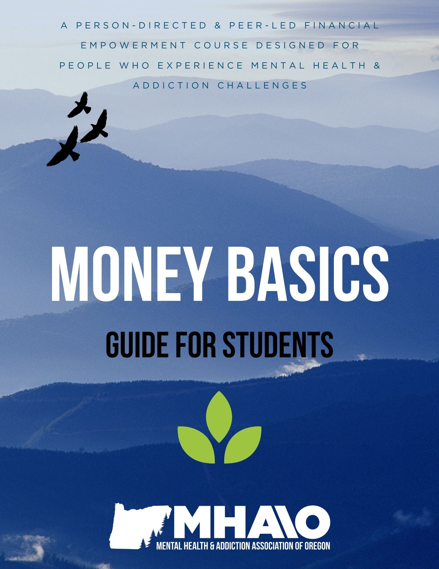
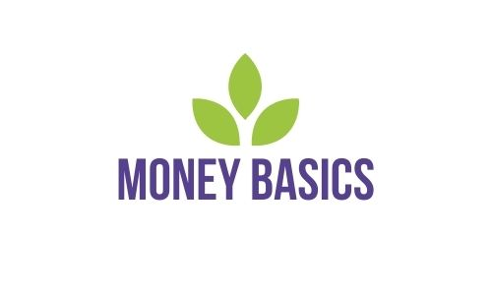

Guide for Students

This guide belongs to: __________________________________________

Money Basics is a program of The Mental Health & Addiction Association of Oregon.
Table of Contents

Acknowledgments 3
Syllabus 4
Workshop 1: Introduction & Course Overview 9
Workshop 2: Setting Financial Goals; Person Directed Planning 30
Workshop 3: Creating a Budget & Resources to Save Money 40
Workshop 4: Banking Basics & Checking Accounts 59
Workshop 5: Debit Cards, ATMs, Online Banking & Money Safety……………………...80
Workshop 6: Credit & Loans………………………………………………………………….99
Workshop 7: Debt & Tools to Get Out of It………………………………………………..118
Workshop 8: Mental Health, Relationships, & Money, Financial Crisis Planning……..134
Workshop 9: How to File a Tax Return & Resources for Doing So…………………….155
Workshop 10: Savings Accounts & Savings Goals………………………………………172
Glossary of Financial Terms………………………………………………………………...186

Acknowledgments
Money Basics was originally developed by Peerlink National Technical Assistance Center, a project of The Mental Health & Addiction Association of Oregon (MHAAO). MHAAO is an inclusive, peer-run 501(c)(3) non-profit organization dedicated to self-direction, honoring the voice of lived experience. Peerlink operated from 2010 to 2020 as a federally-funded national consumer/survivor technical assistance center through the Substance Abuse and Mental Health Services Administration (SAMHSA). Money Basics was created in 2012 by Donita Diamata, Peerlink Director. We thank Donita for her hard work in building the original curriculum and facilitating Money Basics over the years. We are grateful for her vision of a strengths-based, person-directed financial literacy course designed by peers, for peers, and for bringing this vital resource into our community. Additional contributions to the original Money Basics course were made by Jessica Carroll, Teanna Edwards, and Emily Nelson. We thank you all.
Money Basics was updated in 2021 by Chloe Safar through a partnership with AmeriCorps VISTA and Mercy Corps Northwest (MCNW). AmeriCorps VISTA is a national service program dedicated to eradicating poverty in communities across the U.S. The profound isolation, job loss, and economic stress experienced in our community during the COVID-19 pandemic have increased the need for resources such as this and the community these workshops can build. Chloe edited and re-wrote portions of the curriculum and developed the virtual Facilitator Toolkit and Facilitator Training. Chloe would like to thank Sunny Briscoe, Emily Nelson, Scott Tidmore, Adrienne Scavera, and Kaity Riordan for all of their contributions and support. Without your help, this would not have been possible. Chloe would like to thank Emily Nelson, Sebastian Rodrigues, and Gregory Charles for kindly reviewing the curriculum and providing fantastic feedback. Chloe would also like to extend gratitude to Janie Gullickson and all of MHAAO’s incredible staff for the important work they are doing in our community.
We offer our sincere thanks to all contributors and hope that these efforts contribute to the continued recovery and healing of those in our community.
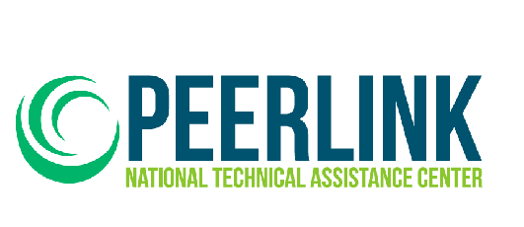
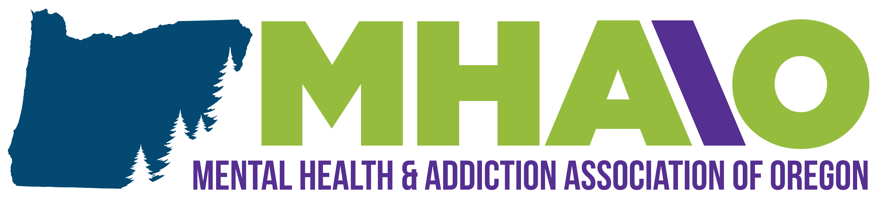

Syllabus
Workshop 1 | Introduction & Course Overview  - Welcome and introductions  - Ground rules, course goals  - Preview course schedule  - Pre-class questionnaire, demographics form, class topics questionnaire  - Thoughts and beliefs about money  - Mental health and money issues  - Addiction and money issues  - Mindfulness tips to reduce financial stress  - Poverty, class, intersectionality, and privilege  - Social justice and equity  - Financial resilience  - Poverty guidelines and living wages  - Individual course goals  - Money saving ideas  Homework:  - Choose one money-saving idea and commit to using it this week. Facilitators will do this too. Note which ideas are going well and which are not.
Workshop 2 | Setting Financial Goals; Person Directed Planning  - Welcome back and group sharing  - Person Directed Planning  - Life now; what works and what doesn’t  - List of my strengths, gifts, and capacities  - My financial dream  - My life one year from now  - Action Plan  Homework:  - Choose one more money-saving idea and commit to using it this week. If you’d like, continue the money-saving idea from the last class.  - Gather information (a list of expenses) for your budget.
Workshop 3 | Creating a Personalized Budget & Resources to Save Money  - Welcome back and group sharing  - Different types of expenses  - Separating expenses into needs vs. wants  - Creating a personalized, working budget  - Additional budgeting options  - National, state, and local resources for saving money  Homework:  - Choose one more money-saving and commit to it for this week.  - Find one community resource that could help save you money.  - Commit to one week with your new budget.
Workshop 4 | Banking Basics & Checking Accounts  - Welcome back and group sharing  - Common banking terms  - Different types of financial institutions  - Common banking fees  - How to open a bank account  - What to do if you have poor banking history  - Checking accounts  - How to read a check, how to write a check  - How to balance your checkbook  Homework:  - Choose one more money-saving idea and commit to it for this week.  - Commit to another week with your budget and revise if needed.  - Find out the amounts of 1-3 bank fees charged at your bank (or a bank you are interested in).
Workshop 5 | Debit Cards, ATMs, Online Banking, & Money Safety  - Welcome back and group sharing  - Debit cards: how they work, fees and incentives, and safety tips  - How to use an ATM  - ATM safety  - Internet banks and online banking  - Mobile banking and cash apps  - Direct Deposit  - Debit system through Social Security  - Automatic bill payments  - Money safety: tips to avoid identity theft, resources  Homework:  - Choose one more money-saving idea and commit to it for this week.  - Commit to another week with your budget and revise if needed.
Workshop 6 | Credit & Loans  - Welcome back and group sharing  - How credit works; credit reports and credit scores  - Credit facts and terms  - Pros and cons of credit  - How to build credit  - How much credit is too much and steps to paying down credit cards  - How loans work; reasons for taking out a loan  - Pros and cons of loans  - Understanding loan contracts and interest rates  - Predatory lending: warning signs and resources  Homework:  - Choose one more money saving idea and commit to it for this week.  - Commit to another week with your budget and revise if needed.  - Gather information on interest rates of personal debt.  - Gather information on any loans you have (or are thinking about).
Workshop 7 | Debt & Tools to Get Out of it  - Welcome back and group sharing  - Thoughts on debt  - Figuring out how much you owe  - Debt to income ratio  - Methods for organizing debt payments  - Other options for getting out of debt: debt consolidation, credit counseling  - Pros and cons of bankruptcy  - Action Plan for working your way out of debt  Homework:  - Choose one more money saving idea and commit to it for this week.  - Commit to another week with your budget and revise if needed.
Workshop 8 | Mental Health, Relationships & Money; Financial Crisis Planning  - Welcome back and group sharing  - Poverty and mental health challenges  - Financial issues and addiction challenges  - Financial issues and physical health issues  - Creating a Financial Crisis Plan  - Identifying someone to support you  - Relationships and money issues  - Financial abuse: recognizing warning signs, resources  Homework:  - Choose one more money saving idea and commit to it for this week.  - Commit to another week with your budget and revise if needed.  - Complete your Financial Crisis Plan and share it with someone you trust.
Workshop 9 | How to File a Tax Return & Resources for Doing So  - Welcome back and group sharing  - Taxes and mental health  - Why we file taxes  - Federal vs. state taxes  - Common forms and common terms  - How to file a federal income tax return  - Resources for filing: free websites, IRS support, VITA and TCE  - Claiming deductions and credits  - Owing and paying taxes; payment plans  - Tax extensions and back taxes  Homework:  - Choose one more money-saving idea and commit to it for this week.  - Commit to another week with your budget and revise if needed.  - Brainstorm small-scale, short-term financial goals or purchases you’d like to save up money towards.
Workshop 10 | Savings Accounts & Savings Goals  - Welcome back and group sharing  - Different types of saving accounts and their pros and cons  - ABLE accounts  - Asset-building  - Individual Development Accounts  - Retirement plans; investments  - Savings goals: dreaming big with minimal resources  - How to save money on a limited income  - Working toward a goal: planning saving into your budget  Homework:  - Choose one more money-saving idea.  - Commit to another week with your budget and revise if needed.  - Commit to one or two goals that require saving money. Work out a budget to support that goal.



Workshop 1

Welcome
Congratulations on making the decision to take positive steps toward greater financial security!

Money Basics is a financial literacy program that is peer-led and person-centered, designed for individuals with lived experience of mental health and/or addiction challenges and recovery.

Throughout these workshops, we will be using a strengths-based approach. Odds are, you already have many skills you use to get by. These are skills we can use as a base, with the goal of adding new information and resources to what you already know and use each day. By building upon your existing knowledge, strengths, and experiences, this course will help you build financial resilience, reduce financial stress, and feel empowered to budget, save, and spend money in ways that work for you.

Course Expectations:
Active Listening: Listen carefully to other speakers and to your own reactions.

Mutual Respect: Accept the validity of another point of view, even if you disagree.

Suspend Judgment: Approach other people’s opinions with an open mind.

Speak up: Share your views fully and honestly, if comfortable. If you’ve spoken a lot, step back to allow space for others to share.

Above all, we want you to feel comfortable sharing your thoughts and experiences without shame or embarrassment. We want to create a safe, welcoming, and fun space for learning and collaboration. If you ever have a hard time understanding a topic, please do not hesitate to ask questions at any time. If a topic ever brings up negative emotions or experiences, you are welcome to leave class briefly or do whatever else you may need to take care of yourself.
Course Goals:
New knowledge & skills: Participants will leave the course with increased knowledge and improved skills relating to money and finances.
Confidence: Participants will have greater confidence in handling their finances.
Financial goals & a plan to achieve them: Participants will have healthy financial goals and habits and will be able to question and reflect on their current financial situation to strategize ways to improve it.
Reduced financial stress: Participants’ feelings of shame or hopelessness around money and financial situations are reduced as they learn new information and skills in a safe environment.

Thoughts & Beliefs about Money
Most people have strong thoughts and feelings about money, especially when their financial situation is insecure. First, spend a few minutes thinking about how money makes you feel. What words come to mind?
Mental Health & Money Issues
When people experience money problems, mental health issues often follow. Poverty, debt, and difficulty paying bills and necessary expenses can take their toll on a person’s mental health. This can take the form of depression, anxiety, anger, despair, frustration, shame, relationship problems, and more.

Mental health issues can also lead to money problems. During periods of depression, a person may not keep up with paying bills; anxiety or paranoia may prevent someone from opening mail, and manic episodes can lead a person to overspend. These types of situations can have lasting consequences on a person’s finances.

In what ways have mental health issues affected your financial situation? In what ways has your financial situation affected your mental health?
Addiction & Money Issues
Most addictions have a severe impact on finances. In the Diagnostic and Statistical Manual used by clinical providers to diagnose mental health issues, financial problems are cited as a possible symptom of substance dependence and compulsive gambling.

Alcohol dependence, drug addiction, and internet addiction all tend to carry significant financial costs, both in terms of paying for the addictive substance or behavior and the time taken away from other activities, including work. Gambling and shopping addictions tend to cause money problems because they strike at the core finances of the person struggling with the addiction. Addiction is a chronic, progressive disease, and as such, the longer a dependency goes on, the worse one’s financial situation may become.

By beginning or continuing on your path to recovery from addiction and/or mental health issues, you are also embarking on a journey to improve your economic situation. Likewise, improving your economic situation will likely reduce many of the negative emotions or experiences you may have when it comes to money.

There is hope.

This course is designed specifically for individuals with lived experience of mental health and addiction challenges and recovery. Many participants likely also have the additional lived experience of poverty or financial insecurity. By building upon your existing knowledge, strengths, and experiences, the resources and activities in this course will help you to reduce anxieties and stress caused by money and feel prepared and empowered to improve your financial situation and achieve your goals and dreams.

“Go confidently in the direction of your dreams. Live the life you have imagined.”

Henry David Thoreau
Mindfulness & Stress Reduction
You can do several things to address financial stress and the toll it takes on your mental health, your relationships, and your quality of life. One of them is attending this economic empowerment course! Another is having honest and thoughtful conversations about money and financial stress with your partner, family, and friends. Another is making time for self-care.
Financial insecurity, such as being in debt or not having a steady income, can be highly stressful, as can opening up a new bank account or paying bills. Existing mental health challenges can exacerbate these stressors. By practicing self-care and mindfulness, you can work to lessen some of the stress you might feel in situations of economic insecurity.
A few ways to practice mindfulness while on a budget:
- Make sure you are getting enough sleep.
- Spend some time each day, such as at the beginning of this class, taking deep, slow breaths to calm your nervous system and soothe anxious thoughts.
- Exercise.
- Go for a walk.
- Do yoga or stretching.
- Meditate. Many free meditation videos, websites, and apps are available (for example, apps like Headspace and Insight Timer, or guided meditations on Spotify or YouTube).
- Connect or reconnect with friends and family.
- Keep a journal. Write down what you’re grateful for.
- Spend some time outside.
- Clean and organize your living space.
- Practice self-compassion and forgiveness.

Poverty, Intersectionality, & Privilege
This section explores poverty, class, economic mobility, privilege, intersectionality, social justice, and equity. In order to understand how to improve one’s financial situation, it is essential to recognize how poverty, class, privilege, power, and oppression function in the United States. It is impossible to discuss poverty without discussing the other systems and institutions that interact with and reinforce poverty and social class. It is important to understand how poverty and classism intersect with other systems that discriminate and harm, and recognize that these barriers and injustices can affect a person’s economic situation and mental health and well-being. Just as lived experience of poverty and economic insecurity can negatively impact a person’s mental health, so too can discrimination based on one’s race or ethnicity; gender, sexuality, ability, nationality, religion, immigration or refugee status; and more.

Poverty: measured in the United States by comparing an individual or family’s income to a set poverty threshold (the minimum amount of income needed to cover basic needs). People whose income falls under this threshold are considered poor. However, many other factors go into defining poverty, including geographic location, resources such as childcare or financial assets, a state’s minimum wage and public benefits, multigenerational or cyclical poverty, demographics such as race/ethnicity, gender, ability, migrant status, veteran status, and more. These factors can make it difficult for people to experience economic mobility – improving an individual or family’s economic status over a lifetime or over generations. The U.S. is a wealthy country, yet millions of Americans remain in poverty or on the brink of poverty. In 2019, an estimated 34 million Americans lived in poverty.

Economic insecurity: a lack of a stable income or confidence in maintaining an adequate standard of living, often caused by unemployment or low-wage jobs. Economic insecurity can result in debt, food insecurity, and housing insecurity and/or homelessness.

Economic well-being: defined as having present and future financial security. Present financial security means individuals or families can meet their basic needs and have control over their daily finances. Future economic security means that individuals or families have the ability to absorb financial shocks or unexpected expenses, build assets, and maintain an adequate income during their lifetime.

Economic inequality: measured as the gaps in income and wealth between rich and poor households. Income inequality is how unevenly income is distributed between individuals, groups, populations, social classes, or countries. In the United States, income inequality has increased since the 1980s as the wealthiest Americans’ incomes continue to grow, the middle class shrinks, and lower-income families’ incomes remain stagnant. A very small percentage of Americans take home a significant amount of the country’s total income, while the share held by lower-income families is decreasing. Similar to income inequality, there is significant wealth inequality in the United States, where a tiny portion of the population holds nearly all of the country’s wealth, while middle and working class folks hold very little. Economic inequality is a contributing factor to social class and social division based on factors such as income, wealth, education level, gender, race/ethnicity, occupation, or power. Many economists believe that growing income and wealth inequality will affect the economic mobility and opportunity for lower-income groups, as well as less political influence and the division of populations based on income/class.

Classism: differential treatment based on social class or perceived social class. Classism is the systematic oppression of working-class people to strengthen the power and privilege of the dominant, wealthy class. In classist societies, characteristics of worth and ability are assigned to individuals and groups based on their social class.

Intersectionality: the many systems of oppression in our society (racism, sexism, classism, ableism, homophobia, transphobia, xenophobia) simultaneously overlap and interlock – they are intersectional. Civil rights scholar Kimberlé Crenshaw, who coined this term in 1989, wrote: “It’s basically a lens, a prism, for seeing the way in which various forms of inequality often operate together and exacerbate each other. We tend to talk about race inequality as separate from inequality based on gender, class, sexuality or immigrant status. What’s often missing is how some people are subject to all of these, and the experience is not just the sum of its parts.”

Poverty cannot be separated from the other structural inequalities that shape society, such as discrimination formed along the lines of gender and sexuality, race or ethnicity, nationality, migration status, religion, or disability. The effect of systemic racism on economic mobility among People of Color is an example of how the structures and policies that uphold racism and classism intersect. Systemic racism in the United States has been, and continues to be, a barrier to economic mobility and building generational wealth for BIPOC (Black, Indigenous, and People of Color) communities.

Systemic racism: racism that has been embedded in the institutions and laws of a society, and is found in American housing, employment, education, health care, and criminal justice systems. For example, racist housing policies after the Great Depression and during the housing boom of the 1950s and 1960s allowed for the creation of generational wealth for White Americans, while denying African Americans the same opportunities to build and pass on assets. Because of this, the average White family holds almost eight times the wealth of the average Black family.

Redlining is a key example of racist housing policies that affect economic stability today. In the 1930s, the government marked neighborhoods with high minority populations in red and refused to provide mortgages to residents in these areas; while at the same time subsidizing suburban homes for White families. Without access to federally-insured mortgages, BIPOC families were unable to purchase homes and build equity or were forced into predatory and abusive loans.
In Portland, Oregon, systemic racism in housing and city planning excluded communities of color from homeownership and wealth-building, denied them access to educational resources, jobs, healthcare and more, and displaced many families from their homes. This displacement continues today due to rising prices and gentrification of historically Black neighborhoods. We acknowledge that systemic racism impacts the opportunities, resources, and economic well-being of many in our community. To those in our community who have experienced the pain of racism, we stand in solidarity with you.

Privilege: the advantages that an individual receives from belonging to a certain social identity group; the opposite of belonging to groups that are systematically and simultaneously oppressed. White privilege refers to the unearned power that White people experience simply because they are White, in which they will never experience racism or other forms of discrimination because of the color of their skin. In addition to White privilege, one can have male privilege, heterosexual privilege, cisgender privilege, able-bodied privilege, class or wealth privilege, and more. If you are privileged in certain ways, it does not mean that you have never faced hardships in your life. Rather, having privilege means that you are not being discriminated against in a number of ways because of your social identity or identities. If you have privilege, you have benefited from it whether you wanted to or not. If you have lived experiences with mental health and/or addiction issues and are on your journey to recovery, you have likely experienced significant pain and struggle and it is a privilege to not live with these challenges.

Social justice: justice and fairness as it manifests in society -- in education, healthcare, employment, housing, and in the distribution of wealth, opportunities, and privileges. Social justice includes human rights, access to resources, political participation, and equity. Racial and gender equity, LGBTQ+ rights, and environmental justice are examples of social justice.

Equity: involves understanding the barriers or privileges afforded to different groups, how these create different circumstances and needs, and how resources and opportunities should be allocated in different ways (because of these different circumstances) to create equal outcomes for all in the community. This is different from equality, in which all groups are given the same resources and opportunities, regardless of circumstances or needs.
Financial Resilience
Financial resilience is the ability to withstand life events that impact one’s income and/or assets. Similar to economic well-being, financial resilience focuses on a person’s strengths and their ability to recover and improve their situation. We are building financial resiliency in this course.

What can I do to increase my financial resilience?
- Build and maintain an emergency fund of at least three months’ expenses. Keep this money accessible in a bank or credit union savings account.
- Maintain a low debt-to-income ratio. Monthly debt should be 15% or less of take-home pay. This will be discussed in more depth in Workshop 7.
- Purchase adequate insurance (health, car, life, home or rental). Emergency spending can increase debt, and medical expenses are the #1 cause of bankruptcy. Home, auto, and health insurance in particular are essential to financial stability. If you have a low-income, you likely qualify for Medicaid. You can learn about how to apply for Medicaid in Workshop 3.
- Protect your credit. Following the Money Safety tips laid out in Workshops 5 and 6 can help minimize the risks of losing money to credit or debit card fraud.
- Build your financial knowledge (like attending this course!) so you can make smarter financial decisions
- Develop human capital. How to develop your human capital:
  - Take college or trade-school courses to continue your formal education
  - Enroll in job training courses
  - Take non-credit courses to develop your skills and interests
  - Develop a professional network
  - Maintain good health (good nutrition, exercise, screening exams, doctor’s visits)

Note: Learning new money management skills and information can be an important tool in achieving economic mobility and greater economic well-being. We are building financial resilience and developing human capital in this course. Money Basics is designed to help you build the skills and knowledge to improve your economic situation, whatever it may be, and empower you to make decisions about money that are right for you.
Poverty Guidelines
Many of us have lived experience with poverty. The following chart shows the United States Department of Health and Human Service guidelines for poverty. Where do you find yourself?
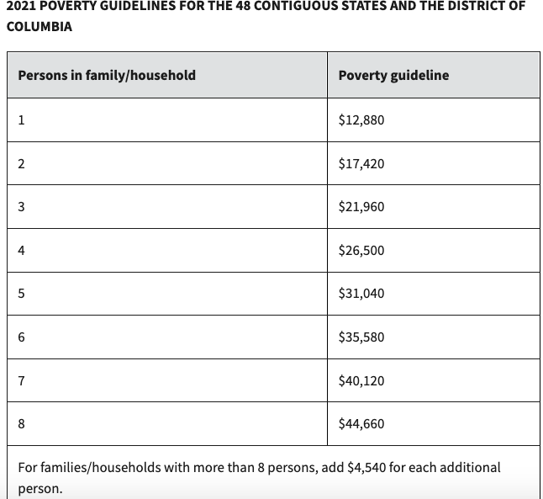

Note: These guidelines are used to determine eligibility for a number of federal programs, including SNAP, parts of Medicare and Medicaid, Head Start, National School Lunch Program, Weatherization Assistance for Low Income Persons, and Job Corps. These are the national figures, and poverty guidelines vary from state to state and the cost of living in your city or town.

Earning a Living Wage
A living wage is the hourly rate that an individual needs to earn in order to support themself or their family. Many states have a higher minimum wage than the federal minimum wage, which is $7.25/hour, or about a dollar over the poverty wage.
MIT has developed a Living Wage Calculator, which compares the federal poverty wage, a state’s minimum wage, and a living wage for that state. They estimate the living wage in a state or metropolitan area using typical expenses such as food, child care, transportation, and medical and housing costs; which will vary based on family size, composition, and location,
For Oregon, a living wage for one adult without children is $16.85, which is quite higher than the state’s minimum wage of $12 and the poverty wage of $6.13. Expenses increase substantially when a person has a dependent to care for. For example, the Oregon living wage for one adult with one child is $33.07, which is nearly triple the state’s minimum wage. These costs are higher in urban areas, such as the Portland Metropolitan Area, and lower in smaller cities and towns. However, even in smaller towns, the income needed to support a household is more than the state and federal minimum wage.
The living wage calculator shows how families and individuals working in low-wage jobs are not paid enough to meet the minimum standard of living in their area.
Until the local or federal government raises the minimum wage or all businesses pay their employees a living wage, we can find additional ways to support ourselves and our families. For example: by attending this course, we can utilize local and state-wide resources, follow money saving tips, learn healthy credit and banking habits, stick to a budget, and create and follow personalized plans for achieving our financial goals.

To compare typical expenses and the living wage in your state based on the number of dependents and adults in your household, visit https://livingwage.mit.edu/

Individual Course Goals
Now that we’ve identified some of the ways poverty functions in the United States, let’s set a few personal goals for improving your financial situation and building financial resilience.

What do you hope to accomplish by the end of this course? What are the financial areas that are most important for you to address?

In this Guide for Students, you will learn tools that will help you with:
- Budgeting;
- Tips and resources to save money;
- Establishing (or re-establishing) a bank account;
- Balancing a checking account;
- Money safety;
- Online banking and bill-paying;
- Debit and credit;
- Loans;
- Debt;
- Money and mental health;
- Money and relationships;
- Taxes;
- Savings and asset building;
- And more.
Money Saving Ideas
Shopping | N/A | Already Doing | Will Try
Buy generic products.
Make your weekly/bi-weekly menu from items that are on sale.
Use what you have at home before you shop for more.

Buy only what you need to get by the next one or two weeks.
Make a list before you go shopping.
Watch out for expiration dates on perishable goods.

Buy generic over-the-counter medicines.

Buy bulk whenever possible.

Avoid impulse buying. Follow the 24 hour rule (if you want to buy something, wait 24 hours and see if you still want it)
Don’t buy anything if you can get it for free.

Use coupons. Utilize services like Groupon or check out this list of coupon smartphone apps.
Go to a farmer’s market.
Find free fridges and food pantries in your Neighborhood.
Apply for SNAP benefits if you’re not on it already.
Do a clothing swap with friends instead of buying new clothes.
Shop at thrift stores like Goodwill, Salvation Army, St. Vincent de Paul, and local shops for clothes or household items like kitchenware or furniture.
Utilize Facebook Marketplace and Buy Nothing Groups where people sell used items or give them away for free.

Lifestyle Changes | N/A | Already Doing | Will Try
Cook at home as often as you can.
Make your own coffee.
Go to the matinee rather than the evening movies.

Change the ingredients in the recipe to cheaper ones.

Choose food that gives a lot of taste for little money.

Serve water with meals.
Rehang towels after showers to use more than once.

Turn old clothes into usable rags.
Walk, ride your bike, or carpool whenever possible.

Get your books from the library.
Get DVDs from the library.
Agree to limit gift-giving.
Take your lunch to work one more day a week.

Sell something you no longer use
Find 1-time income opportunities (work an event, pet sit, yard or house work, take a survey)
Meal prep: make a large portion at the beginning of the week to have multiple meals prepared and freeze extra food for later use.
Get a reduced bus pass and take public transportation to work.
Getting Smart About Bills | N/A | Already Doing | Will Try
Slow down your internet service. Apply for reduced Wi-Fi costs.
Consolidate and pay off debts as soon as possible.

Pay your bills on time and avoid late fees.

Pay car insurance semi-annually instead of monthly.

Get rid of your home telephone.
Get rid of premium channels from your cable package
Enroll in automatic bill-paying
Cancel non-essential services (Netflix, Hulu, Spotify, HBO, Disney+ etc.)

Home Energy Efficiency | N/A | Already Doing | Will Try
Check the insulation in your home.
Shut vents in unused rooms.
Regulate your electric use. Turn off lights, computer(s), TV(s), etc. when not needed.
Buy energy efficient appliances.
Unplug appliances when not in use.
Sign up for the federal Weatherization Assistance Program
Other | N/A | Already Doing | Will Try

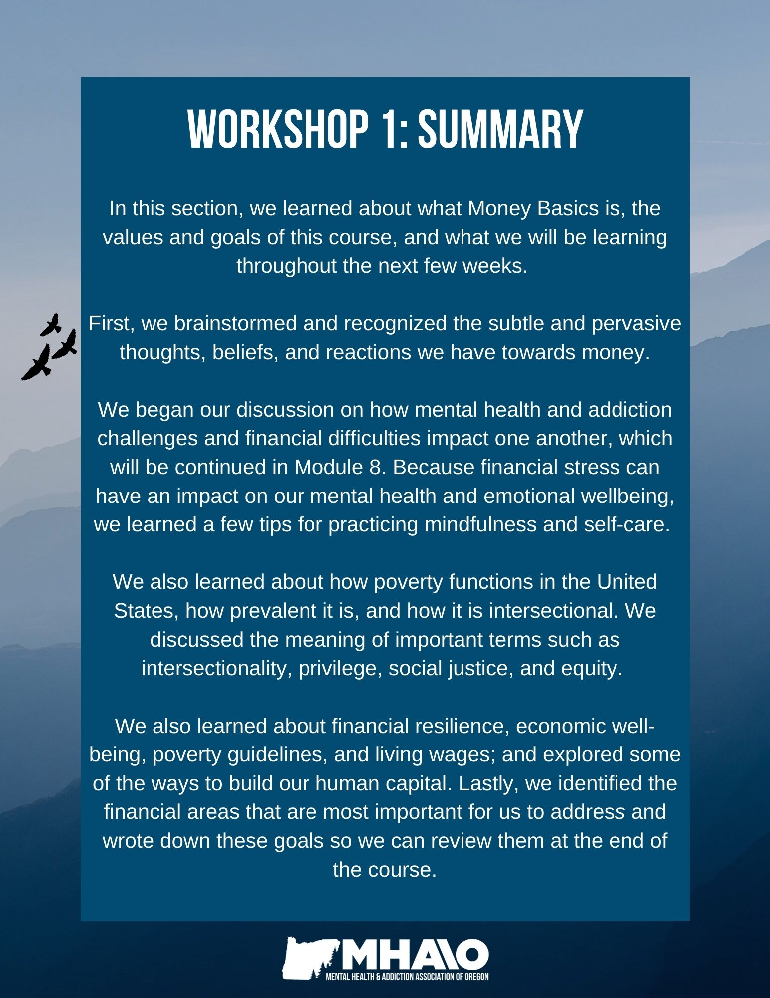
How can the topics I learned in this section be helpful for me?
Topic | N/A | How this will be helpful to me:
Recognizing positive & negative thoughts/ beliefs about money
Understanding the relationship between mental health issues & money issues
Understanding the relationship between addiction & money issues
Mindfulness & self-care practices
A basic understanding of poverty, privilege, class, intersectionality, and social justice
Setting individual financial goals



Workshop 2

My Financial Self-Sufficiency Person Directed Plan
What is Person Directed Planning?
Person-directed planning is a tool used to assist people in making life changes. It focuses on your strengths and guides you to identify your long-term goals and the short-term steps you can take to get there. The process outlined in this curriculum is based on the Making Action Plans (MAPs) format, which was originally developed by Marsha Forest and Jack Pearpoint.

Person-directed planning is directed by you. Just like recovery is your own unique and self-directed journey, so too is planning for your financial future.

Your financial person-directed plan (PDP) will be unique and personalized and will look different from those of your peers.

Throughout this course, we will incorporate person-directed planning that will capture your strengths and your financial hopes and dreams. Person-centered planning focuses on your interests and what is important in your life. This type of planning enables you to be in charge of your finances and your future, and to recognize the many strengths and abilities you already have.

The Rules:
- Be gentle with yourself. Dealing with money is stressful and challenging for everyone.
- Dream big without barriers! Imagine your life in 1 year, 5 years, and 10 years. Identify the steps needed to move toward those dreams.
- Everyone has a voice – be open to the ideas of those around you.

Life Now:
Use words and/or pictures to describe how your life is now. Paint a picture of your whole life, but pay special attention to your current financial picture:
    - What is your current source of income?
    - Who manages your finances?
    - What type of housing do you have?
    - Do you work? If so, where and how much do you make?
    - What debts are you aware of?
Describe your current relationship to money (e.g. “Worried about debt,” “Can’t open mail,” “No more student loans”)
Life Now

What Works & What Doesn’t Work:
What works well for you? What makes things run smoothly in your life? What causes problems for you in your life currently?
Now think about these questions specifically in regards to money/finances. What helps you manage your money well? What gets in the way of your financial empowerment?
What Works: | What Doesn’t Work:

Strengths, Gifts, & Capacities:
Strengths: Valuable or useful abilities, assets, or qualities.
Gifts: Special talents or natural ability that you seem to have been born with, especially an artistic ability or social skill.
Capacities: Areas of potential growth, development, or accomplishment, such as your physical, mental or financial power to accomplish something.
My Strengths, Gifts, & Capacities
Strengths:

Gifts:

Capacities:

Financial Dreams & Goals:
Describe your dreams. Do your best to imagine your ideal future without barriers. For example, your dream home, career, relationships, hobbies, etc. in 5-10 years. Focus on big goals and dreams. The final step of this PDP process will be to create an Action Plan to identify the smaller financial steps you can take to achieve these dreams.
My Financial Dream/Goal:

Life One Year from Now:
While keeping in mind your long-term financial/life goals, create a vision of what your life will be like one year from now. Will you live in the same place? Will you find a job or have a different job than you do now? What will your life be like when you are one year closer to your dreams?
My Life One Year From Now:
My Financial Action Plan:
Action Plan
 | What? | Who? | When?
1.
2.
3.
4.
5.
6.
7.

How can the topics I learned in this section be helpful for me?
Topic | N/A | How this will be helpful to me:
Understanding what person-directed planning is and why it's helpful
Identifying what works and what doesn’t with my current finances
Identifying my strengths, gifts, and capacities
Brainstorming big financial/life goals and imagining my life 1 year from now
Making an action plan for achieving my financial dreams

“Empty pockets never held anyone back. Only empty heads and empty hearts can do that.”
Norman Vincent Peale



Workshop 3
The Different Types of Expenses:
Fixed Expenses: Expenses that are reliably similar from one billing statement to the next, such as rent or mortgage payments, car payments, insurance payments, or the cost of groceries.
Variable Expenses: Expenses that change significantly from one week, month, or quarter to the next. For example, home repair, some utilities (electricity, oil, gas), or car maintenance.
Non-monthly Expenses: Occur quarterly, twice a year, or annually. For example, water bills often come every three months.
Unexpected Expenses are unplanned. They can be difficult to plan ahead for because they can’t be predicted if, or when, they occur. Maintaining a savings account for emergency funds can be vital in managing unexpected and non-monthly expenses.
What are some examples of fixed and variable non-monthly expenses that you can plan for and include in your budget?
Fixed Non-Monthly Expenses | Variable Non-Monthly Expenses
- Property taxes  - AAA  - Car registration renewal and tabs  - Home/renter’s insurance  - Life insurance, disability insurance  - Car insurance  - Prescription medications  - Child care  - Tuition costs, school fees  - Bank or credit card fees | - Living space maintenance or repair  - Car maintenance (tires, oil change), repair  - Trash service  - Water bill  - Firewood or propane  - Dental or eye care  - Emergency Room visit  - Books, school supplies  - After-school programs, field trips  -Vacation, gifts, entertainment

Budgeting Basics
What is a Budget? A budget is a spending plan. It is an estimate of how much money you have coming in (income) and where it goes (expenses) for a certain time period, usually a month. It is a principle tool for financial success.
When creating a budget, is important that you:
- Understand how it works and know what works for you
- Feel comfortable with using this tool
- Allow yourself some freedom to make changes as needed
Making a personal budget can help you:
- See more clearly where your money goes
- Save money toward a particular goal
- Give you peace of mind about your finances
- Put you in control of your finances
- Reduce stress over unpaid or late bills
- Pay off debts
- Realize your full financial potential
While creating a budget is an important tool for your financial security, sticking to the budget you create is equally as important. Since most people experience unexpected expenses from time to time, or changes to their income, you should consider your budget a living document, which means you may need to adjust your budget as your income or expenses change.
The key to a successful budget is a commitment to making a real change in your spending habits. Attending financial classes and learning new tools is an amazing first step, but it needs to be followed-up with action. In order to improve your financial situation, you will need to commit to making fundamental changes in your financial behavior that are directed by you, for you.
Beginning the process of budgeting can be daunting, especially if you have never used a personal budget before. It is important to find a budgeting template or tool that works for your needs and lifestyle. We have provided a few budget templates you can choose from, as well as suggestions for budgeting apps and websites. The most important thing is to make it work for you.
Step 1: Income
Gather every source of income you have. Examples of types of income include:
- SSI/SSDI payments
- Paychecks
- Student loans
- Alimony/Palimony payments
- Child support payments
- Bonuses
- Commission
- Money earned from a business
- Interest earned on investments
- “Odd jobs” (yard work, pet sitting) or gig economy work (Uber, food delivery)

Source: | Monthly Income:
 | $
 | $
 | $
 | $
 | $
 | $
 | $
 | $
 | $
 | $
 | $
 | $
 | $
 | $
 | $
Total: $ _______________

Step 2: Regular Expenses
Gather all of your regular expenses. Examples of regular expenses include:
- Rent or mortgage payments
- Utility bills
- Car payments
- Healthcare premiums
- Student loan payments
- Child support payment

Type: | Amount:
 | $
 | $
 | $
 | $
 | $
 | $
 | $
 | $
 | $
 | $
 | $
 | $
 | $
 | $
Total: $ ________________

Note: Don’t forget to include any debts you might have, such as outstanding medical bills, credit card bills, and other outstanding loans.
Remember to think ahead about increased utility bills in the winter, and non-monthly payments you may have, such as trash, sewer and water, car insurance, or taxes.
Step 3: Monthly Expenses
Write down all of your additional monthly expenses, such as groceries, prescription medicine, pet food and supplies, household goods, clothing and shoes, toiletries, gas or bus fare, etc.
Type: | Amount:
 | $
 | $
 | $
 | $
 | $
 | $
 | $
 | $
 | $
 | $
 | $
 | $
 | $
 | $
 | $
Total: $ ________________

Step 4: Needs vs. Wants
After you have compiled your list of expenses, separate each item out by needs (food, shelter, utilities, clothing, and transportation) and wants (entertainment, eating out). What do these things cost you?
Note: This is an individualized exercise – what you may perceive as a want may be a need for another person.
Needs | Annual  Cost | Wants | Annual  Cost
 | $ |  | $
 | $ |  | $
 | $ |  | $
 | $ |  | $
 | $ |  | $
 | $ |  | $
 | $ |  | $
 | $ |  | $
 | $ |  | $
 | $ |  | $
Total | $ | Total | $
Are there areas or items under either column you could cut down to save money?
Examples of this might include reducing your utility bills by conserving electricity and water, buying used furniture or clothing, or bringing your lunch to work instead of eating out.
Compare your lists of needs with Maslow’s Hierarchy of Needs

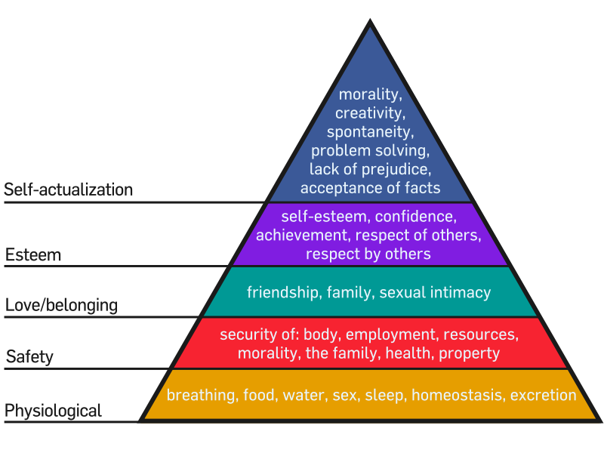

Exercise: List specific things that would fall under each of Maslow’s Needs and estimate their cost (if any).
Maslow’s Need | Specific Need | Cost
Physiological
Safety
Belonging-Love
Self-esteem
Self-actualization
Total Cost:

Step 5: Basic Budget Worksheet
Choose a budget worksheet or online/mobile budget system that works for you. This example is a simple monthly budget. There are additional options available online that may be a better match for your needs but begin with this one to familiarize yourself with the budgeting process.
Enter your income and your expenses into the worksheet. When filling out your budget, it is important to be as accurate as you can with your current situation (how you spend money now).
Once you have filled it out, see if you have any money left over after all of your bills are paid. If you do not, brainstorm ways to cut expenses and save money each month.
After completing an initial budget and you don’t like what you see, you can make a new budget that will help you stay on target with your goals. You may be surprised by how much money you actually spend in certain areas. These are the areas to focus on if you need to bring your expenses down.
CATEGORY | BUDGET AMOUNT | ACTUAL AMOUNT | DIFFERENCE
Spendable Income:
Expenses:
Rent or Mortgage
Electricity
Natural Gas or Oil
Water & Sewer
Garbage & Recycling services
Phone(s)
Internet
Cable/Satellite
Subscriptions (Netflix, Spotify, Amazon etc.)
Credit Card Payments
Other Loan Payments
Transportation (Bus Pass or Gas for Car)
Childcare
Insurance (Auto, Health, Home, Life)
Out of Pocket Medical Expenses
Groceries
Toiletries/Household Goods
Pet Care/Food
Dining Out
Entertainment
Other Expenses:
Total

After filling out this basic budget, you are welcome to use more complex budgets online or on your smartphone. There are a number of free budgeting websites and apps, such as Mint, PocketGuard and Truebill.

What should I do if my expenses are greater than my income?
The best (and most difficult) thing to do is to find expenses in your budget that you are willing to eliminate. Things like premium cable channels, streaming or music services, and trips to restaurants are common things to either eliminate or cut back.
But what if you don’t even have that kind of elbow room? What if all of your financial resources are already devoted to the basics (food, shelter, and clothing)?
This is a challenging situation and one that many of your peers have likely faced or are currently facing. The following lists of suggestions and government and community resources are to provide options and ideas for ways to save money, meet your needs, and help you achieve economic stability and well-being.
Suggestions for cutting expenses:
- Share living expenses with someone. Find a housemate or move into an established shared living situation – rent will be cheaper and so will utilities.
- Move into a less expensive apartment. However, moving and deposit costs may make this option difficult.
- Seek rental assistance from local government or nonprofit organizations.
- Apply for the Supplemental Nutrition Assistance Program and buy all your groceries with your SNAP card.
- Sell any clothing, shoes, electronics or other items you no longer use or need.
- Find additional part-time or temporary work to bring up your income to meet your needs.
Monitoring & fine-tuning your budget:
- First month: monitor your spending weekly and check for unnecessary spending.
- Second and third month: monitor your spending b-weekly and continue to check for unnecessary spending. Make adjustments to your spending as needed.
- Rest of the year: review your budget at the beginning of each month, as well as your income and expenses. Continue to make adjustments as needed. Most importantly, stick with your budget!
Resources for Saving Money
There are many resources in your community that can help you save you money and assist with:
- Utilities
- Emergency rental assistance
- Food
- Household supplies
- Clothing
- Transportation costs
- Medical care and/or costs
- Prescription medications
- Dental services
- Computer equipment
- Internet access
- Furniture

Federal & State Resources:
Supplemental Nutrition Assistance Program (SNAP): The national food assistance program (formerly called Food Stamps). Money is deposited directly into your account and you can use your SNAP card at stores or farmers markets like a debit or credit card. Many Americans qualify for SNAP benefits and can receive $200+ a month for groceries (significantly more if you have dependents in your household to care for). If you are a resident of Oregon, you can apply for SNAP, medical, cash, or childcare benefits here: https://one.oregon.gov/
Social Security Benefits: Social Security is the retirement plan for nearly all working Americans. The Social Security Administration offers Social Security Disability Insurance (SSDI) and Supplemental Security Income (SSI) for people with disabilities, including mental health conditions. Apply for SSDI and SSI online at https://secure.ssa.gov/iClaim/rib or by phone.
Medicare & Medicaid: Medicare is the federal health insurance program in the United States that is generally for people 65 years of age or older or individuals with a qualifying medical condition or disability. Medicaid is the state health insurance program that helps pay the costs of healthcare for low-income individuals and families. The Oregon Health Plan is Oregon’s Medicaid program. You can apply for free or reduced health coverage here: https://www.oregon.gov/oha/hsd/ohp/pages/apply.aspx
Free or Reduced Clinics: Most cities and towns have free or income-based healthcare clinics, including for emergency care, doctor’s visits, and dentist appointments. To find a free or reduced clinic in your area, visit https://www.freeclinics.com/
Individual Development Accounts (IDAs): Special asset-building savings accounts that match the deposits of low-income individuals or families to help them save for higher education, job training, home ownership, etc. IDAs are discussed further in Workshop Ten.
Reduced Public Transit Passes: Many public transit systems have reduced fare options for low-income riders. For example, in Portland, you can apply online for an Honored Citizen Hop Card, which will reduce your bus or train fees. To apply, visit: https://trimet.org/lowincome/index.htm
Medication Assistance: Pharmaceutical companies offer medication scholarships for low-income individuals. PhRMA has a service called the Partnership for Prescription Assistance that will link you with the maker of your drug. Go to http://www.PPARX.org for access to more than 475 different assistance programs. The site is easy to use and is a great starting point, however be cautious of other sites that charge fees for their services.
VA Benefits: Veterans may be eligible for a number of benefits including physical and mental health care; disability compensation; tuition assistance for college, graduate school or other training programs; educational and career counseling; job training; housing assistance/loan programs; a pension program; and life insurance. Visit the U.S. Department of Veterans Affairs at https://www.va.gov/ for more information, eligibility requirements, and to apply for benefits.
Reduced Internet: If you are eligible for public assistance programs like SNAP, SSI, Medicaid, Housing Assistance, and the National School Lunch program, you may qualify for Internet Essentials from Comcast. Internet Essentials benefits include high-speed internet service for just $9.95/month, no activation or equipment rental fees, access to Xfinity Wi-Fi hotspots, the option to purchase a computer for $149.99, and more. To check eligibility requirements and to apply online, visit: https://www.xfinity.com/support/articles/comcast-broadband-opportunity-program
Weatherization Assistance Program (WAP): The U.S. Department of Energy’s Weatherization Assistance Program gives money to states to distribute to local governments, community action agencies, and nonprofits, who use the money to assist low-income homeowners or renters in reducing their energy costs. If you are approved, an inspector will conduct an energy audit, which involves checking your home for heat loss and safety features. If the audit shows that your home could benefit, a work crew will come to add insulation, plug leaks, improve dryer vents, install weather-stripping, etc. There is a limit to how much can be spent on each home, but everything that is done is free. This is a great opportunity for lower-income households to reduce their heating bills and improve the safety in their homes. To learn how to apply, visit: https://www.energy.gov/eere/wap/how-apply-weatherization-assistance

Community Resources:
Mutual aid funds: can address a variety of needs such as emergency rental assistance, medical bills, cash bail, or food. Mutual aid funds are a pool of donations by and for community members in which the money goes directly to those in immediate need.
- Free fridges & pantries: Another example of mutual aid, many communities are building and stocking free pantries and refrigerators. The idea is to leave food and other resources if you can and take what you need. Many schools, charities, churches, and shelters also have food pantries and food assistance programs.
- Farmer’s markets: Many farmers markets now accept SNAP cards, which means you can get local and farm-fresh food for free or reduced prices.
- Second-hand stores: If you need clothing, shoes, or household items, second hand and thrift stores are usually the most budget-friendly way to shop. Some stores will also allow you to sell old clothes or give you in-store credit or discounts for donating items.
- Community Credit Unions: Credit unions are nonprofits that can help save you money when you bank with them by offering little-to-no fees and higher interest on savings.
- Community Development Financial Institutions (CDFI): Community-based financial institutions that promote economic development by providing services to low-income communities and other groups traditionally under-served by banking institutions. For a list of CDFIs in Oregon, visit: https://www.cdfi.org/wp-content/uploads/2015/02/Oregon.pdf
- The Buy Nothing Project: a money-less economy in which neighbors can post anything they’d like to give away, lend, or share, and ask for anything they’d like to receive or borrow. Join a Buy Nothing Group on Facebook or download the Buy Nothing app. For more information, visit https://buynothingproject.org/join/
- Useful websites to identify resources: http://www.wisebread.com/resources & https://www.211info.org/search-resources ​​
If you are a resident of Oregon:
- Find reduced-cost or free community resources in the Portland Metro Area at https://rosecityresource.streetroots.org/#/
- Find free food in your community by typing in your Zip Code at www.oregonfoodbank.org
- If in Portland, find free fridges near you at https://linktr.ee/pdxfreefridge
- Find emergency rental assistance programs at https://www.oregon.gov/ohcs/housing-assistance/Documents/05-13-2021-OERAP-program-admin-contact.pdf
- For energy and weatherization services, youth services, housing support, nutrition services, and re-entry services in the Salem area, visit https://mwvcaa.org/programs/
- Get your movies and books at your local library: https://multcolib.org/e-books-and-more
- Find discounts and coupons in Portland at https://portlandlivingonthecheap.com/
- For Head Start programs in Oregon, visit https://www.ohsa.net/
- For home energy assistance, visit https://www.oregon.gov/ohcs/energy-weatherization/pages/index.aspx
- Great meals in Portland for less than $10: https://www.oregonlive.com/portland_cheap_eats/2017/03/cheap_eats_2017_99_delicious_d.html
- Fun activities to do in Portland on a budget: https://www.oregonlive.com/living/2015/08/free_for_all_favorite_no-cost.html
​​https://www.frugallivingnw.com/portland-staycation/
- Portland Farmers Markets: https://www.portlandfarmersmarket.org/
- Oregon Farmers Markets that participate in Double Up Food Bucks (the SNAP dollars you spend at a Farmers market double, so you can buy more): https://doubleuporegon.org/
- To find clothing swaps in Portland, visit https://swappositive.wordpress.com/
- Biketown for All: Portland residents who are eligible for social services can receive a reduced Biketown Membership (city bikes available to the public). For more details, visit: https://www.biketownpdx.com/pricing/biketown-for-all
Applying for Social Security Benefits:
Some individuals experiencing mental health and/or addiction challenges find that there are times when working becomes too difficult. Social Security Disability Insurance Benefits (SSDI) and Supplemental Security Income (SSI) are programs by the Social Security Administration (SSA) that provide monthly income and health insurance for people with qualifying conditions, which can include severe depression, bipolar disorder, PTSD, anxiety disorders, or SUD, as detailed in the SSA Blue Book. The SSA has strict guidelines for qualifying for these programs that can be difficult to navigate. Generally, an individual needs to have detailed medical documentation that shows how their condition prevents them from working and that they are undergoing treatment.
To qualify for SSDI, you must have an impairment that prevents you from working for at least 12 months and you must have worked and paid into the Social Security program (payroll taxes or FICA) for at least five of the last ten years. Your spouse and children can receive your SSDI benefits and after 24 months on SSDI, you are eligible for Medicare benefits. You may also be eligible to receive Supplemental Security Income (SSI) benefits.
To qualify for SSI, you must have an impairment that prevents you from working on a regular basis and you must have very low income, resources, and assets. An individual cannot have more than $2,000 in assets ($3,000 for couples). There are some exceptions, such as your home and car. In addition to federal benefits, you may also receive monthly payments from your state. You are eligible for Medicaid coverage and may be eligible for SSDI benefits at the same time if you have paid your Social Security taxes. SSI is a need-based program only available to applicants that meet strict limitations on income and asset holdings.

It can be helpful to consult with your doctor, therapist, mentor, or trusted friend or family member to help you navigate these criteria and gather all of the required information to apply for benefits. This will include all of your medical records, from hospitalization to therapist sessions, your doctor or psychologist’s recommendation, and a list of all medications you are on and any side effects. You can apply for SSDI or SSI online at https://www.ssa.gov/, over the phone, or at your local Social Security office. If you are approved, your case will be reviewed every year.
If you decide to return to work, the SSA has a program called “Ticket to Work” that provides resources and assistance. A Benefits Counselor can help you to identify employment opportunities, discuss how returning to work will affect your SSDI or SSI benefits, and connect you to resources outside of the SSA. Visit https://www.ssa.gov/work/ for more information.
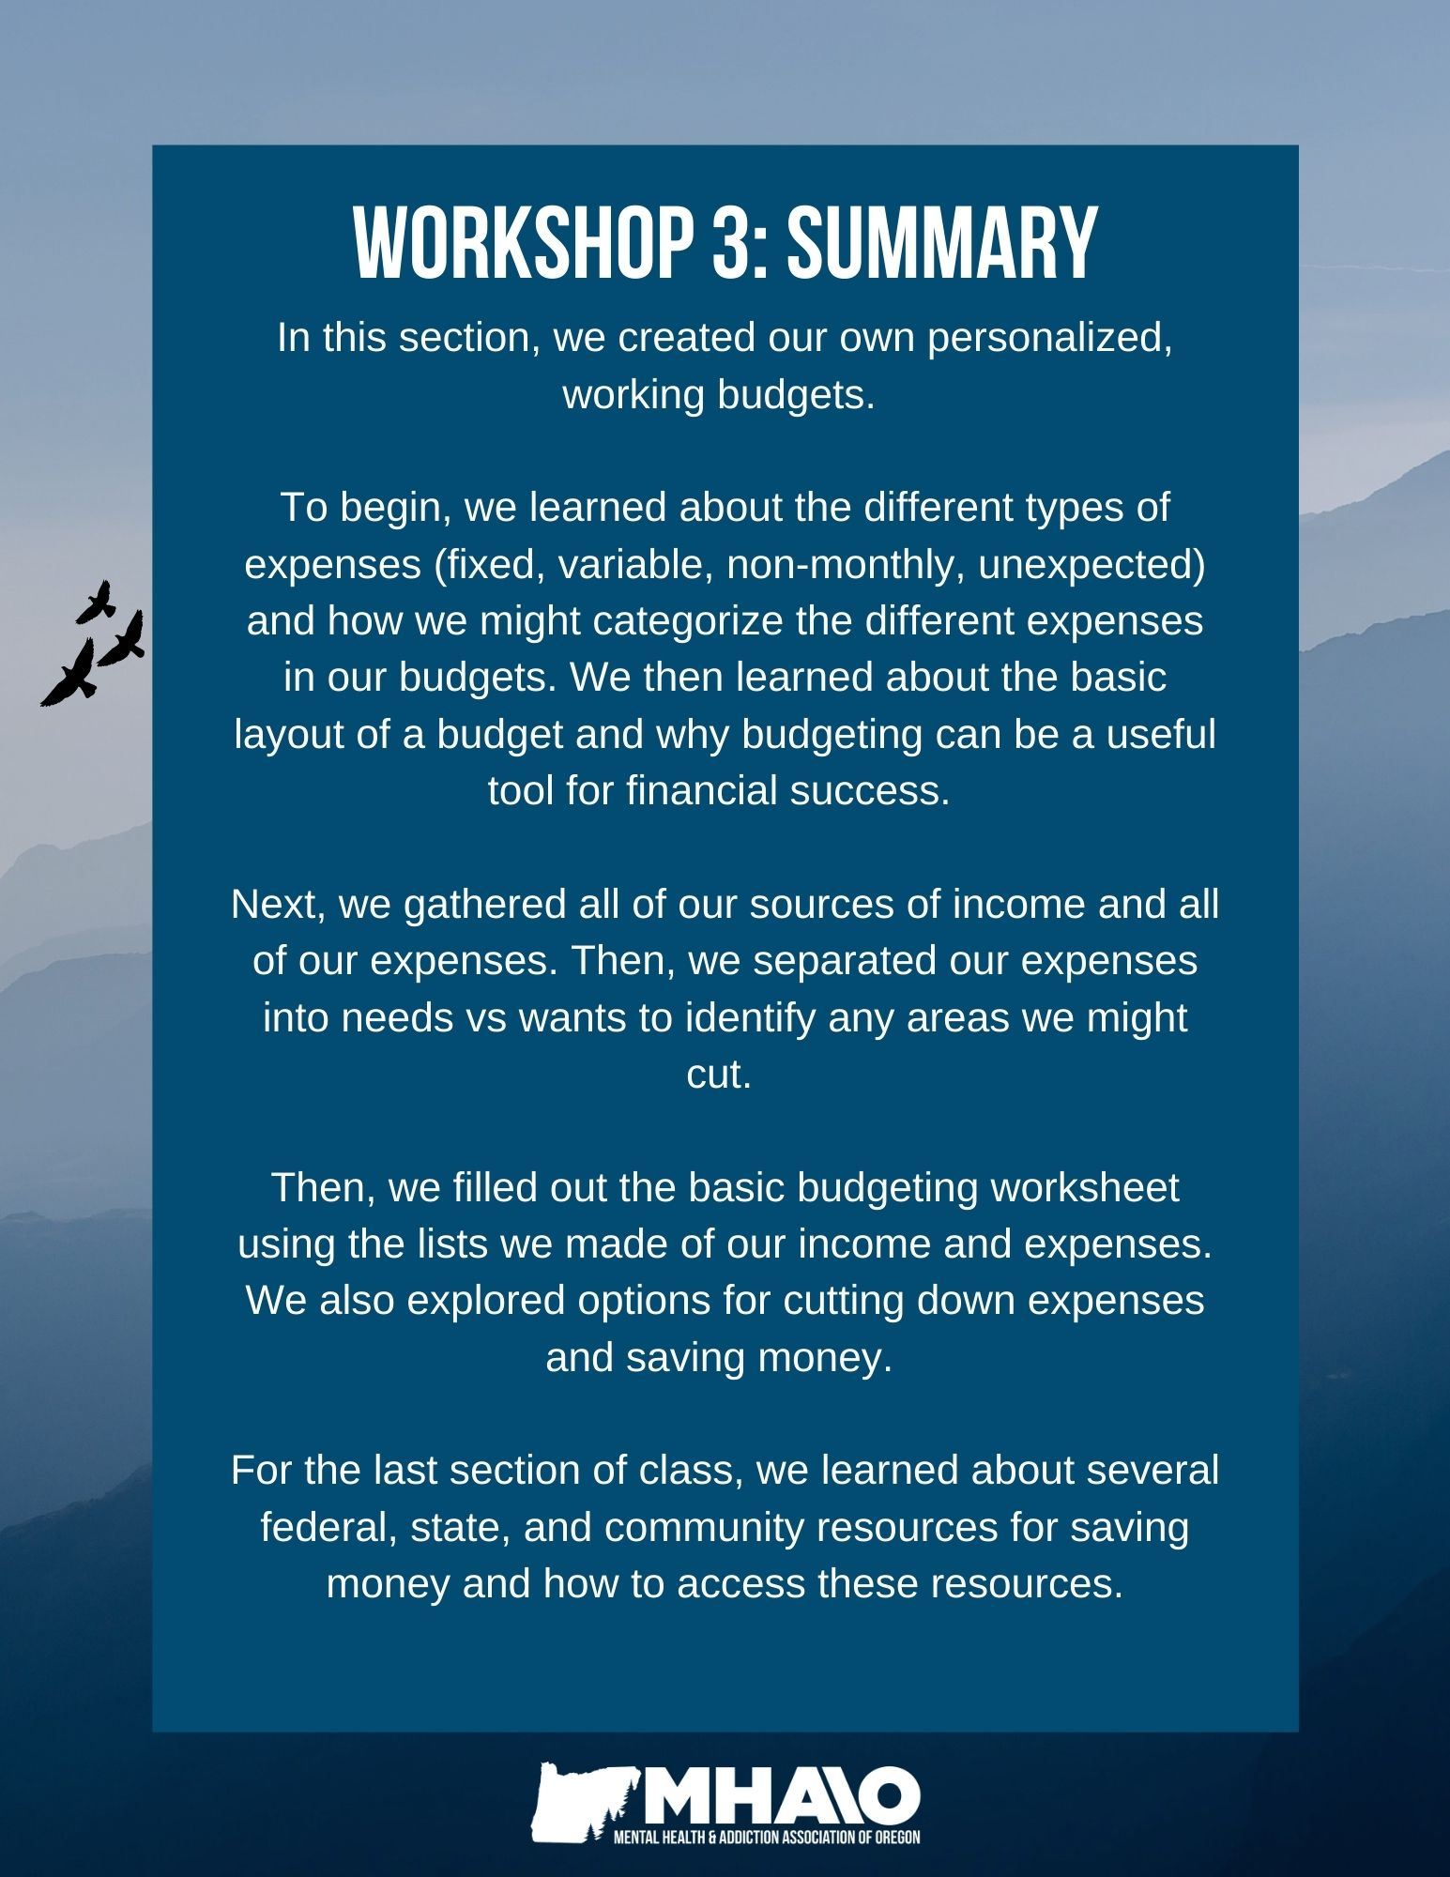
How can the topics I learned in this section be helpful for me?
Topic | N/A | How this will be helpful to me:
The different types of expenses
Gathering all our sources of income and regular / monthly expenses
Separating our expenses into needs vs. wants
Making a personalized, working budget
Federal, state, and community resources to save money

“We make a living by what we get, but we make a life by what we give.”
Winston Churchill

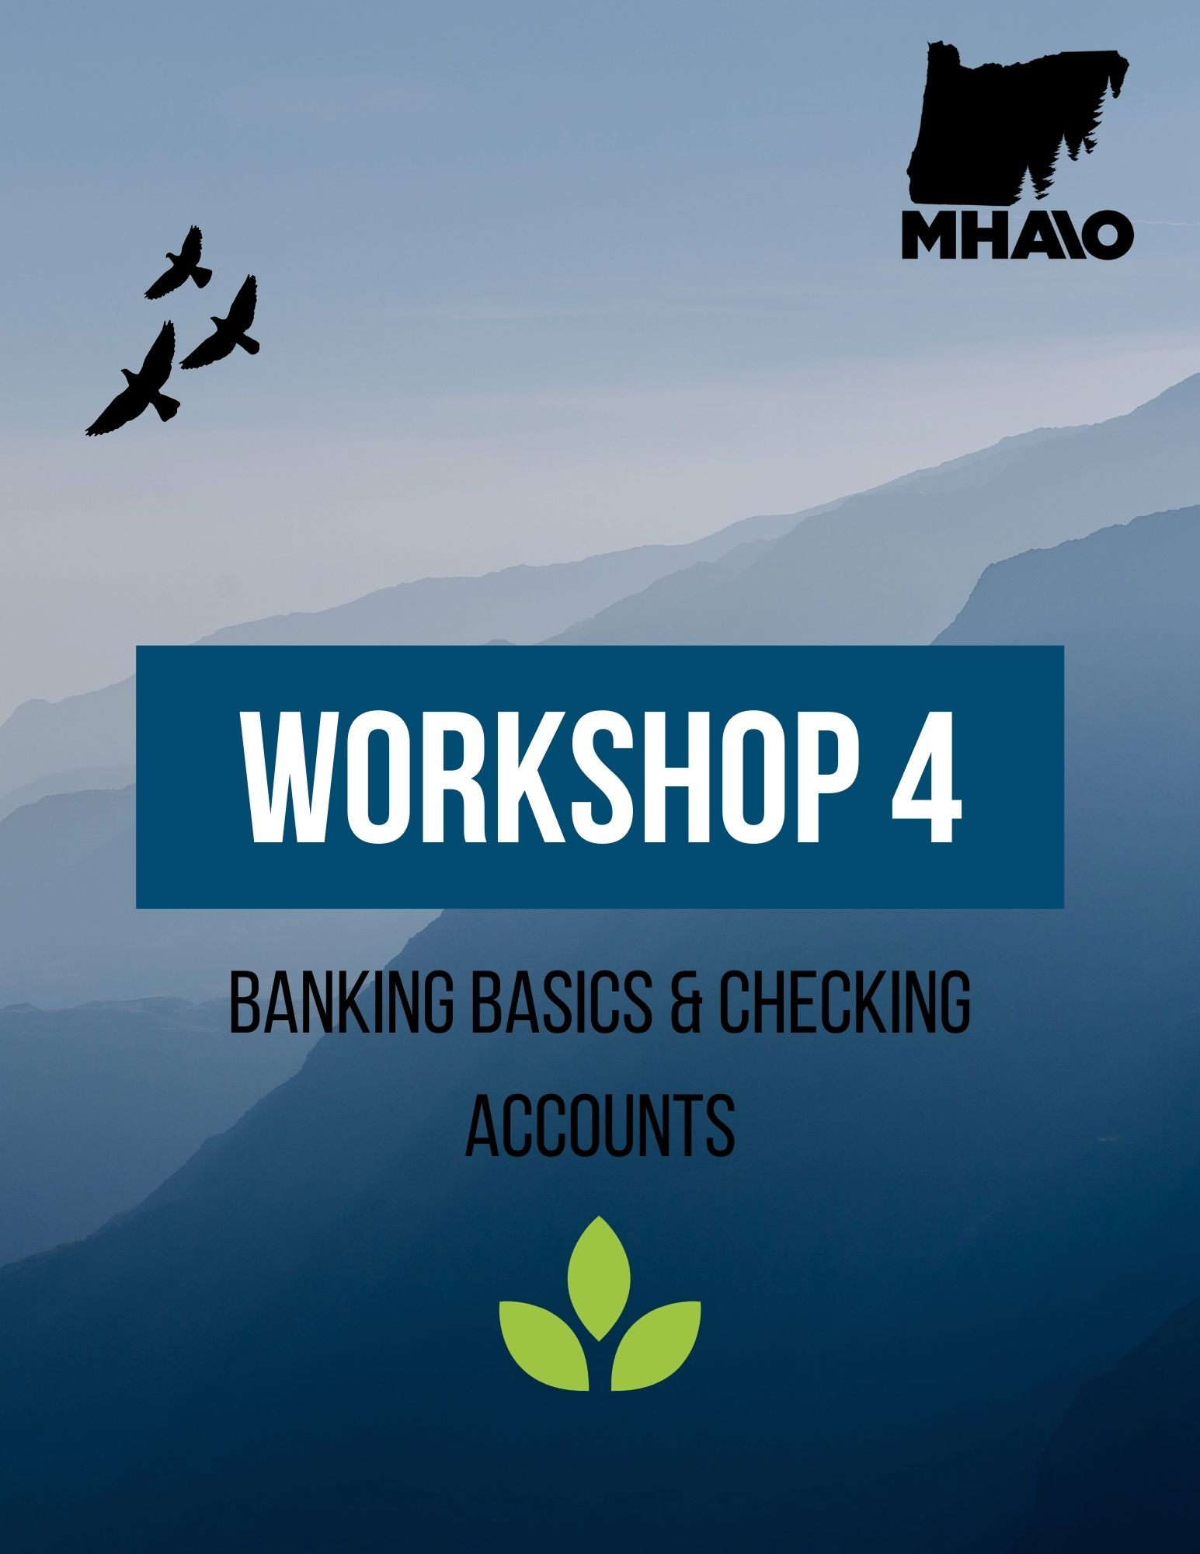

Workshop 4
Banking Terms
There are numerous and often very complicated terms used in banking. We will focus on just a few key terms that can be helpful when choosing a bank and setting up a bank account.
The definitions of these terms, and other financial terms you will come across, can be found in the Glossary of Financial Terms at the end of this Guide.
APR (Annual Percentage Rate) Finance Charge
Check Hold Interest
Debit Card Interest Rate
Delinquency Overdraft
Federal Deposit Insurance Corporation (FDIC)
Service Charge

Financial Institutions
There are many different types of financial institutions that offer various cash management services. The two major types of financial institutions are banks (deposit-type financial institutions) and nonbanks (non-deposit-type financial institutions). In this Guide, we will focus on deposit-type financial institutions, although you may be interested in exploring non-deposit type financial institutions as an option for your banking.
Deposit-type financial institutions mainly fall under four classifications: 1) commercial banks, 2) savings and loan associations, 3) credit unions, and 4) Internet banks.
- Commercial banks generally compete by offering the widest variety of services. However, they usually do not offer the highest interest rates on deposits or the lowest interest rates on loans.
- Savings and loan associations have slightly different ownership arrangements than banks, but they are similar to commercial banks. Savings and loan associations may offer slightly higher rates than commercial banks on deposits and somewhat lower rates than commercial banks on loans.
- Credit unions are nonprofit organizations that are owned by their members. They can sometimes offer higher rates on savings accounts and lower rates on loans because they are not driven to provide a profit to shareholders.
- Internet banks are electronic banks that do not have traditional brick-and-mortar branches. Because they have fewer branches, employees, and capital expenditures than traditional banks, they can generally pay higher interest rates on deposits and charge less for loans than traditional banks do.
Nonbank financial institutions consist of mutual fund companies and brokerage firms.
- Mutual fund companies are a type of investment agency in which a pool of money is collected by investors to invest in stocks, bonds, and other securities. These mutual funds can give small investors access to professionally managed portfolios at a low price. Many mutual fund companies now offer some banking services, such as writing checks against your mutual fund account.
- Brokerage firms act as middlemen between buyers and sellers of assets. Many brokerage firms now allow you to write checks, issue credit cards and ATM cards, and make loans.
Both banks and nonbanks offer online financial services, which allow you to access your account balance, transfer funds, deposit checks, and more 24 hours a day. With the blurring of roles between deposit and non-deposit institutions, banks can now offer investment services and non-banks can offer check-writing privileges, credit cards, and savings accounts.

Common Banking Fees
The following are some of the most common banking fees you will may encounter, regardless of which institution you choose to bank with, and how to avoid these fees:
Monthly maintenance/service fee: Some banks charge a fee every month to hold your money in an account with them. These fees can range from $4 to $24 and usually apply to checking accounts. The easiest way to avoid these fees is to choose a free checking and/or savings account that does not charge monthly fees. Additionally, some banks may waive your monthly maintenance fee if you set up monthly direct deposits; keep a minimum balance in your account, have other accounts or products with them, or are a student.
Automated teller machine (ATM) fees: Often around $1 to $2 per transaction, ATM fees can often be avoided by using your own bank's ATMs or by using an ATM that is part of your bank’s co-operative network of institutions that allow free withdrawals at their ATM locations. Remember, while you can withdraw funds at any ATM that is a member of your general network, you can usually only deposit money at an ATM owned by your bank. Avoid ATM fees whenever possible and convenient.
Overdraft fees: If your account balance is insufficient but you have a check or transaction that is cleared, your institution may have paid the check or transaction for you. However, you may be charged a fee for this service. These charges are often in the $25 to $35 range per check or transaction cleared. While this result is preferable to enduring a bounced check (and a similar fee), these fees can quickly add up if you've miscalculated and presented more than one check for payment. This can also happen when you use your debit card on an insufficient balance – your bank might cover it, then charge you, instead of declining your transaction.
Overdraft fees are an easy accident to have happen. To avoid these fees, sign up for direct deposit so your income is automatically and consistently deposited into your account. This will help maintain a minimum balance in your checking account. You can also download your bank’s mobile app to check your balance easily and frequently to make sure you have the money before making purchases.
Not sufficient funds (NSF) fees: If you don’t have enough money in your bank account and you don’t have overdraft protection, insufficient funds can cost you when you try to make a purchase. The maximum NSF fees that can be charged are set by individual states, usually up to $35- $45 per check or transaction. These fees should be avoided at all costs (pun intended).
Insufficient funds fees and bounced check fees can be avoided by checking your account balance frequently and transferring money to your account in advance. You can often sign up for notifications via text or email to be alerted by your bank when your balance is low.
Stop payment fees: If you've sent someone a check, but it never arrived at its destination, you may have to stop payment on this missing check. Stop payment fees are more widely accepted than many other bank charges, because they are sometimes necessary to protect you from further loss. Often these fees are in the $5 to $10 range.
Early withdrawal fees: Normally associated with a certificate of deposit (an account similar to a savings account but usually with a fixed term and fixed interest rates), these fees can be substantial. A common early withdrawal fee is the loss of all interest due. For example, if you have a $5,000 CD earning 6% interest per year, with interest that is posted every three months, and you decide to withdraw your funds after just two months, your fee could be $50 (all interest earned).
Always attempt to avoid early withdrawal fees by not touching your certificate of deposit until its term is over. CD terms can range between 3 months and 5 or more years, and the longer you let it sit, the more interest you will gain.
Early closing fee: Most banks charge you a fee if you close your account during a specified period of time after opening it (usually 90 to 100 days). These fees can be up to $25, so check with your bank about their rules before you cancel your account.
Low balance checking account fees: If you have a checking account that requires a minimum balance amount, you might incur $5 to $15 dollars in fees every month that your "average balance" dips below the minimum specified by your account terms. Should you have trouble keeping the minimum amount, switch your checking account to one without this requirement or keep tabs on your account with phone or internet banking options so you can deposit money into your account when it gets low.
Excessive transaction fee: Excessive transaction fees occur when you withdraw over the federal limit from your savings account. The federal limit is six free withdrawals and transfers per month. These fees range from $3 to $25 per transaction. They can be avoided if you use your checking account for consistent withdrawals, such as paying bills, instead of your savings account.
Opening a Bank Account
Step 1: Choose an Institution
You may have already done this. If not, shop around. What type of account do you want? A savings account? A free checking account? Would you like to use a credit union? See who has the features you want and open a bank account with them.
Step 2: Go to the Bank or Website
The easiest way to get this done is find the institution’s website. The advantage of opening a bank account online is that you can do it at anytime, anywhere. You can also show up at the branch during business hours to open an account in-person.
Step 3: Pick the Product You Want
Any financial institution will have a variety of account types and services that you can mix and match. Pick the one that has the combination of services that is right for you. On the bank’s website, you may need to click “Open Bank Account,” then “Checking,” and finally “Free Checking.” If you open a bank account in person, you can just chat with a banker who will help you open the best account for your needs.
Step 4: Provide Your Information
In order to open an account, you must provide some information to the bank. This is to protect them against risk and comply with a variety of regulations. You’ll need to provide your name, birthday, address, and identification numbers (in the U.S., this is most likely your Social Security Number). You may also need to provide a government I.D. like your Driver’s License or Passport. When filling out this information online, make sure you are on the bank’s official website before proceeding to avoid the possibility of being scammed. You will also likely need money to deposit into your account as your opening balance. This is usually no more than $25. If you’re doing this online, you’ll just type the information in. If you’re opening an account in-person, you’ll hand your ID over to the banker who will likely make photocopies.
Step 5: Agree to Terms
You’ll have to agree to abide by certain rules and accept responsibility for certain actions. When you open a bank account, you form a relationship with the bank, therefore you should know what you’re getting into. You’ll likely need to sign or click “I Agree” to the Bank’s Terms & Conditions.
Step 6: Print, Sign, and Mail (If Applicable)
If you are opening your bank account in person, this step does not apply. If you are opening an account online, you may have to print, sign, and mail a document to the bank before the account is officially opened. Some banks may use electronic disclosure and consent that is legally binding, but many will not open an account for you unless you complete this step. Until they receive the documents, your account is not active.
Step 7: Congratulate Yourself
Congratulations, you are the proud owner of a new bank account! Now, you’ll just need to wait a few days to a few weeks for the bank to process your paperwork. Then, they will mail you everything you need for the account, such as your debit card or your checkbook if you request one. Once you have your account information, debit card etc., you can sign up for online and mobile banking options to check your balance, transfer money, deposit checks, and more.

What to Do if You Have a Poor Banking History
There are a number of ways you can end up with a poor banking history. Common examples are:
- Cashing bad checks (or bouncing checks)
- Making late payments on a loan or mortgage
- Defaulting on a loan
- Having a bank foreclose on a mortgage
- Accruing overdraft fees (and not paying them off)
- Failing to pay bank fees
When you apply to open a checking account, there's a good chance the bank will run your name through ChexSystems. ChexSystems, Inc. reports individuals who “mishandle” checking and savings accounts and is somewhat similar to credit information bureaus. If your name winds up in the ChexSystems database, it can be extremely difficult to open a bank account. A negative ChexSystems report stays in the database for five years and can ruin your chances of opening a checking account during that period.
Tips for Staying Out of the ChexSystems Database:
- Don't write checks or use your debit card without having money in the account to cover them.
- Find out from your bank or credit union how long it takes for deposits to be credited to your account.
- Keep track of your balance and reconcile your checkbook with your bank's statement as soon as you receive it, or go online and check it.
- Before closing a checking account, make sure all checks have cleared, all automatic debits have stopped, and you have paid all fees.
Note: There are a very small number of banks that do not use Chex Systems and they do not advertise it, so they are not easy to find.

Two Options if you Have Developed a Poor Banking History:
Option 1: Try to Remedy the Situation
- Obtain a copy of your credit report and correct any inaccuracies in your credit file. A low score can sometimes be the result of errors on your report.
- Obtain a copy of your ChexSystems report. Some banks do not check credit history but they will check ChexSystems. If you have a negative history with a bank, try to settle your debt. Sometimes banks will let you reopen a closed account if you pay what you owe.
- Open a savings account. Savings accounts can facilitate many of the same transactions as a checking account, minus the checks and debit cards. Most savings accounts can receive direct deposits and some may offer an ATM card. After maintaining your savings account for a little while – even with a negative credit history – some banks will allow you to open a checking account.
- Open a checking account at a local credit union. Credit unions usually have more relaxed standards than do traditional banks. To open a checking account at a credit union, you may only need to open a savings (or shared) account first.
- Open an account with a bank affiliated with your employer. Direct deposit has become more popular and many workplaces have special arrangements with banks to open accounts. Check with your HR department for more information.
- Open a prepaid Visa/MasterCard account. Prepaid, reloadable cards generally do not require you to open a bank account. They function like a debit card or gift card that you can use anywhere. You will be able to pay bills, accept direct deposits, mail in deposits, and make ATM transactions.

Option 2: Open a “Second-Chance” Checking Account
Some banks and credit unions offer second-chance checking accounts for those whose names are in the ChexSystems database. These accounts can help individuals rebuild their banking histories; however their services are usually fairly limited.

Some limitations of second chance accounts include monthly fees that cannot be waived and requirements such as setting up direct deposit. However, these drawbacks are usually worth it when it comes to rebuilding your banking history. When researching second-chance banks and credit unions, look for accounts with low or no monthly fees; no minimum balance requirements; few limits on daily or monthly transactions; and free services such as debit card access, online bill pay, and unlimited check writing. Some national banks that offer second-chance checking accounts include Chime, Wells Fargo, Green Dot Bank, and LendingClub. Credit Unions are also great options, such as Point West Credit Union in Oregon, which has a “Fresh Start Checking” option.
Checking Accounts
The Different Types of Checking Accounts:
Basic Checking: This is for people who use a checking account to pay certain bills and a debit card to pay daily expenses. Some basic accounts require direct deposit or a minimum balance to avoid monthly "maintenance" fees. You may be limited to a certain number of checks per month. If you exceed that number, you'll pay a "per item" fee for each additional check you write. You don't want to maintain a high balance in these accounts because you won't be paid interest.
Free checking: For most people, this is the best checking account. Free checking accounts mean that regardless of your balance or activity, you will not be charged any monthly service or per-item fees. In other words, you may write all the checks you like, or keep your balance as low as you like, without worrying about paying a fee. Free checking doesn't mean you won't have to pay any fees ever – for example, if you bounce a check, you'll have to pay a nonsufficient funds fee.
Interest-bearing: These accounts usually require a minimum balance to open, and you may need to maintain an even higher balance to avoid fees. For example, a bank may require $100 to open an account, but will charge $10 in service fees each month if you don't maintain a $1,500 balance. Interest usually is paid monthly. However, these accounts pay a very low interest rate so for most people, it's simply not worth maintaining the high required balance.
Joint Checking: An account owned by two or more people (usually people who share a household and expenses). Each co-owner has equal access to the account. Most types of accounts, whether it's basic checking, savings, or money market, allow for joint use. Good bookkeeping is essential with all checking accounts, but especially so with joint accounts. An overdrawn account usually results in steep fees for insufficient funds.
Express: Designed for people who prefer to bank by ATM, telephone, or personal computer, these accounts usually include unlimited check writing, low minimum balance requirements, and low or no monthly fees. The catch is you pay a fee for using a teller. You might get one or two free teller visits per month and then have to pay a fee for subsequent visits. These accounts are especially popular with students and people on the go who don't want to spend a lot of time on banking transactions.
Lifeline: These are "no-frills" accounts meant for people with low incomes. These accounts usually have monthly fees ranging from $0-$6; require a low, if any, minimum deposit and balance; and allow the user to write a certain number of checks per month. Lifeline accounts are required by law in Illinois, Massachusetts, Minnesota, New Jersey, New York, Rhode Island, and Vermont. In those states, minimum terms, fees and conditions are set by law, not by individual banks.
Senior/Student Checking: Many institutions offer special checking deals if you are a student or if you're 55 or older. The perks vary from bank to bank, but may include free checks, cashiers and traveler's checks, free ATM use, better rates on loans and credit cards, or discounts on things such as travel and prescriptions.
Money Market: These accounts combine checking with savings and/or investment opportunities to help you pursue higher earnings. It requires a very high minimum deposit to open (usually $1,000 to $10,000) and higher balances to avoid fees, and imposes tighter limits on checking transactions than other accounts. These accounts pay more interest than basic checking or savings accounts. This account is for people who can afford to maintain a high balance and do not write more than three to five checks each month.

How to Read a Check
Wondering how to read a check, understand the check format, and review the individual parts that make up a typical check?
- What are the different areas of a check?
- How do I read the MICR line? The Federal Reserve requires a person’s account number, routing number, and check number to be printed in MICR (magnetic ink character recognition) ink or toner. MICR is a type of magnetic ink that verifies the legitimacy of a check.
The example below is a personal check. Each numbered section is defined below.
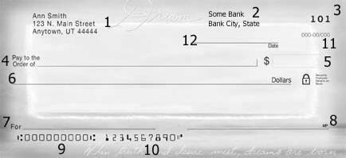

Section 1: Account holder’s name, address, phone number, and email address can appear in this section of the check, called the Address Field.
Section 2: The bank name, city and state of the processing facility, or the city and state of the account holder's branch; the bank's phone number; the bank's website address and/or the bank's email address may appear in this section. This section can also be located above field 7 (the memo field).
Section 3: The check number appears at the top right, shown here as 101.
Section 4: Pay to the order of. This section should have the name of the person or company that is being paid (the name of the party receiving the check).
Section 5: The amount written numerically. If this check were for one hundred dollars, within the box labeled "5" in the example above, it should read, "$100.00."
Section 6: The amount written in words. If this check were for $100, in the blank section labeled "6,” you would write, "One Hundred and 00/100." Many people will then draw a line to the preprinted "Dollars" to discourage alteration. If the check were for $101.59, it would be written, "One Hundred One and 59/100."
Section 7: The 'For" or "Memo" section can be left blank, or you can enter any information about the payment. Some people note an account number or invoice number that is being paid with the check, others may just write, "For Birthday" or another note to remind them what the check was for. This field is not read by the bank and does not change how the check is processed.
Section 8: The signature line. This is where the account holder would sign the check. On a check draft, the signature is not required, although it is common to have a signature disclaimer in this section.
Section 9: This MICR field is the routing number. This is the 9 digit code that routes the check to the issuing bank. The routing number should match the bank name and the fraction code. This number is needed when providing direct deposit information to an employer.
Section 10: The account number. This is an MICR field that lists the account holder's account number at the bank. This number is also needed when providing direct deposit information to an employer.
Section 11: Fraction Code. This field is the fraction that denotes the routing for the check. The fraction code is another way to write the 9-digit routing number. If the MICR line on the check is mutilated, the fraction code will be used in its place.
Section 12: The date field. Fill this in with the date the check is created.

How to Write a Check
Step 1: Start by writing the date and payee.
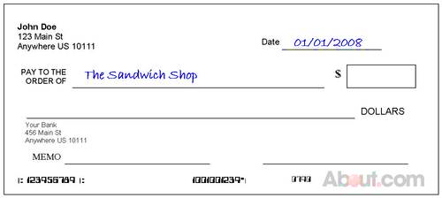

Step 2: Write the amount of your payment in numeric form.
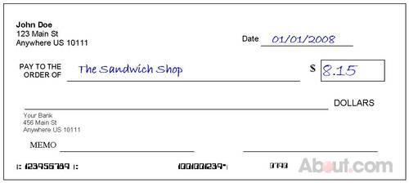

Step 3: Write out the amount of your payment using words instead of numerals.
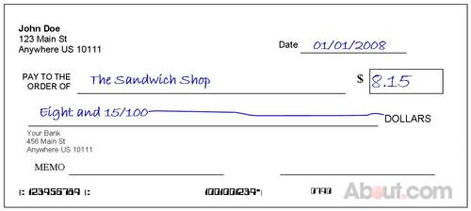

Step 4: Sign your check. Write a memo if you’d like.
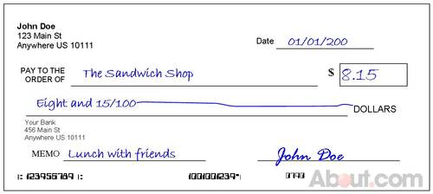

Step 5: To be extra careful, you can draw a line through any excess space in the small box with your payment amount.
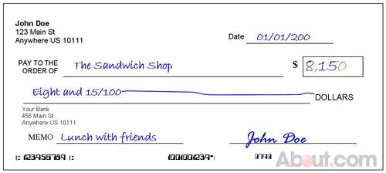

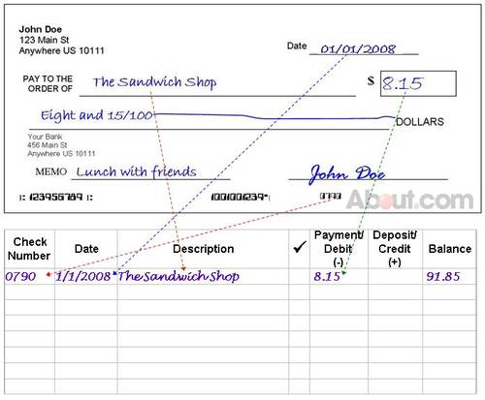
Step 6: Keep track of the checks you write (and your account balance) in your check register.

Balancing Your Checkbook

Today, fewer people are writing checks in their everyday transactions. Many individuals use debit cards, credit cards, or cash to make purchases and rely on online banking and bill paying options. As a result, many people do not know how to write a check, let alone balance a checkbook. Although writing checks is less common in the digital age, checkbooks and learning how to properly use them are still useful financial tools to have in your toolkit.

If you do use checks, do you balance your checkbook each month?
Four reasons why you should:
- Balancing your checkbook verifies that your records match your bank's records.
- Banks can make mistakes, and so can you. It is possible you've made a math error in your checkbook register.
- If you make a mistake or forget to post a transaction in your register, you may start bouncing checks and incurring fees of $25 or more.
- If there's a problem, you won't need to wade through months of transactions to figure it out.

The Ten Steps to Balance Your Checkbook:
What you will need:
- Your most recent bank statement and/or cancelled checks
- A checkbook balancing form
- Your checkbook register
- A calculator and pencil

Step 1: Reconcile Your Checks. Determine if there are any checks that haven't cleared the bank. Sort your cancelled checks in check number order, or use the listing of your cleared checks in numerical order as shown on your statement.
In your checkbook register, check off each cancelled check returned to you or each check that appears on the check listing, making sure the amount you recorded is the amount the bank shows.
Step 2: Reconcile Your Deposits. Make sure each deposit shown on your bank statement is recorded in your check register (especially if you have direct deposit, which you can easily forget to record).
Go through your deposit slips, paycheck stubs, etc., and make sure the bank statement shows all the deposits you made. Check off the deposits in your check register as you did for checks.
Step 3: Reconcile Your ATM Withdrawals & Debit Card Purchases. Go through the same process with your ATM withdrawals or debit card purchases, checking off each transaction on the bank statement in your check register. If the bank shows transactions that aren't included in your check register, record them now.
Step 4: Record Interest Earned & Bank Fees. Check your bank statement for any fees and record them in your checkbook register. Record any interest earned in your checkbook register.
Step 5: List Outstanding Checks. Go through your checkbook register and in Column 2 of the balancing form, list your outstanding checks (the checks that you did not check off in your check register as having cleared the bank), as well as any outstanding debit purchases or ATM withdrawals that have not yet cleared the bank. Total the column of outstanding checks, debits, and ATM withdrawals.
Step 6: List Outstanding Deposits. Go through your checkbook register and in Column 1 of the balancing form, list the outstanding deposits (the deposits that you did not check off in your check register as having cleared the bank). Total the column of outstanding deposits.
Step 7: Record Your Bank's Ending Balance. On line 1 of the bottom section of the Checkbook Balancing Form, enter the ending balance shown on your bank statement.
Step 8: Enter Outstanding Deposits. On line 2 of the bottom section of the Checkbook Balancing Form, enter the total outstanding deposits from column one.
Step 9: Enter Outstanding Checks. On line 3 of the bottom section of the Checkbook Balancing Form, enter the total outstanding checks from column two.
Step 10: Calculate Your Balance. Use a calculator to total lines 1-3 as indicated by the plus and minus signs on the form, and enter the new total on line 4. This should equal the balance shown in your checkbook register. If it does not, check for math errors in your checkbook register, such as reversed numbers (e.g., $53 instead of $35), subtracting a deposit instead of adding it, adding a check written instead of subtracting it, automatic payments that you forgot to record, etc.
Tips:
- For the easiest method of balancing your checkbook, use the Printable Checkbook Balancing Form below or find a template online.
- Don't fall for common mistakes: 1) never recording the pennies on the checks you write; 2) entering incorrect amounts in your check register to "fool" yourself into thinking you have less money (so you can be pleasantly surprised later or to provide a cushion for errors); or 3) only balancing your checkbook once a year when you do your taxes.
- If you find your checkbook in a mess, you cannot reconcile it despite your best efforts, and you're incurring fees because of errors, sometimes the best thing to do is to open a new account and start over, closing the old account after all checks have cleared.
- If you can’t reconcile, see if the amount you're off divides evenly by nine. If it does, it may be a transposed number (you may have written $53.94 instead of $53.49, for example).

“An investment in knowledge pays the best interest.”

Benjamin Franklin

Checkbook Balancing Form
1. Outstanding Deposits  (not included in your statement): |  | 2. Outstanding Checks  (not included in your statement):
Date: | Amount: | Check Number: | Amount:
- Ending balance from your bank statement: $ ____
- Add total outstanding deposits: + ____
- Subtract total outstanding checks - ____
- New balance (should equal your checkbook balance after you record interest and fees in your checkbook register) = ____

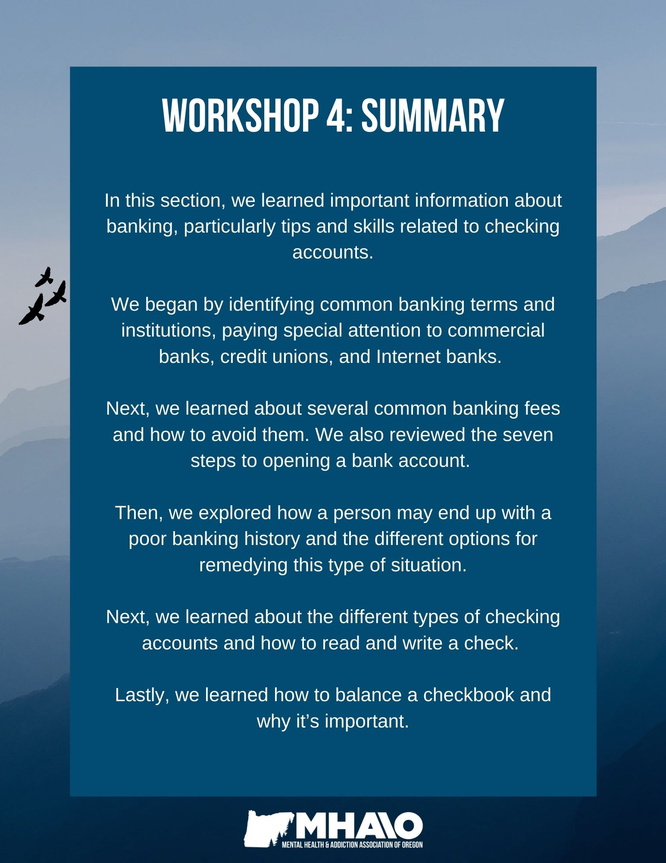
How can the topics I learned in this section be helpful for me?
Topic | N/A | How this will be helpful to me:
Common banking terms & the different types of financial institutions
Common banking fees
How to open a bank account
What to do if you have a poor banking history
Different types of checking accounts
How to read a check
How to write a check
How to balance a checkbook

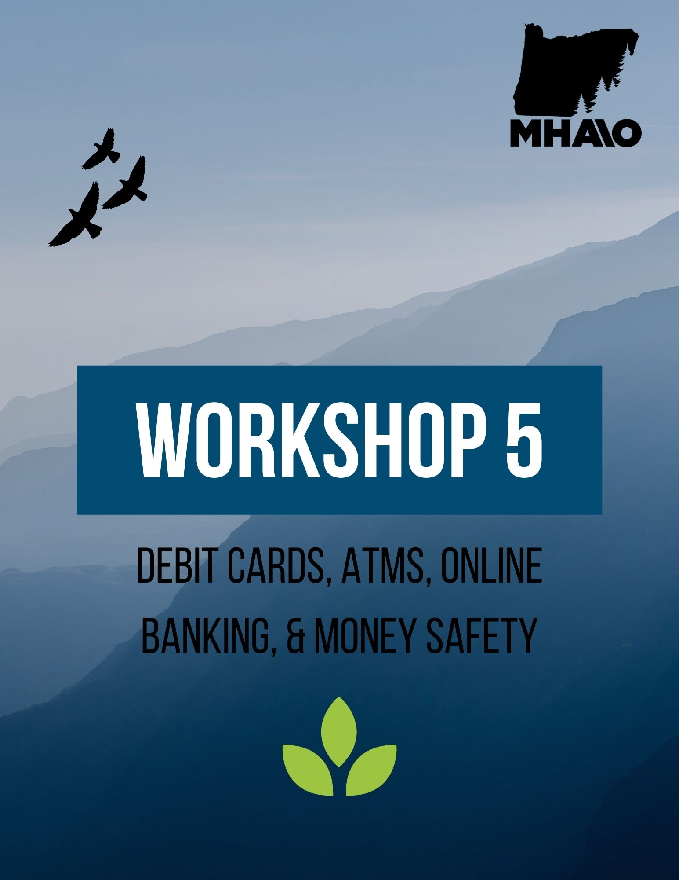

Workshop 5
Understanding Debit Cards
A debit card looks like a credit card but works like an electronic check by deducting your payment directly from your checking or savings account. If you use a debit card at a retail store, your card runs through a scanner that enables your financial institution to 1) verify electronically that the funds are available and 2) approve the transaction. In addition to making instant payments in stores or online, most debit cards can be used to withdraw cash at ATMs or at most supermarkets when you make a purchase.
Benefits of Debit Cards:
For many people, it is more convenient to carry a small, plastic card instead of a bulky checkbook or a large amount of cash. Using a debit card is easier and faster than writing a check. It's a good way to pay for purchases without having to pay interest, as you would if using a credit card with an outstanding balance. Debit cards take the money directly out of your bank account, so there is no worry of racking up credit when using them.
FAQs about Debit Cards
What kinds of costs are associated with debit cards?
There may be fees for using your debit card. As with other bank products, your financial institution must provide disclosures explaining the possible fees associated with a debit card. Be sure to read the disclosures to avoid an unexpected fee.
- Some banks charge a fee if you enter a PIN (Personal Identification Number) to conduct a transaction instead of signing your name.
- You may trigger a fee if you overdraw your account using your debit card, just as you would if you "bounced" a check.
- There could be a charge if you use your debit card at an ATM that is not operated by your financial institution.

Some debit cards come with rewards or other incentives for using them. How can I know which one is a good deal?
As with similar financial products, rewards-linked debit cards are designed to encourage people to use a certain bank and its services. Similar to many credit cards, some debit cards offer rewards, such as cash back, giving you the opportunity to earn points for your purchases. Before opening a new account or changing banks to get a different perk, study the fine print. Begin by reading the disclosures that explain the account terms and fees to understand the potential benefits as well as the costs, such as fees for overdrawing your account (discussed below).
How is it possible to overdraw my account if my bank or bank network must approve a debit card transaction?
Because debit card payments are electronic, they are deducted from your account more quickly than when using a paper check. Oftentimes, a debit card purchase is posted within 24 hours instead of a few days, as may be the case with a paper check. This means there is less time to make a deposit to cover a purchase, if necessary.
In addition, even if a transaction was approved, you may overdraw your account because the bank won't know what other withdrawals you have made that day until it settles all transactions later that day. Or, suppose you don't realize you have only $100 in your bank account and you want to use your debit card to buy a $200 item. Depending on the terms of your account, the bank might approve the $200 purchase as a convenience, but it also might assess an overdraft fee for that transaction and subsequent ones until you make a sufficient deposit.
Note: If your debit card is linked to your savings account, you can transfer money to your checking account when funds get low to avoid these fees. Mobile banking apps also make it easy to check your account balance for sufficient funds before making a purchase.
If I use a debit card to make a purchase can the merchant put a temporary "block" or "hold" on other funds in my account?
Yes, in certain circumstances merchants can take these steps as protection against fraud, errors, or other losses. For example, a hotel might put a hold on a certain amount when you use a debit or credit card to reserve a room. Another example is when you use your debit card at the gas pump. Typically, the gas station will create two transactions: the first to get approval from your bank for an estimated purchase amount (like $50) when you swipe your card before pumping gas, and the second for the actual charges when you're done. Until the first ($50) transaction is cancelled by the bank, usually within 48 hours, you won’t have access to that amount in your account.
Because a debit card transaction is processed so fast, is it possible to order a "stop payment" or obtain a refund if I later discover a problem with the merchandise?
It depends. Because funds are deducted from your account very quickly, don't expect to have the option to stop payment or obtain a refund. If the transaction cannot be cancelled, you may be able to work out other arrangements with the store. For example, if you return an item to a merchant and you're not able to get a refund, you instead may qualify for store credit or a gift card.
Consumer protections are stronger for credit cards than debit cards, so if you are concerned that merchandise may be damaged or not what you expected, you may consider using a credit card for those types of purchases. The Fair Credit Billing Act (which only applies to credit cards) gives you the ability, under certain circumstances, to withhold payment on defective goods until the problem has been corrected.
Sometimes I’m asked to enter a PIN to approve a debit card transaction, other times I can sign my name. Does it matter?
It could matter. If you use a PIN at a merchant's sales counter, you also may be able to get cash back, and that can save you a trip to the ATM. However, be aware that some financial institutions charge consumers a fee for a PIN-based transaction. There also may be differences in how quickly the transaction is posted to your account, depending on how your bank processes PIN vs. signature debits.
If you would rather sign for a debit card transaction, you can generally swipe your card through the reader and choose "credit" (even though you are authorizing a debit withdrawal from your account, not a credit card transaction). To use your PIN instead of signing, select "debit."

Debit Card Safety
Debit card fraud is a common form of identity fraud that can affect anyone. It is important to protect your debit card as well as your account number, expiration date, security code (the three-digit number on the back of your card), and your PIN. Identity theft can occur even if you don’t lose or misplace your debit card. Someone who has learned your account number, security code, and PIN can use that information to access your account, withdraw funds, or create counterfeit cards. While in many cases you are not responsible for unauthorized transactions, it can be a hassle to resolve the situation.

Tips to Avoid The Risk of Debit Card Fraud:
- Never write your PIN on or near your card. Memorize it instead.
- Don't give out bank account information over the phone or the Internet unless you have initiated the contact or you know the person is who they claim to be. Beware of deceptive calls or emails from individuals claiming to be from your bank asking you to "verify" your account information. A true bank representative would never ask for your PIN because your bank already has that information.
- Don't share your PIN, security code or other account information with friends or relatives who aren't co-owners of your account. Never reveal this information to new friends you meet over the Internet. Common scams occur with a false job offer or Internet friendship or romance, in which the victim is asked to transfer money to the perpetrator.
- Take precautions at the checkout counter, ATM, and gas pump. Always stand so that no one can see the keypad where you enter your PIN. At retail establishments, it's best to use do-it-yourself scanners. If you give your card to a clerk, make sure they don’t run your card through two scanners instead of one. The second scanner could be capturing your account information to make a counterfeit card. In general, be alert for suspicious-looking devices that may be used to "skim" information from your card.
- If you use your debit card to shop online, consider extra precautions with your personal computer. Use similar precautions with Internet and mobile banking. Experts advise installing virus and spyware protection to stop thieves from secretly installing malicious software that can be used to spy on your computer and obtain account information.
- Look at your bank statements as soon as they arrive. Or better yet, review your account each week. Promptly report any discrepancy, such as a missing payment or an unauthorized transaction, to your bank. Your quick attention to the problem may help limit your liability and give law enforcement authorities a head start on stopping the thief.
Federal Protections for Consumer Debit Cards: The federal Electronic Fund Transfer Act (EFTA) protects you from errors, loss, or theft of your debit card. However, unlike the Truth in Lending Act protections for credit cards, which cap a consumer's liability for unauthorized transactions at $50, the law limits liability to $50 if the cardholder notifies the bank within two business days after discovering the theft. If you do not notify your bank within those two days, you could lose up to $500. If you receive a bank statement that includes an unauthorized debit-card withdrawal and you wait more than 60 days to alert your bank, you could be liable for any amount of the transactions made after that 60-day period. The good news is that many banks do not hold a consumer responsible for unauthorized transactions if they notify the institution in a timely fashion. However, remember that with a debit card, the money tapped by the thief has already been taken out of your account.
Under the EFTA, a bank has 10 business days to investigate the matter (20 business days if your account is new) and report back to you with its results. If the bank needs additional time, it may, under certain circumstances, temporarily give you some or all of the disputed amount until it finishes its investigation. Generally, a bank is allowed up to 45 days of additional investigation time.
How to Use an ATM
While machines vary slightly, most ATMs have similar characteristics which makes them fairly easy to navigate. The basic steps are generally the same:
- Either insert your card into the slot or swipe it, depending on the machine.
- Enter your personal identification number (PIN).
- If you are using a machine unaffiliated with your bank, you may be asked if you accept the charge to use the machine (usually between $1.00 and $3.00). If you do not want these charges to be taken from your account, you can cancel at this time.
- Choose a transaction.
  - If you want to withdraw money, select this option. Most machines dispense money only in increments of $20 (i.e. $20; $40; $60 etc.). Most banks have a limit of what you can withdraw from an ATM in a single day, usually $300 0r $400. If you want more than your limit, you’ll have to go into your bank and speak with a teller.
  - If you want to make a deposit, select this option. Some machines require a deposit slip and your cash and/or checks to be placed in an envelope. Some machines do not allow you to make deposits in cash.
- You will be asked if you want a receipt. Click “Yes” or “No.”
- When you are finished with your transaction(s), be sure to take your card, your money (if you made a withdrawal), and your receipt (if you requested one).
Note: It’s a good idea to find out which machines are affiliated with your bank (to avoid charges) and what the withdrawal limits are for those ATMs.
What is an ATM Skimmer?
ATM skimming is a form of credit or debit card fraud in which scammers rig ATMs with hidden recording devices to steal a person’s card information. A skimmer is a card reader that is disguised to look like part of the ATM. The skimmer collects a person’s card numbers and PIN, which theives can use to make purchases, withdraw cash, or produce fake cards. Some methods of ATM skimming include an overlay on the keypad that captures a person’s PIN as they enter it; an overlay on the card insertion slot that records the data on the card’s magnetic strip; or tiny cameras that record a person typing in their PIN. Skimmers are becoming more advanced as technology advances. However, there are ways to protect yourself from ATM skimming, such as:
- Check the PIN keypad and the slot where you insert your card, which are usually bulkier when a skimmer is in place.
- Check for tape or glue residue on the ATM and wiggle the card slot or keypad to check for loose-fitting attachments. Don’t use ATMs that have damaged or loose parts.
- Use debit and credit cards with chip technology, which is more secue.
- Use your smartphone instead of a physical card, such as through your bank’s mobile app or Google Pay, Apple Pay, Samsung Pay or PayPal.
- Run your debit card as a credit card transaction so you won’t need to enter your PIN.
- Review your debit and credit card transactions at least once a week to catch any form of fraud early on. Sign up for account alerts.
ATM Safety Tips:
Below are a few practices for using an ATM safely:
- Always pay close attention to the ATM and your surroundings. Don't select an ATM at the corner of a building – corners create a blind spot. Use an ATM located near the center of a building.
- Do your automated banking in a public, well-lit location not blocked by shrubbery. Bring another person with you, if possible.
- Maintain an awareness of your surroundings throughout the entire transaction. Be wary of people trying to help you with ATM transactions. Be aware of anyone sitting in a parked car nearby. When leaving an ATM make sure you are not being followed. If you are, drive immediately to a police, fire station or business or to a crowded, well-lit location.
- Do not use an ATM that appears unusual-looking or offers options with which you are not familiar or comfortable.
- Do not allow people to look over your shoulder as you enter your PIN.
- Memorize your PIN, never write it on the back of your card. Do not re-enter your PIN if the ATM eats your card – contact a bank official instead.
- Do not wear expensive jewelry or take other valuables to the ATM. This is an added incentive to the assailant.
- Never count cash at the machine or in public. Wait until you are in your car or another secure place.
- When using a drive-up ATM, keep your engine running, your doors locked and leave enough room to maneuver between your car and the one ahead of you in line.
- Maintain a supply of deposit envelopes at home or in your car. Prepare all transaction paperwork prior to your arrival at the ATM. This will minimize the amount of time spent at the machine.
- Closely monitor your bank statements, as well as your balances, and immediately report any problems to your bank.
- If you are involved in a confrontation with an assailant who demands your money, the best thing to do is comply.

Online Banking
Today, many people use their computers and smartphones as a way to communicate with the world and do business. There are a wide variety of applications that have been created to assist with banking, budgeting, sending money to other individuals, and investing. When downloading and using these apps, make sure they are secure and certified. Technological advancements have made these convenient banking and money sharing apps possible, but have also made Internet hacking and scams more efficient.
There are a number of apps made to assist individuals with their financial needs. Depending on its particular service, these apps may allow you to:
- Check your balance
- View all of your transactions (all your purchases for a particular time period
- Pay bills
- Open a new account
- Deposit checks
- Transfer money within your personal accounts (such as from savings to checking)
- Send and receive money
- Invest your money
- Budget
This is not an exhaustive list, as there are numerous apps that can be used for online banking and personal finance. Your financial institution will most likely have their own website and app available to support your online banking needs, as well as a bank representative who can help you with learning how to use these services. Check in with your bank if you have questions or concerns about their banking apps.

Virtual Banks
If you don't mind foregoing the teller window, an online or e-bank – such as USAA, Chime, NationWide, Discover Bank, Giant Bank or Alliant Credit Union – may save you money. From the customer's perspective, virtual banks exist entirely on the Internet. They offer nearly the same range of services and adhere to the same federal regulations as a brick-and-mortar bank.
Virtual banks pass the money they save on overhead costs, like buildings and tellers, along to you in the form of higher yields, lower fees, rewards such as cashback, and more generous account thresholds. Many of these online banks provide customers access to free (no fee) ATMs across the country. However, out-of-network ATM fees can apply if there are limited ATMs in your area affiliated with your virtual bank. This is the primary disadvantage of virtual banks.
Advantages of Online Banks:
- Low fees: Online banks tend to have lower (or no) monthly maintenance or overdraft fees.
- Better interest rates: Deposit accounts at online banks tend to have higher annual percentage yields. For example, the best online savings accounts have APYs around 0.45%, while the national average rate for savings accounts is 0.06%.
- Convenience: Unlike your corner bank, online banking sites never close; they're available 24 hours a day, seven days a week, and they're only a click away.
- Ubiquity: If you're out of state or even out of the country when a money problem arises, you can log on instantly to your online bank and take care of business, 24/7.
- Transaction speed: Online bank sites generally execute and confirm transactions at or quicker than ATM processing speeds.
- Efficiency: You can access and manage all of your bank accounts, including IRAs, CDs, even securities, from one secure site.
- Effectiveness: Many online banking sites now offer tools such as account aggregation, stock quotes, rate alerts, and portfolio programs to help you manage your assets. Most are compatible with money managing programs such as Quicken and Microsoft Money.
Disadvantages of Online Banks:
- Start-up may take time: In order to open an account at a virtual bank, you will likely need to mail in a signature.
- Cash deposits can be difficult: Because there are no physical branches to make deposits at, you may have to find a deposit-accepting ATM.
- Cash withdrawals can be difficult: Some online banks have limits for how much you can withdraw at an ATM. This can be difficult if you need to make a big purchase in cash.
- Fewer options: Some online banks may not offer additional accounts and services, such as CDs, whereas traditional banks tend to often offer a number of services all in one place.
- Learning curve: Banking sites can be difficult to navigate at first. Plan to spend some time reading the tutorials in order to become comfortable in your virtual lobby.
- Bank site changes: All banks periodically upgrade their online programs and add new features. In some cases, you may have to re-enter your account information.
- The trust issue: For many people, the biggest hurdle to online banking is learning to trust it. Did my transaction go through? To be sure, always print the transaction receipt and keep it with your bank records until it shows up on your bank statement.
Money Transfer Applications
Along with online banking, money transfer apps like CASH APP, PayPal, Venmo, and Zelle are becoming more and more common. These apps enable you to pay friends or people you are doing business with directly from your phone instead of through cash or checks. Note that Venmo now taxes small businesses for doing business on their app.
Cash apps are intended to request and send money to and from people whom you know and trust or have interacted with before on a financial level. Most financial institutions enable you to request and transfer funds by linking your bank account to your Venmo or PayPal account. If you are hesitant about the safety of these apps, ask a bank representative at your financial institution.
Investment Applications
Investment applications such as Acorns, RobinHood, E*Trade, or Vanguard enable you to put spare change or additional savings into an investment account that will help your money to grow like a 401(k) or an IRA (these are common retirement accounts, which will be discussed further in Workshop 10). Depending on your financial institution, you may be able to invest funds through your bank’s mobile app as well. These apps build and manage portfolios for you, making investment easy and jargon-free.
There are several different types of investment apps. Some are micro-investing apps like Acorns, which automatically invests your spare change into diversified portfolios. There are also “robo-advisor” apps, like Betterment, that use algorithms to assist users on how to invest their money; and stock trading apps, like RobinHood, that provide commission-free investing and trading.
The major downside to these applications is that they cost a monthly subscription fee, which can often be quite high compared to the returns on your investment you are receiving each month. In this case, sometimes traditional investment companies like Charles Schwab or Vanguard, which both have electronic and low-fee options, may be a better option.
If you are interested in investing, make sure you have enough money to meet your daily needs, as well as emergency savings funds, in case your investment loses money. Investments can be risky and a person or family should reach financial stability and resiliency before investing.
Direct Deposit/ACH payments
ACH stands for “Automated Clearing House” and is a financial network used for electronic payments and money transfers in the United States. Many employers, instead of handing or mailing your paychecks, have switched over to directly depositing money into your account. If your employer deposits money directly into your account or you pay your bills online, ACH payments are most likely occurring.
When you begin a job that prefers direct deposit payments, you will often need to provide your employer with your checking or savings account number and your bank’s routing number. These can be found on a blank check (see Workshop 4) or your account information on your bank’s app or website. Sometimes you will need to request a Direct Deposit/ACH letter from your bank to get this information.
Payments from Social Security
If you qualify for Social Security benefits, you must receive your payments electronically. One way to receive your benefits is through direct deposit. It is a simple, safe, and secure way to get benefits. Contact your bank to help you get set up with direct deposit or sign up through the SSA. The other way to receive your benefits is through an electronic debit card, called the Direct Express card. This card is:
- Convenient and reliable: Your money will be automatically loaded onto your card on payment day each month. You will have access to your money at all times.
- Easy to use: You can make purchases, pay bills online, get cashback at stores, get cash at an ATM or from bank or credit union tellers; or buy money orders at the post office.
- Secure. Similar to a regular debit card, you have a PIN that protects your account. The money in your card account is protected and insured for up to $250,000 by the FDIC.
- Funds are protected from creditors: Federal law makes it illegal for a creditor to seize your Social Security benefits. This includes benefits you get on a debit card.
- It's free to use the card: There are no sign-up or monthly fees, though some optional services do charge fees.
Visit https://www.ssa.gov/deposit/howtosign.htm to sign up for Direct Deposit or Direct Express.

Automatic Bill Payments
Automatic bill pay can be a convenient way to pay most of your monthly bills. The money is automatically taken from your checking account on the same day every month (if the date lands on a holiday or a Sunday, it is usually taken out the next business day). It is relatively easy to set up by phone or through a company’s website. You will need the name of your bank, your checking account or debit/credit card number, and your account number that appears on your bills.
What to consider before deciding to use automatic bill pay:
- Check the due dates and make sure the money is in your account. Can you guarantee your account will have enough money for each bill every month when it’s due? You may incur fees from your bank and the company if your account has insufficient funds.
- Check your statements for discrepancies in your bills. It’s easy to overlook mistakes if the bill is taken care of automatically.
- Keep records. If you only get receipts through emails, flag or print them.
- To protect your identity with various accounts, don’t use easy-to-guess passwords. Make sure your computer has up-to-date anti-virus software installed.

Safe Banking over the Internet
The Internet offers the potential for safe, convenient new ways to shop for financial services and conduct your banking business. Whether you are selecting a traditional bank or an online bank, it is important to make sure that the bank is legitimate and that your deposits are federally insured.
When using online banking systems:
- Keep your personal information private and secure
- Understand your rights as a consumer; and
- Learn where to go for more assistance from banking regulators.
Tips for Safe Internet Banking:
1. Read key information about the bank on its website. Most bank websites have an “About Us” section that describes the institution, where you might find the bank’s history, the official name and address of its headquarters, and information about its FDIC insurance coverage.

2. Protect yourself from fraudulent websites. Watch out for copycat websites that deliberately use a name or web address very similar to that of a real financial institution. These websites try to get your personal information, such as your account number and password. Check if you have typed in the correct web address for your bank before conducting a transaction.

3. Verify the bank’s insurance status. Look for the FDIC logo or the words “Member FDIC” or “FDIC Insured” on their website. You can also check the FDIC’s online database of FDIC-insured institutions. If your bank does not appear on that list, contact the FDIC.
- Some bank websites provide links directly to the FDIC’s website to assist you in identifying or verifying the insurance protection of their deposits.
- Note that not all banks operating online are insured by the FDIC. Many banks that are not insured are chartered overseas. If you choose one of these banks, know that the FDIC may not insure your deposits, which can be risky. Contact your bank or the FDIC if you are uncertain.
- For insurance purposes, be aware that a bank may use different names for its online or traditional services. This does not mean that you are dealing with two separate banks. Talk to your banker if you have questions.
4. For assistance from the FDIC regarding the legitimacy of an institution or the insurance of your deposits, you can call the FDIC’s Division of Compliance and Consumer Affairs or send an email through their website. Their website also has an Electronic Deposit Insurance Estimator that can help you determine the amount of your insurance coverage.
Note: Only deposits offered by FDIC-insured institutions are protected by the FDIC. Non-deposit investment and insurance products, such as mutual funds, stocks, annuities, and life insurance policies sold online or through the bank itself are not FDIC-insured, are not guaranteed by the bank, and may lose value.
Money Safety
Identity theft: Identity theft occurs when someone uses your personal, sensitive information to either steal from you or pretend to be you. Some forms of identity theft include: using the money in your bank or investment accounts, opening up new lines of credit, using your insurance information, or stealing your tax refund.
The first step to preventing identity theft is awareness of how and when you use your personal information. By keeping close tabs on your personal information, you can reduce your chances of becoming a victim of identity theft.
Tips to Avoid Identity Theft:
Protect Your Personal Information:
- Memorize your Social Security number and passwords. Do not record your password on papers you carry with you and do not carry your Social Security card or birth certificate with you.
- Do not use your date of birth as your password. Use strong, complex passwords and add an authentication step (such as text message or email verification) to your financial accounts.
- Shred pre-approved credit applications and other financial documents before discarding them.
- Watch your mailbox for stolen mail, which is one of the easiest ways for people to steal your identity.
Review Your Transactions & Statements:
- Order credit reports every year from each of the major credit reporting agencies and thoroughly review them for accuracy.
- Sign up for alerts from your bank, so you can track your transactions and quickly identify any that are suspicious.
- Check your monthly credit card and bank statements for unusual activity.
Practice Internet & Phone Safety:
- Be aware of phishing and spoofing – spam phone calls and emails from what seems to be a government entity or financial institution asking for sensitive information.
- If you are using a shared computer to check your bank balance or transfer funds, log-out of your account when you are finished to protect your money and information. Do not auto-save passwords.
- Do not download files sent to you by strangers or click on hyperlinks from people you don’t know. Be aware of opening attachments in emails or text messages, as they could contain malicious software.
- Don’t use public Wi-Fi for sensitive transactions, like banking or online shopping.
- Use a firewall program on your computer.
- Never give personal or financial information over the phone or Internet unless you initiated the contact. Be aware of common phone scams, which can be found here:
https://www.consumer.ftc.gov/articles/phone-scams

Take Immediate Action:
- Freeze your credit with the three major credit bureaus if you suspect someone has stolen your information. This stops new lines of credit from being opened.
- Report lost or stolen credit or debit cards immediately.

Additional Money Safety Tips
- Do not carry large amounts of cash in your pocket.
- Be watchful of your surroundings. Be careful not to show money you have on hand (i.e. counting out your cash at an ATM).
- Don’t leave money out when you have visitors in your home. Keep only small amounts at home in a safe place.
To report identity theft, go to ​​https://www.identitytheft.gov/#/
You may also have to contact your local police department, the Credit Bureaus, the Postal Service, your bank or Credit Card Company, the IRS, or your medical provider depending on the type of theft that occurred.

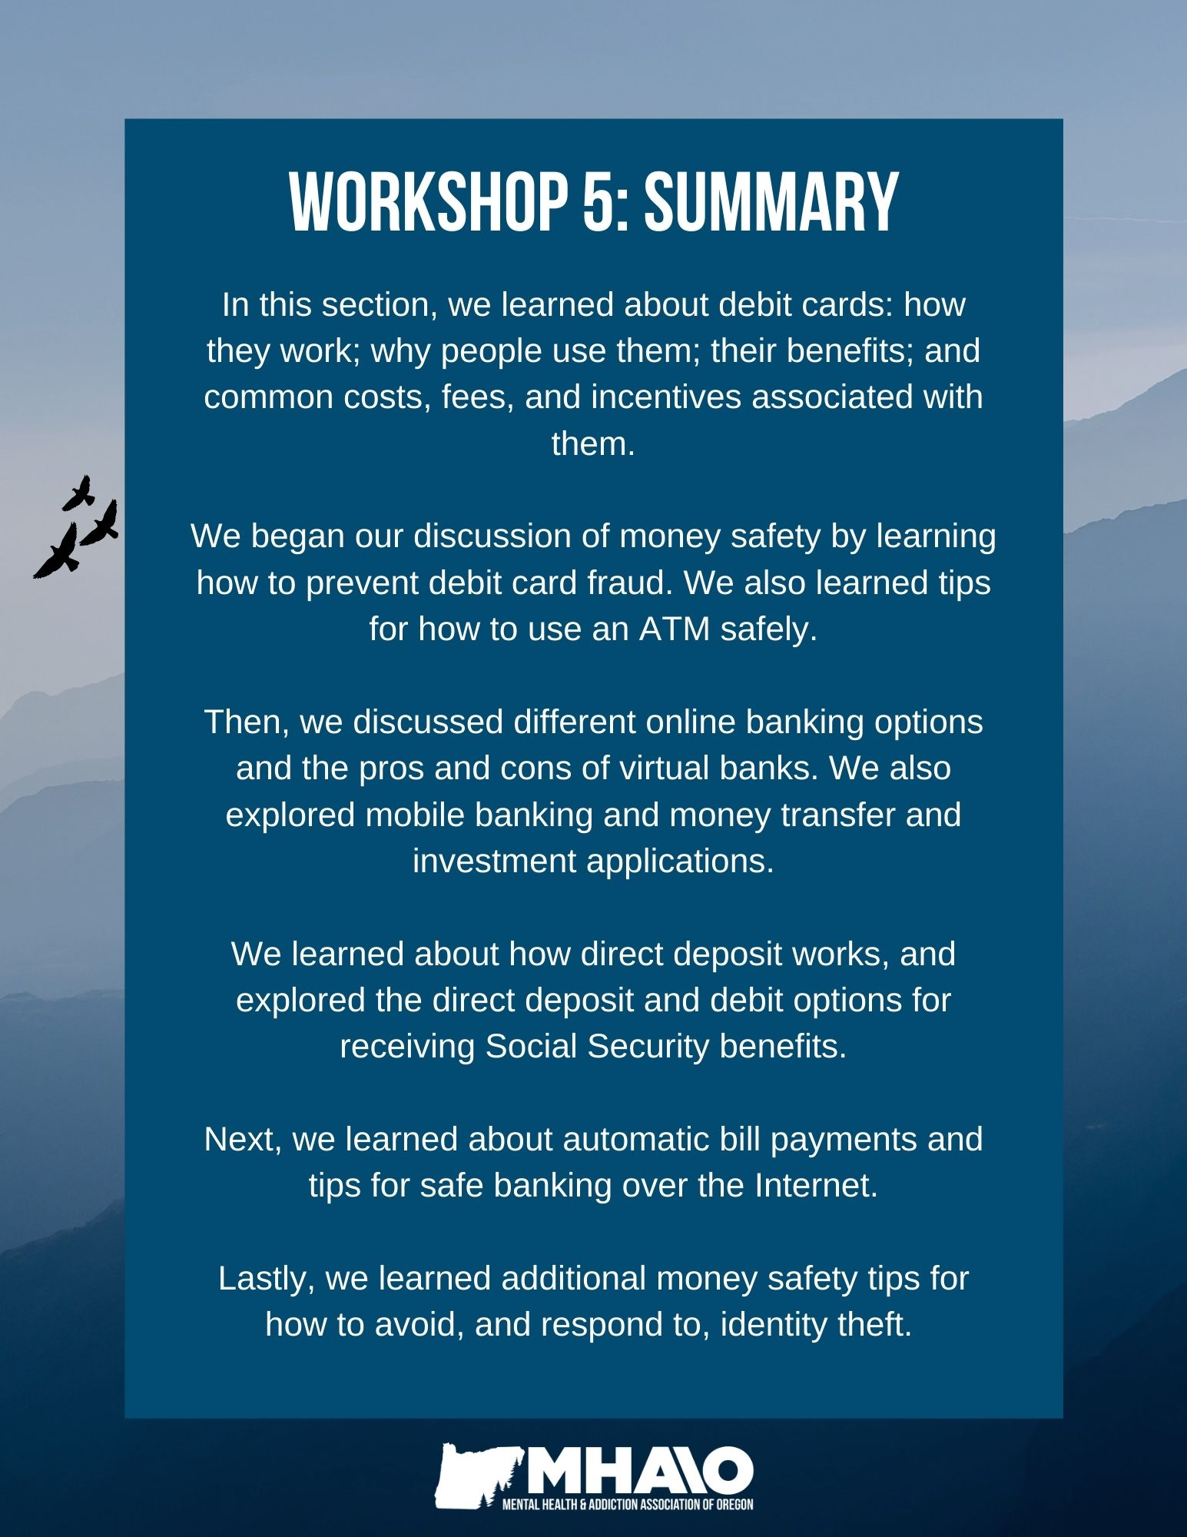
How can the topics I learned in this section be helpful for me?
Topic | N/A | How this will be helpful to me:
Understanding how debit cards work and debit card safety
How to use an ATM & ATM safety
Virtual banks & electronic banking
Banking, money transfer, and investment apps
Automatic bill paying
Direct Deposit & the debit system through Social Security
Money safety and tips to avoid identity theft



Workshop 6
Understanding Credit
How Credit Works:
The credit reporting system is made up of three main players: consumers, credit bureaus, and financial companies. Information about your credit card and loan accounts is reported electronically to the three national credit bureaus by each of your creditors every 30 days.
These bureaus -- TransUnion, Equifax, and Experian -- collect and store your credit information for future reference.
The three national credit bureaus do not share information with each other. Because of this, your credit reports from TransUnion, Equifax, and Experian can contain significantly different information about you. It is important to monitor all three reports since you can never be sure which one will be used when you apply for a new account, loan, line of credit, etc.
Credit Reports & Credit Scores
A credit report is an accumulation of information about how you pay your credit bills, how you repay loans, how much credit you have available, what your monthly debts are, and other types of information that can help a potential lender decide whether you are a good credit risk or a bad credit risk.
Businesses such as auto lenders, banks, credit card companies, and insurance agencies use your credit reports from the three credit bureaus to determine if you are a risky customer. The lower the risk, the lower the interest rates you will have to pay. They also use this information to send you pre-approved offers in the mail.
Under federal law, Americans have access to a free credit report from each of the credit bureaus every 12 months. You can access your free credit report online at AnnualCreditReport.com.
Accessing your credit report can be a good way to keep track of any loans and debts you may have, and can be a good practice for monitoring your accounts for fraudulent activity. You can access all three free reports at once, or request them separately to monitor your accounts throughout the year. After you use up your three free reports, you can request reports from the bureaus for a fee.
Many, but not all, creditors will report your account information to the credit bureaus. While businesses are legally required to report accurate information, there is no law that says they have to report at all. While nearly every major creditor reports to all three bureaus, smaller lenders and banks may not send your monthly account information to all or any of the credit bureaus.
Along with your credit card and loan account records, your name, address, employer, and recent applications are recorded in your credit files. Public records such as bankruptcies, tax liens, and judgments can also appear on your reports. Information about your income, race, checking accounts, gender, age, religion, or health is not included on your credit report. Most information expires from your credit reports after 7-10 years. If there is something inaccurate on your credit reports, you can file a dispute to have it removed from your record.
It’s important to keep the information on your credit reports positive and accurate. The data in your credit files is used to calculate your credit score. This three digit score is a numerical representation indicating how risky a borrower you are from a lender’s perspective. Your credit score number reflects your credit risk level, with a higher number indicating lower risk. It is generated through statistical models using elements from your credit report.
A higher credit score (700+) will get you the best deals on big purchases. For example, your credit report and credit score impact the deals and interest rates you will receive when you buy a home, finance a car, rent an apartment, apply for a job, buy insurance, purchase a cell phone, or open a new credit card.
The best way to have “healthy” credit is to have a few credit cards and loans that you pay on time every month. Making late payments or maxing out credit limits can negatively impact your credit report and credit score and make it difficult to apply for a loan or make a big purchase. Being on top of your bill payments, including credit card payments, can be an empowering financial practice.
Your credit score depends on the information in your credit reports. Your score is not physically stored as part of your credit history on the credit file. Rather, it is typically generated at the time a lender requests your credit report, and is then included with the report that will be viewed by the creditor.
Your credit score changes as the elements in your credit report change. For example, payment updates or a new account can cause your score to fluctuate. Additionally, many different credit scores are used in the financial services industry, and your score may be different from lender to lender or loan type to loan type (car loan vs. mortgage loan). It all depends on the type of credit scoring model that is used.
You can create an account with Credit Karma on their website or app to access your credit score for free anytime, anywhere. Visit https://www.creditkarma.com/free-credit-score to learn more.
FAQs about Credit Scores
Why are credit scores used?
Before credit scores, lenders looked over each applicant’s credit report to determine whether to grant credit. In this system, a lender might deny credit based on a subjective judgment that a consumer already held too much debt, or had too many recent late payments. Not only was this time consuming, but human judgment was prone to mistakes and bias.
Credit scores help lenders assess risk more fairly because they are consistent and objective. Consumers also benefit from this method, because your credit score only reflects your likelihood to repay debt responsibly, based on your past credit history and current credit status.
Who uses credit scores and how are they used?
Banks, credit card companies, auto dealers, retail stores and most other lenders that issue credit or loans use credit scores to quickly summarize a consumer’s credit history, saving the need to manually review an applicant’s credit report and provide a better, faster risk decision.
Although many additional factors are used in determining risk, such as an applicant’s income vs. the size of the loan, a credit score is a leading indicator of an individual’s basic creditworthiness. Some landlords ask for credit scores during the rental application process, so building and maintaining good credit can be important not only for banking and getting loans but also in finding housing.
What information impacts your credit score?
The information that impacts a credit score varies depending on the score being used. Generally, credit scores are affected by elements in your credit report, such as:
- Number and severity of late payments
- Type, number, and age of accounts
- Total debt
- Recent inquiries
Credit bureau-based scores cannot use demographics prohibited under the Equal Credit Opportunity Act, such as race, color, religion, national origin, gender, age, marital status, receipt of public assistance, or exercise of rights under the Consumer Credit Protection Act. Scores used by individual lenders may use such elements as income, occupation and type of residence in determining their own custom credit score.
Facts about Credit
Credit limit: A credit card company sets limits on how much you can charge on your card. This limit is based on your ability to handle debt.
Paying only the minimum monthly payment: Is a bad idea. After you subtract the minimum payment from your balance, finance charges will be added to your remaining balance. These charges add up month after month. The minimum payment is the LEAST amount you can pay to keep the card active. If you pay less, your card will be deactivated (turned off).
Grace period: If you pay your bill in full during the grace period, you won’t have to pay a finance charge on purchases for that bill. A grace period is usually about 25 days.
Late fees: If you don’t pay your bill by the due date (the date your grace period expires), you will be charged a late fee. These can be as high as $35! Because paying late can be costly, get yourself organized to pay on time. Write yourself reminders or sign up for automatic payments to avoid these fees.
Interest rates: Remember that when you use your credit card, you are borrowing money, so you will be charged interest whenever you do not pay your bill in full. With a credit card, you are paying for convenience. Credit card interest rates can be as high as 18% or 24% depending on your credit history. The best way to avoid interest rates is to pay your credit card bill in full and on-time.
“Secured” credit cards: Some banks and credit card companies offer secured credit cards to people with a poor credit history or no credit history at all. Secured cards can be the best option for your first credit card. The card is “secured” with a cash balance, such as a savings account. Your savings account acts like collateral for a loan -- if you charge over your limit, the bank will take the balance.
Other secured credit cards require you to pay a cash balance, usually equal to your line of credit. The financial institution will take this money if you do not pay your bill. You can get these funds back when you close your account in good standing or when you upgrade to a regular credit card. Secured cards may charge higher interest rates but they offer the convenience of using a credit card while you build a good credit history.
If your Credit Card is Lost or Stolen:
You must notify your credit card company as soon as you know your card has been lost, stolen, or used without your permission. If you do, you will be responsible for only the first $50 of unauthorized charges. Sometimes thieves don’t need the actual credit card – they can use your money simply by stealing your credit card number. Always know where your card is and keep all of your receipts.

Note: Debit cards do not offer the same protection as credit cards, though some credit card companies offer debit cards with similar protection. With debit cards, the money is immediately taken out of your account. If you do not report a false charge or charges within 60 days of receiving your bank statement, you could be held responsible for the false charges. Be sure you understand the details when you sign up for a debit card.

Interest Rates
There are two basic types of interest: the interest you pay (mortgage, loans, debts) and the interest you earn (retirement, investment, and savings accounts). Because using credit is a form of borrowing money (like a loan), you will be required to pay interest whenever you do not pay your credit card bill in-full.

Credit card interest rates can vary widely, usually from as low as 0% (introductory rate) to as high as 36%. Your credit history, banking history, income, and your credit score are all used by a bank or credit union to calculate your likelihood of making good on payments. Generally, the lower the perceived risk to the bank, the lower your interest rate will be. Interest rates on loans are calculated the same way.

The best practice for avoiding paying credit card interest, which can add up significantly over time, is to pay your credit card bill in-full. If that is not possible, try to pay as much over your credit card minimum payment as you can. Even just $10 more each month can reduce your credit card interest and enable you to pay off the balance faster.

The Pros & Cons of Credit
Benefits:
- Security: Credit cards can be safer than carrying cash. Unlike cash, if you report your card lost or stolen, the card will be canceled, rendering it unusable.
- No-Interest Grace Period: Grace periods allow you to float money. If you pay the amount in full before the payment due date, you can essentially ‘borrow’ money interest-free. However, if you are late with the payment, you will be charged a penalty and your interest rate will likely rise.
- Rewards & Rebates: You can use credit cards that offer rewards or rebates. Some credit card companies are affiliated with airlines, allowing you to earn airline miles that, eventually, can be redeemed for free airfare or upgrades on travel. Other companies offer cash back awards. Keep in mind that these schemes can only work in your favor if you pay off the balance most, or all, months to keep your interest down to a minimum.
- Online Management: Similar to internet banking, credit card companies have websites and apps where you can check your credit balance and interest rates, and make payments easily and securely. You can also enroll in auto-pay so you never miss a payment.
Drawbacks:
- Credit Limit Can Be Too High: Credit card companies often extend credit limits far above a reasonable amount compared to a person’s income. This can leave a person in debt and it may take years to pay it down.
- Too Easy to Buy Now, Pay Later: Having a credit card can make it too easy to make a purchase now rather than waiting until you have the money saved for that purchase. If you make too many of these decisions, your debt to the credit card company could increase to thousands of dollars.
- Identity Theft: Using credit cards can increase your chances of becoming a victim of identity theft. It is important that you stay vigilant with your credit card receipts, only give your credit card number to trusted sites when making internet purchases, and scrutinize your monthly bill for any transactions that do not look right.

Developing Better Credit Habits
To build and maintain good credit:
- Pay your credit bills on time.
- Do not accumulate too much credit debt. If it starts to add up, stop using your credit card until you have paid off that debt.
- Monitor your credit reports to look for errors and to avoid identity theft.
How much credit is too much?
Acquiring a lot of credit can add up quickly and be hard to pay off. Here are some signs that a person’s credit card debts are accumulating and becoming difficult to manage:
- You pay only the minimum amount due on your credit cards each month.
- You buy so much on credit that the amount you owe from one month to the next never goes down.
- You take out new loans or get new credit cards to pay off old ones.
- You have to skip some payments.
- You are borrowing to pay for regular expenses like groceries because you do not have cash.
- You are frequently late making your monthly payments.
- You must rely on extra income from overtime work to make ends meet.
- You must use savings to pay current bills.
- You have more than 20% of your take-home pay committed to credit payments other than your home mortgage.
- You have lost track of how much you owe.
- You put off essential medical or dental work because you cannot afford it.

If you answer yes to more than two or three signs, you may need to work on trimming your debt load.

Steps to Paying Down Credit Cards
Although the following steps to paying down your credit cards are simple, they will require a firm commitment on your part:
- Stop using your credit card(s).
- Pay off the card with the highest interest first.
- Pay more than the minimum due.
To calculate how long it would pay down your credit card(s) and what you will pay on interest over time, visit: http://www.calculatorweb.com/calculators/creditcardcalc.shtml
Best Credit Cards for Building or Rebuilding Credit:
- Best for Building Credit: Petal 2 “Cash Back, No Fees” Visa Credit Card
  - No credit history required, no fees – great beginner card
- Best Secured Card: Discover it Secured Credit Card
  - You put down a deposit and that is your credit limit, after eight months you can transition to an unsecured card and get your deposit back
- Best Low Deposit: Capital One Secured MasterCard
  - No annual fees, low security deposit options, and you can get a higher credit limit after making your first 5 monthly payments on time
- Best for International Applicants: Deserve Digital First Card
  - No annual fee or security deposit, no prior credit history needed
- Best for Students: Discover it Student Cash Back
  - Cash back perks and a welcome bonus, student-centric benefits
- Best for Average Credit: Capital One Platinum Credit Card
  - No annual fee, travel benefits, good for building existing credit
Note: We are not advertising any of these credit cards. One should keep in mind the pros and cons of opening up a new line of credit. Credit cards can be an important and helpful financial tool, but they must be handled responsibly so as not to increase debt.

Understanding Loans
A loan is a type of debt. In a loan, the borrower borrows an initial amount of money, called the principal, from the lender, and is obligated to pay back an equal amount of money to the lender at a later time. Typically, the money is paid back in regular installments, or partial repayments.
A loan is generally provided at a cost, referred to as interest, on the debt. In a legal loan, each of these obligations and restrictions is enforced by loan contract, which can also place the borrower under additional restrictions known as loan covenants.
Financial institutions use the same tools for calculating risk and interest rates for borrowers as they use for credit card offers.
Reasons for Taking out a Loan:
Debt consolidation: If you have multiple debts at high interest rates, it might work to your advantage to pull all of your debts together under one lower-interest loan.
Making large purchases: Because of the large amount of money involved, buying a home or car is often done through a loan.
Attending school: Many students use federal loans to attend college, trade school, or graduate school.
Additional reasons: Starting or expanding a business, making home improvements, planning a wedding, travel.
Note: Loan debts can be just as difficult as credit cards to pay down and any debt that has become overwhelming can become the source of a great deal of anxiety and stress. Later in this course, we will develop tools to address personal debts and create a person-centered plan to pay off debts.

Pros & Cons of Taking out a Loan:

Benefits:
- A loan gives you the ability to buy something now (like a home or a car) that you could not otherwise afford.
- A small business loan or student loan can help you grow professionally and build your human capital.
- A single, low-interest loan can help you pay off several debts faster and can save you a great deal of money in interest.

Drawbacks:
- You will pay interest. Over time, you will end up paying more than if you had paid for your purchase in-full.
- If you have an unexpected change in your income, you may have difficulties making the payments on the loan.
Understanding Loan Contracts:
It can be useful to have a good understanding of the terms used in loan contracts. The following are some commonly used terms:
Principal: The amount you borrow.
Term: The length of the loan (how long you have to pay it off).
Interest: The charge from the lender for using their money. This is usually expressed as a yearly rate, called the annual percentage rate (APR).
A fixed rate of interest: The interest rate charged on the outstanding loan balance will remain the same for a set amount of time (usually the entire duration of the loan). Fixed interest rates offer greater control over your finances because the repayment amount will always be the same for the fixed interest period.

The fixed interest rate and the time period it applies to must be stipulated in the contract. Generally you will not be able to make more than the agreed-upon repayments (i.e. pay the loan off more quickly). Check the loan contract for any conditions that apply.

A variable or floating interest rate: The interest charged on the outstanding loan balance increases or decreases based on changes to the market interest rate, which is usually set to a benchmark (such as the federal funds rate).

Variable interest rates can be beneficial when the market rate is low, and harmful when the rate is high. When the market interest rate declines, a variable interest rate will decline as well, reducing your loan payment. However, when the market interest rates rise, the interest on your loan will also increase and you’ll have to pay more.

A split interest rate: You may be able to choose to split the type of interest rate that applies to a loan. This occurs in two ways:
  - A fixed interest rate applies for a set amount of time. When that time elapses, the rate can be changed to a variable interest rate
  - Part of the amount borrowed has a fixed interest rate applied and the remaining amount has a variable interest rate applied.
The total amount you pay to the lender will depend on the amount you borrow, the interest rate charged, and the length of time that you borrow the money for (the term of the loan). Lenders will usually calculate interest charges on a daily basis. These interest charges are usually added to your loan account each month.

Calculating Interest Rates:
It is important to keep in mind that the amount you ultimately pay on a loan may be very different from the base amount, depending on the interest rate attached to the loan. Below are three examples of $10,000 loans with different interest rates. Notice how a slight increase in the rate of interest leads to a very different loan amount.
Interest rate | Potential annual loan interest | Actual total interest | Actual total loan and interest
9.0% | $900.00 | $4500.00 | $14,500.00
12.0% | $1200.00 | $6000.00 | $16,000.00
15.0% | $1500.00 | $7500.00 | $17,500.00
To get an accurate calculation of interest rates on your loan, visit:
https://www.bankrate.com/calculators/mortgages/loan-calculator.aspx
Before taking out a loan, ask yourself these questions:
- Do I really need this now? Is this something that can wait while I save more money?
- What will the payments be? Are they affordable now?
- How long will it take me to pay the loan off?
- If my income drops or I have an unexpected financial emergency, will I still be able to make the payments?
- How much money will I have left after payments for my other bills?

Predatory Lending
Predatory Lending: Any lending practices that enforce deceptive, unfair, and/or abusive loan terms on borrowers. These loans benefit the lender by 1) having high fees and interest rates, 2) taking away the borrower’s equity, or 3) putting a borrower in a more expensive and lower credit-rated loan. Federal agencies use the term “predatory lending” as a catch-all for numerous illegal activities in the loan industry.
Predatory lenders take advantage of a borrower’s lack of financial knowledge. Lenders may be accused of tricking a borrower into believing that an interest rate is lower than it actually is, or that the borrower's ability to pay is greater than it actually is.
Predatory lending typically occurs on loans backed by some kind of collateral, such as a car or a house, so that if the borrower defaults on the loan, the lender can repossess or foreclose their assets and sell them for profit. People with poor credit scores, low-income families, BIPOC borrowers, elderly folks, military service members, and people in financial crisis are disproportionately targeted by predatory lenders.
Warning Signs of Predatory Lending:
- There are excessive fees attached to the loan.
- The lender tries to convince you to take out a loan greater than what you can afford to pay back.
- The lender tries to make an expensive loan look as inexpensive as possible.
- The lender promises you one type of loan but gives you a different one.
- The lender links your loan to your assets, like your home, instead of your income.
- The lender increases the price of your loan at the end of the loan term (a balloon payment) without disclosing it up front.
- The lender makes promises of frequent refinancing as needed.
- The lender charges extra high interest rates to low-income neighborhoods, where finding a bank to borrow from often can be difficult.
Types of Loans that Could Become Predatory:
- Payday Loans: Also known as Deferred Deposit Service, payday loans are loans against paychecks. You must be employed and have a checking account to get this type of loan. Typically, you give the lender a post-dated check for the amount you wish to borrow, plus a fee. The length of the loan is usually around two weeks. On the agreed-upon date to pay back the loan, you either bring cash to the lender or let them deposit your post-dated check.
- Pawn Shop Loans: These loans are secured by a piece of property. Interest rates range from 2% to 25% per month, depending on which State you live in. Loan periods range from 30 days to 90 days, depending on the State. The collateral is sold if the interest or loan amount is not paid in the specified period.
- Title Loans: These loans are secured by your car’s title. The lender determines how much you can borrow based on your car's value. Typically, car title loans range from $250 to $1,000, but can go as high as $10,000. The duration of these loans is often 30 days. If you fail to make loan payments – even just one – the lender can repossess your vehicle.
- High-L-TV (Loan to Value) Home Equity Loans: Loans secured by the equity in your home but oblige you to pay more than your equity is worth. Some home equity lenders allow you to create a loan-to-value ratio of as much as 125%, which is risky because houses rarely sell for more than their fair market value.
- Advance-Fee Loans. The companies that offer this service do not directly lend money. Rather, they find lenders who will make a loan or issue another type of credit. While they claim high success rates, even for individuals who have poor credit histories, their fees can be very high. These companies should never require you to pay application, appraisal, or credit report fees before identifying a lender and completing the application.
Note: The interest rates and fees attached to most of these loans are much higher than those offered through conventional lenders (i.e. banks or credit unions). However, these loans generally make it quicker to qualify and obtain much-needed cash, so these types of lenders can often be the first choice for people experiencing a financial crisis. If you’re undergoing financial stress and need a quick loan, it is important to understand the warning signs of predatory lending and review loan contracts thoroughly before signing them.
How to Avoid Predatory Loans:
- Know what you can afford and shop around for loans. Calculate your debt-to-income ratio (monthly debt payments divided by your income). Your new loan should not push your DTI over 36%. Make sure all the lenders you are considering are licensed.
- Ask lenders lots of questions. Ask whether your monthly payments will change at any point, whether there are payment penalties or fees, etc.
- Identify any red flags, such as signing a waiver or contracts with blank spaces, and back out of the loan.
How to Fight Back Against Predatory Lenders:
- Report the lender. File a complaint with the Consumer Financial Protection Bureau (CFPB) at and your State’s banking office.
- Use your Right to Recession, which allows you to cancel your loan within 3 days of signing it. If you never received a Notice of Recession from your lender, the entire loan may be invalid and you m ay be able to rescind the agreement within 3 years of signing it.
- Sue the predatory lender. If your loan agreement violates federal or state law, you may have the option to file a civil lawsuit.
- Refinance the loan. To escape the predatory loan, you can refinance it with another lender.
- For more information and resources, visit:
https://www.moneycrashers.com/spot-avoid-predatory-lending-victim/

“Money often costs too much.”
Ralph Waldo Emerson

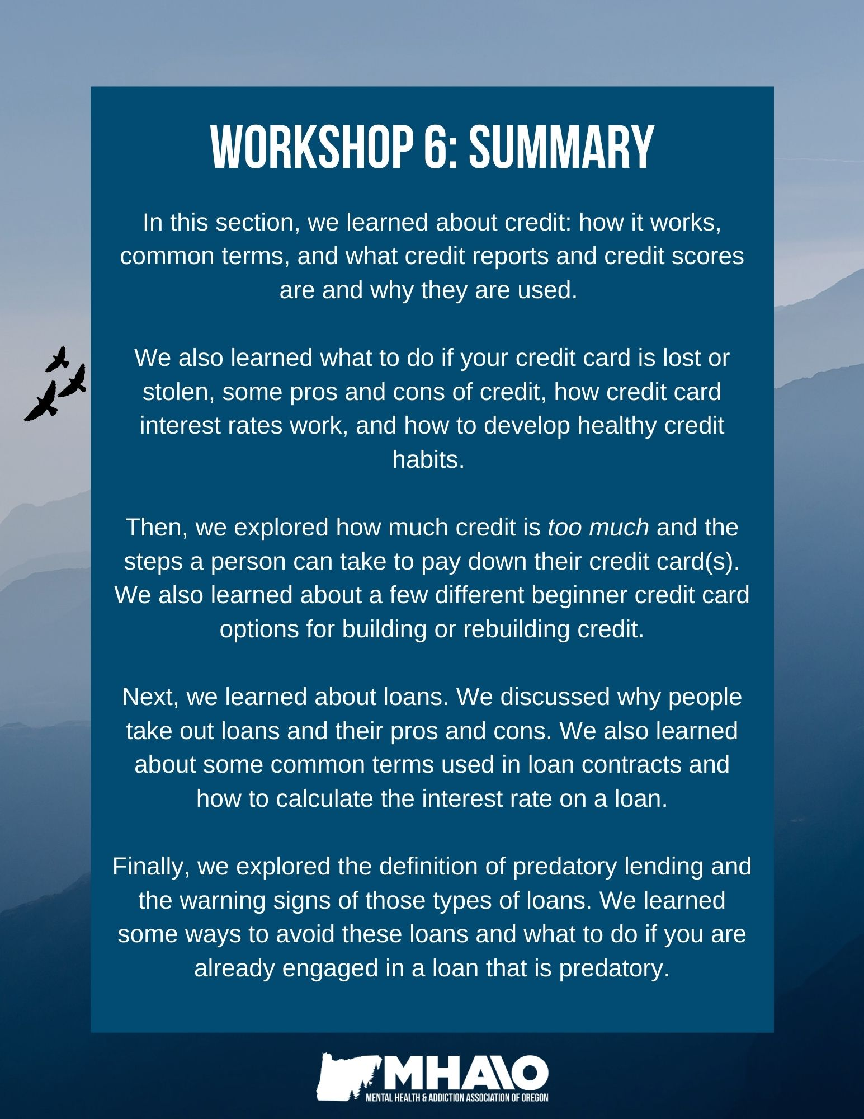
How can the topics I learned in this section be helpful for me?
Topic | N/A | How this will be helpful to me:
How credit works; credit reports and credit scores
Facts about credit
Pros and cons of credit
Interest rates (credit)
How much credit is too much?
Steps to paying down credit cards
Pros and cons of taking out a loan
Understanding loan contracts
Interest rates (loans)
Predatory lending



Workshop 7
Thoughts on Debt
For many of us, debt can be a source of anxiety, fear, shame, and hopelessness. Being in debt can take a toll on our economic well-being, our relationships, and our mental and physical health. This section will provide tools, resources, and most importantly, hope for getting out of debt.
Similar to the strengths-centered financial Person-Directed-Planning from Workshop 2, you will create a unique and personalized plan for getting your debt under control that works for you, your own needs, and your current situation.
When you think about debt, what kinds of feelings does this evoke for you?
How would you like to feel about debt? Where would you like to be in one year? In three?

Figuring Out How Much You Owe
The first step towards making a plan to pay off debt is to figure out what debts you have and how much you owe. Follow the steps below:
Step 1: Check your Credit Reports. The first step to figuring out what debts you have is to access your credit reports from the three major credit bureaus: Equifax, Experian, and TransUnion. You can get one free copy of the report every 12 months from each credit reporting company.

Generally, creditors report debt accounts to one or more of the bureaus, which add it to the credit reports they maintain. Your credit reports will contain information about credit cards, personal loans, mortgages, and more. Your credit report will list the amount owed on each account as well as its status, payment history, and creditor’s contact information.

Visit: https://www.annualcreditreport.com/index.action to access your free credit reports.

Step 2: Gather Any Missing Information. It is possible some accounts won’t appear on your credit report. Because of this, it is a good idea to gather all of your account statements to determine if any debts are missing, such as mortgage statements, student loan statements, credit card statements, and statements from personal and/or car loans. Make sure you have a statement from every lender you have borrowed money from.

Step 3: Compare: Add up the remaining balance on all of your statements. For example, if you owe $500 on one credit card, $300 on another, $100,000 on your mortgage, and $15,000 on your car, you would add up all of those numbers to arrive at the total amount of debt you owe. Compare this number with the total debt shown on your credit report. These numbers may not align exactly if you have recently made debt payments, since your credit report does not update instantly. However, the numbers should be close.

If you have debts on your credit report that you do not have statements for, contact the lender to verify the balance owed. If the listed debt on the credit report isn't yours, you will need to correct this error with both the lender and the credit bureau.

Step 4: Create a List of All your Debts. Write down all of your debts, which may include credit cards, student loans, personal loans, or car loans, highlighting 1) who you owe, 2) the amount you owe, 3) the interest rate, and 4) the minimum monthly payment. You can use the chart below. Later on in this workshop, you will learn different methods for organizing this list and paying off these debts
List of Current Debts
 | What is the debt? | Who do I owe? | How much do I owe? | What is the interest rate? | What is the minimum payment?
1.
2.
3.
4.
5.
6.
7.
8.
9.
10.

Debt to Income Ratio
Your debt to income ratio is how much you owe in debts vs. how much income you make. It measures your ability to make current debt payments by dividing your debts by your take-home pay. Note that items like groceries and utility bills are usually not included. This number helps us consider how much your monthly debt is compared to your monthly income. Your debt-to-income ratio can be a valuable number -- some say as important as your credit score. Ideally, your minimum monthly debt should be no greater than 36% of your gross income.
Step 1: Calculate your monthly debt.
Monthly debt payment: | Amount:
Minimum credit card payment 1* | $
Minimum credit card payment 2 | $
Monthly car payment | $
Other debt payment 1 | $
Other debt payment 2 | $
Expected mortgage payment | $
Total | $
*Your minimum credit card payment is not your monthly balance. It is your required minimum payment. It is recommended to pay as much over the minimum as possible to not accumulate interest.
Step 2: Add up your total gross monthly income (the amount you receive before taxes or deductions are taken out). Gross income can include wages, tips, benefits, alimony, business income, capital gains, dividends, CD account interest, pension, and more.
Step 3: Divide your total monthly debt amount by your total gross income.
Monthly debt: | $
Monthly income: | $
Debt to income ratio: | ____%
Organizing Payment Methods
The following are strategies that can help you prioritize and take control of your debt. Which one you use will depend on your own financial situation and financial goals, and you are welcome to combine elements from different strategies in order to meet your needs. Regardless of which strategies you choose, the key is to start now and take these first steps toward debt management and financial success.
The Long-Term Strategy
This strategy focuses on the kinds of debts that cost the most over time, such as a car loan, student loans, or a mortgage. The goal is to pay the least amount over the course of years, rather than worrying about month-to-month costs. This is considered the most fiscally responsible way to pay off debt, since it reduces the amount of overall interest you pay.
Order your debts by the longest term (or length) of the debt. For example, if you have two loans, one with an interest rate of 15% and six months left to pay on it, and another with an interest rate of 10% and 24 months left to pay, it’s a better long-term decision to concentrate on paying off the 10% loan first. This is because over time, that 10% loan will cost you more in interest charges than the 15% loan will in the next few months.
Organize your debts by looking at which one will cost more throughout the length of the debt, and work your way from most expensive to least expensive.
The Long-Term Strategy & Credit Card Debt
Paying off credit cards is an example of the long-term strategy, because if you make only minimum payments every month, it can take several years to pay off your credit and interest will continue to grow. This is called the minimum payment trap:
- A $1,000 credit card at 17% interest will take nearly 7 years to pay in full if you make only minimum payments, and you will have paid nearly $500 in interest.
- $2,500 credit card at that same 17% interest would take nearly 10 years and cost almost $1,300 in interest.
- $5,000 at the same rate would take 12 years to pay in full and cost an additional $2,665 dollars in interest.
These numbers illustrate how making minimum payments on your credit cards costs an enormous amount of money over time. Keep this in mind if you plan on using the long-term strategy.
The key to paying down credit card debt: Pay as much over the minimum as possible so that more of your payment goes toward the principal, rather than for interest payments. Even an extra $50 a month can make a huge impact on the average credit card bill.
If you find you cannot pay extra or enough to make a dent, then a consolidation loan might be your best option. While the monthly payments may be more than that minimum credit card payment, you’ll know what the cost will be each month and when the debt will be paid in full.
The Interest-Rate Strategy
This strategy involves organizing your debts based on their associated interest rates. As you know from the previous workshop, interest rates can significantly increase the amount of money you owe on loans and bills. Therefore, this strategy focuses on paying off high-interest debts first to reduce the long-term effects of interest.
To follow the interest-rate strategy, gather all of your bills and order them by their interest rate, with the highest rates as the top priority. Work towards paying off your debts with the highest interest first, then move on to bills with lower interest.
If you decide to use this strategy, it's best to use the Effective Interest Rate (EIR). The EIR takes into account any tax deductions you may receive on the debt, such as the deductions you can receive for mortgage and student loan interest, and is usually lower than whatever is stated on the paperwork. If you are not sure what the EIR of a certain debt is, just go with the listed interest rate, starting with the highest and ending with the lowest.
Note: These tax deductions depend on several factors, and you may or may not qualify. It is best to see a tax professional or do some research online to check eligibility.

The Month-to-Month Strategy
This strategy is best suited for those who are currently unable to meet their debt obligations each month. The goal is to reduce the amount you pay in dollars each month. As such, this strategy is a short-term fix for what are likely longer-term financial problems.
To use this strategy, list all of your monthly bills by ease of payoff. This could mean the smallest amount you owe, or the debt with the shortest term until it is paid in full. After you get one debt paid off, move on to the next, and so on, until you get your monthly budget under control.
If you find yourself using the month-to-month strategy, yet never seem able to get ahead, a debt consolidation loan might be in your best financial interests. Doing so can give you control over your monthly payments by reducing many bills into one. It can also help get the debt paid off in a shorter time frame.
Debt Payoff Techniques: Debt Snowball & Debt Avalanche
Paying off multiple debts can feel impossible, especially if you feel like you’re barely making the minimum payments each month. To get out of debt, it is often necessary to accelerate payments. Two strategies to do so are: 1) the debt snowball and 2) the debt avalanche. These techniques can be used on most kinds of debts, such as credit card balances, medical bills, and personal, student, and car loans. However, they do not work with mortgage repayments.
With the Snowball Technique: List your debts in order from lowest balance to largest. Don’t pay attention to interest rates. Put extra money towards your smallest debt, while continuing to make minimum payments on all your other debts, and work your way up. Once you’ve paid the smallest debt off, move on to the next smallest, and so on, working your way through your list. Continue “snowballing” your debt payments until they are all paid off!
This method can produce fast results for your smallest debts, which can build motivation and encourage you to stick with your debt payoff plan. It is also relatively easy to implement. However, this method can be more expensive in the long run (because you continue to incur interest) and can take longer to become completely debt-free.
With the Avalanche Technique: List your debts in order from the highest interest rate to the lowest. Don’t pay attention to the balance. Put extra money toward the debt with the highest interest rate, while continuing to make minimum payments on your other debts. You will start at the top and work your way down, focusing on the next-highest interest rate, and so on. Continue this “avalanche” of debt payments until all your debts are paid off!
This method will significantly reduce the amount you pay in interest over time, which can save you hundreds of dollars, and can be a great way to pay off large amounts of debt relatively quickly. However, this method requires discipline. In order to do the avalanche technique correctly, you need to commit to budgeting out a significant amount of money each month to paying off your largest debt. This method assumes an individual has a steady income in which they can allocate enough money each month to make these additional payments consistently.
These are both fantastic methods for paying off debt in an accelerated manner. Although it may take longer and cost more in interest in the long-run, the snowball technique is likely a better strategy for individuals on a budget who cannot put significant amounts of money toward their debt payoffs every month. You might also choose to combine the methods by choosing a debt that’s relatively small but carriers a high interest rate and start paying that off first.
Which technique you choose will depend on your unique financial situation and personality. The best method is the one you can realistically stick to.
Tips for Short-Term Debt Payoff:
- Make paying off debts part of your budget
- Pay off the highest interest debt first
- Do not accumulate more debt
- For past due bills or debt payments, call the creditors and settle on a payment plan. They will work with you and are accustomed to people asking for leniency.
Links for Calculating Debt Payoff:
- http://www.moneychimp.com/features/debt_payment_calculator.htm
- http://www.bankrate.com/calculators/credit-cards/credit-card-payoff-calculator.aspx
- https://www.cnn.com/business/calculators/credit-card-payoff-calculator
Resources for Paying Off Debt:
- https://www.thebalance.com/debt-elimination-plan-2385990
- https://www.nerdwallet.com/blog/pay-off-debt/
Additional Options for Paying Off Debt
If paying off debt on your own is too overwhelming, or seems impossible, there are other options you might consider.
Debt Consolidation
You may want to consider merging your multiple bills into one loan. With a debt consolidation loan, the lender pays off your existing debt, and you make one monthly payment to that lender.
Consider consolidation when:
- You need to lower monthly payments
- You need more time to pay off the debt
- You can have a lower interest rate under one loan
- You are willing to make a substantial commitment to learn how to manage your money
- You are willing to stop using your credit cards entirely until their debts are paid off
- It will be easier to manage a single loan than trying to make multiple payments every month
Debt consolidation will not decrease your total amount of debt, but it will buy you time to budget, increase income, decrease expenses, and eventually pay off your debt. You can receive a debt consolidation loan from a bank, credit union, or online lender. Credit unions often offer more flexible loan terms and lower rates, especially for borrowers with low credit scores.
Debt Management Plan
A similar option is to enroll in a Debt Management Plan. This is a structured debt repayment program that does not require a loan. Debt Management Plans are typically administered by a nonprofit credit counseling agency. A financial counselor from the organization helps set up an agreement between you and your creditor. You make one lump-sum payment to the nonprofit agency and they disperse the funds to the creditors as agreed. With the help of a financial counselor, these plans can help you feel less alone in your debt repayments and can help you pay off all your debts more quickly.
Getting a Second Loan
Another option is to obtain a new loan and use that to pay off the old one. When you get a new loan, you are usually given 30 days until the first payment due date, which could address an urgent need at that time. This is not as direct an option as debt consolidation but it is a viable approach, especially if you can prolong the maturity date of your debt and pay a lower interest rate.
Credit Counseling
Consumer Credit Counseling Services can help you by negotiating monthly payments, late and over-limit fees, and interest rates with your creditors. Credit counselors from nonprofit organizations can help you set up Debt Management Plans. They can also help you learn how to budget and teach good money management skills so you can improve your financial situation and meet your financial goals. Credit counseling can be expensive, but the upfront counseling costs could save you money in the long-run by helping you get your debts under control. For more information on credit counseling services, visit: https://www.nfcc.org/
Debt Settlement
Debt settlement involves negotiating with a creditor to reduce the principal balance of what you owe. This is done by paying a lump-sum payment to a creditor in exchange for the lender forgiving a portion of your debt. Typical debt settlements can range from 10% to 50% of what you owe. This can be a viable option for individuals who simply cannot pay back the full amount they owe.
File for Bankruptcy
A final, last resort option is to file for bankruptcy. When you file for bankruptcy, a judge and a court trustee examine the assets and liabilities of individuals whose debts have become too overwhelming to be able to pay them. The court decides whether to discharge the debts so the individual is no longer required to pay them, or dismiss the case if they believe the person has enough assets to pay what they owe.
You should try all other options first before filing for bankruptcy. Bankruptcy has benefits, but it also has serious drawbacks. Among them is the negative information it adds to your credit record, which remains in the system for 10 years and can negatively impact future credit applications.
Deciding whether or not to declare bankruptcy is a difficult decision. Bankruptcy will affect your future credit negatively. It may also affect your relationships, your self-image, and your mental health. However, it can also improve your short-term quality of life and possibly keep you from losing your home, car, or other essentials.
Pros & Cons of Bankruptcy
Personal bankruptcy is generally considered the debt management tool of last resort because the results are long-lasting and far-reaching. It's the financial equivalent of major surgery – not something you should undergo unless it's absolutely necessary. You should consider the pros and cons carefully before making a decision.
Benefits:
- When you file for bankruptcy, it stops all collection actions by creditors, including foreclosure, repossession, and garnishments. If you have filed with an attorney, they can shield you by handling all inquiries from creditors.
- Most states allow you to exempt your home, car, and other essential assets and items.
- Declaring bankruptcy now can get you started on rebuilding your credit, your finances, and your life sooner.
- While nothing will get rid of student loan debt, bankruptcy can prevent your lenders from aggressive collection action.
Drawbacks:
- You will lose all of your credit cards (unless you pay them off before filing.)
- You may also have to give up some luxury possessions.
- A recent bankruptcy makes it nearly impossible to get a mortgage. It will take about five years to be able to do so again.
- A bankruptcy stays on your credit report for 10 years, making it difficult to acquire credit, buy a home or car, get life insurance, and sometimes even get a job.
- Not all debts may be discharged in a bankruptcy, such as student loans and back taxes.

If you are overwhelmed by your debts, cannot realistically pay them back in less than 5 years, and decide to file for bankruptcy, it is recommended to file with a bankruptcy lawyer. Note that attorneys and filing fees can be expensive and there are usually options for free legal services. To learn more about the steps toward filing for bankruptcy, visit: https://www.debt.org/bankruptcy/
Action Plan for Paying Off Debts
The following is a simple Person-Directed-Planning worksheet for organizing and paying off your debts. You can determine which payment option to use for which debt and when and how you will pay.
Which monthly debt? | How much is still owed? | What is the interest rate? | Payment option: | When will it be paid off? | How will it be paid off?
Credit card #1 | $500 | $14% | Long-term strategy + Snowball Method | In 6 months | This is my smallest debt (Snowball Technique). I will pay over the minimum each month on this bill, while continuing to make minimum payments on my other debts. Once this bill is paid off, I’ll focus on my car loan (my next largest debt).

Planning for the Future:
One year from now, I would like to reduce my debt by: | $
One year from now I realistically think I can reduce my debt by: | $
Three years from now, I would like to reduce my debt by: | $
Three years from now, I realistically think I can reduce my debt by: | $

“If you want to feel rich, just count the things you have that money can’t buy.”

Unknown Author

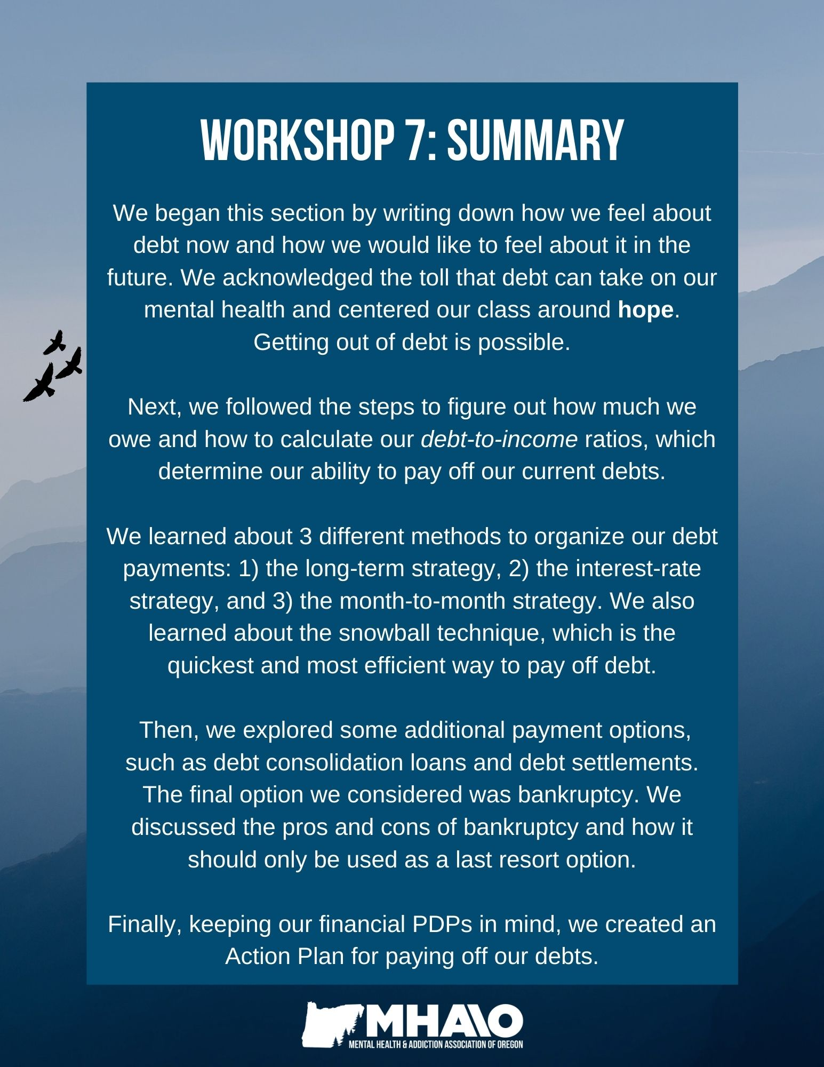
How can the topics I learned in this section be helpful for me?
Topic | N/A | How this will be helpful to me:
Thoughts on debt
Figuring out how much I owe
Debt to Income Ratio
Organizing payment methods; the Snowball Technique
Additional options for getting out of debt
How bankruptcy works; pros and cons
Creating a PDP & Action Plan for paying off debts



Workshop 8
The Relationships between Mental Health, Money & Poverty
As discussed in Workshop 1, there is a reciprocal link between mental health issues and financial issues. A person’s mental health issues may affect their financial situation in a number of ways. For example:
- If your ability to work is affected, you may experience a sudden drop in your income.
- If you are depressed, you may find it difficult to keep up with incoming bills.
- If you experience manic feelings, you may deplete your savings by spending more money than you can afford to, or you may accumulate a great deal of debt.
Likewise, a person’s financial situation may affect their mental health issues in a number of ways. For example:
- If you have accumulated a lot of debt, you may feel hopeless about your situation.
- Living in poverty can cause continual stress.
- Having your money controlled by a representative payee can cause you to feel powerless.
Additionally, sometimes treatment for mental health issues can lead to financial problems:
- Hospitalizations can not only interfere with a person’s ability to access their personal finances while hospitalized, but the bills afterward can be overwhelming.
- Some psychiatric medications can cause memory problems, which make it difficult to keep up with finances.
- Blurred vision, shaky hands, or slowed movements caused by some medications can make signing checks or using ATMs or debit cards difficult.
- If psychiatric medications cause lethargy, a person may have difficulty with motivation to keep up with personal finances.
Poverty can have a significant impact on a person’s mental and emotional well-being. Numerous studies indicate a correlation between mental health issues and poverty. For example:
- The lower the socioeconomic status of an individual is, the higher the risk of mental illness (Hudson, 2005).
- Major depression occurs more frequently among people of lower socioeconomic status (Gilman et al, 2002).
- Lower income children are 1.86 times more likely to report an emotional or nervous condition in adult life, and lower income boys ages 7-8 are 3.2 times more likely to (Fan, 2001).
- Low-income, uninsured populations had a higher prevalence of 1 or more psychiatric disorders (51% vs. 28%): mood disorders (33% vs. 16%), anxiety disorders (36% vs. 11%), alcohol use disorders (17% vs. 7%), and eating disorders (10% vs. 7%) (Mauksch, 2001).
- Higher unemployment, poverty, and lack of housing affordability in poorer communities account for more than half of community differences in psychiatric hospitalization rates (Hudson, 2005).
- The prevalence of serious mental illness is highest among those with the lowest family income level (less than $20,000) at 16.3% and lowest among those with the highest income level ($75,000 or more) at 6.4% (SAMHSA, 2002).
- The serious mental illness rate is higher among persons who were unemployed or had "other" employment status (i.e., not in the labor force) (14.2% and 15.5%, respectively) than among persons who worked full time (7.9%) (SAMHSA, 2002).

Groups experiencing structural barriers to economic mobility often experience discrimination in their daily lives. Discrimination because of one’s class, gender, sexuality, race/ethnicity, ability, nationality, religion, and more can take a serious toll on a person’s mental health and well-being. Research has shown that discrimination exacerbates stress and can lead to mental health challenges like anxiety, depression, and PTSD. Experiencing discrimination and racism can be extremely stressful and traumatic. Racism is a form of interpersonal trauma.

BIPOC communities continue to experience structural barriers to behavioral health services, including biases and a lack of cultural competency among mental health and addiction recovery service providers. There are culturally-specific and responsive mental health practitioners who can understand the intersections between financial insecurity, discrimination, and behavioral health challenges and provide support from a lens of understanding and similar lived experiences.
Financial Costs of Substance Use Addiction
Many people do not realize the true cost of addiction because it can be such a slow drain on a person’s finances, career, relationships, and quality of life. Although it is impossible to put a dollar amount on the total cost of addiction, living with an addiction can be expensive. The economic side effects of addiction can impact a person’s financial health for many years due to several factors, including:
Money Spent: The actual cost of buying substances adds up fast. The following information is based on an inexpensive six-pack of beer. Other forms of alcohol can cost significantly more.
Six Pack of Beer Purchased Weekly: | Weekly Cost: | Monthly Cost: | Annual Cost: | Cost in 10 Years: | Cost in 20 Years:
One | $5.79 | $23.16 | $277.92 | $2,779.20 | $5,558.40
Two | $11.58 | $46.32 | $555.84 | $5,558.40 | $11,116.80
Three | $17.37 | $69.48 | $833.76 | $8,337.60 | $16,675.20

Loss of Productivity: Substance use dependency is associated with increased absenteeism from work, fewer promotions, and increased risk of unemployment. In this way, addiction can lead to lower incomes, job loss, and greater financial stress.

Lifestyle Changes: The time spent buying and using drugs, recuperating from drug use, and repeating this cycle of substance dependency could be spent on other aspects of a person’s life. For example, learning new skills to increase job opportunities, exercising to take better care of one’s health, or simply spending quality time with friends and family. Addiction can change one’s lifestyle significantly and cost a person valuable time.

Illness: Drug and alcohol dependency can often result in illness, increased risk of injury, and/or higher medical bills that are either directly or indirectly related to addiction. Substance use disorders can also result in long-term loss of earning capacity due to illness, disability, and/or medical costs.

Insurance: A person who is struggling with addiction may have to pay more for car insurance or health insurance. The average person struggling with an addiction is charged with 1.4 DUIs, which can result in increased car insurance rates (up to 300%), if not outright cancellation. DUIs can also lead to the suspension of a person’s driver's license, which can make it difficult to apply for a job or loan or open a bank account. Comorbidity, illness, and injury caused by intoxication further increase the cost of insurance, which can leave an individual and/or their family more susceptible to higher medical bills.

Legal Bills: DUI’s, arrest warrants and other legal problems may occur when a person is battling an addiction. These costs can add up significantly over time.

Loss of Earned Income: Substance use issues are strongly correlated with dropping out of high school or college, which can create a lifelong loss of earned income. In addition, Social Security and retirement benefits are correlated to earned income, so the loss of annual earnings can impact retirement and public benefits.

General Money Problems: Late bills, higher interest rates, and bad credit scores are also common problems when a person is struggling with a substance use disorder. These types of financial problems can occur when money that could go toward paying bills or debts goes toward buying the addictive substance instead. Accidents and higher insurance rates can also increase expenses and affect a person’s chances of buying a car or qualifying for a mortgage. Not only does this hurt the person suffering from the addiction, it can impact the lives of partners, parents, siblings, and children for years to come.

Note: Addiction can pose a real threat to a person’s financial future. The sooner treatment begins, the better the chance for success. Early intervention reduces the risk of illness, injury, increased legal and insurance rates, and can allow for the completion of educational, professional, and personal goals. The cost of treatment amounts to very little in the big picture. When the total impact is calculated, treatment costs often add up to only a few weeks or months of the cost of the addiction.

Financial Costs of Gambling Addictions
The most obvious costs of problem gambling are the expenses associated with gambling activities, such as sports betting, online gambling, lotteries, horse tracks, and casinos. Other economic side effects of problem gambling can include:
Increased Debt: Compulsive gambling results in a destructive “snowball effect” on finances. The average person receiving treatment for compulsive gambling is over $30,000 in debt from gambling activities alone.
Many individuals who gamble max-out their credit cards and open up new lines of credit in order to fund their gambling. This increased debt frequently results in ruined credit, because anytime a person opens up a new credit card or charges it to more than 30% of its limit, their credit drops as a result. If a person has multiple lines of credit that are maxed out, they probably will also have difficulty making minimum payments. People struggling with gambling addictions frequently use money set aside for bills and paying off debts on gambling.
Higher Chance of Bankruptcy and Foreclosure: Individuals struggling with gambling addictions have a much higher chance of filing for bankruptcy. In Ontario, an estimated 20% of people with gambling addictions file for bankruptcy, while the overall bankruptcy rate is just 0.4%. People who struggle with compulsive gambling are also more likely to default on their mortgages and foreclose on their homes.
Recovery Costs: People who struggle with gambling addictions and decide to seek treatment can face thousands of dollars in recovery costs, from outpatient treatment with a counselor to the higher costs of an inpatient treatment facility. Yet without treatment, people struggling with compulsive gambling are more likely to relapse. Gambling recovery costs are much less in the bigger picture than the costs of not receiving treatment.
If you think you have lost control over your gambling or have developed an addiction, you can contact local resources for gambling addiction or call Gamblers Anonymous at 1-888-GA-HELPS. To find help and resources in your state for problem gambling recovery, visit: https://www.ncpgambling.org/help-treatment/help-by-state/
Physical Health & Financial Issues
The Effect of Financial Issues on Physical Health: In addition to our mental health, our physical health can also be adversely impacted by economic insecurity and financial stress. People with higher debt-related stress can be more likely to experience a number of health issues, such as being:
- More than 13 times more likely than low- to no-stress people to lose sleep at night
- More than seven times as likely to have severe anxiety
- Nearly seven times as likely to take stress out on others
- Nearly six times as likely to experience severe depression
- Four times as likely to have ulcers or other digestive problems
- Twice as likely to have heart problems and migraines
Chronic financial stress has been linked to frequent headaches and migraines, stomachaches, heart disease, diabetes, insomnia, and more. Constant stress and anxiety put the body in survival mode, not allowing the body to recover, which weakens the ability of our immune systems to fight off infection.
The Effect of Physical Health Issues on Finances: Physical health issues can also lead to financial problems by affecting one’s ability to work for periods of time or leading to large medical bills. Being uninsured or not having the savings to pay for routine or emergency medical costs can be extremely stressful. It can also delay much-needed medical care and lead to worse health outcomes and higher costs in the long-run. A key to financial stability is adequate health insurance. Many individuals and families with low incomes qualify for free health insurance, including mental health care, through Medicaid.
Note: Many states offer reduced or no-cost health insurance coverage for lower-income people and their families through Medicaid. Sign up for the Oregon Health Plan if you have not already at: https://one.oregon.gov/
Planning ahead: Although you cannot plan for every possibility, creating a plan for potential health problems is a good idea. If you can, start saving up money in a savings account that you set aside specifically for emergencies. If you are able to and your job allows it, keep a good amount of paid time off saved up in case of illness. There are also insurance plans designed to assist during times of short-term disability or medical crises. Some insurance plans have benefits that pay for lost or reduced wages, medical bills, and other costs that go beyond your general health insurance.
Tips for Reducing Financial Stress:
- Find additional sources of income and set aside that money for bills, paying off debts, or put it in a savings account.
- Follow your personalized budget and make adjustments when needed. Cut expenses where you can.
- Organize your debts. Create and follow a personalized debt-reduction plan, such as the Action Plan you created and debt-payoff techniques you learned in Workshop Seven.
- Write down and organize the aspects of your finances that cause you stress, and brainstorm ways to address them. Reach out to trusted friends, family members, or mentors for assistance in brainstorming solutions.
- Practice stress-reduction strategies, such as meditation, yoga, deep breathing, physical exercise, eating nutritious foods, and getting enough sleep. Follow some of the mindfulness and self-care strategies you learned in Workshop One.
- Seek support from your family, friends, mentors, counselor, partner, etc.
- Make time to relax and have fun. Get creative with low-cost, budget-friendly leisure and entertainment activities.
Note: Economic insecurity and mental health and/or addiction challenges are intertwined and impact one another. By taking this financial empowerment course, you are already taking important steps towards reducing financial stress and taking care of your mental and financial health and well-being. By getting our finances in order and taking care of our mental and physical health, we can reduce the impact money-related stress has on our mental and physical health and improve our overall well-being.

Creating a Financial Crisis Plan
Step 1: Before beginning your financial crisis plan, it can be helpful to first identify the ways in which your mental health is affected by your current financial issues or stressors. After this, identify the ways in which your finances are affected by your mental health, physical health, addiction/ substance use, and/or treatment issues.
How Financial Issues Affect Me | Never | Rarely | Sometimes | Often
I experience anxiety.
My sleep is interrupted.
I feel hopeless.
I can’t purchase needed medication or access services.
I can’t buy the things I want.
I do without necessities.
I feel ashamed.
I worry about my future.
My relationship with my partner is strained.
I dread (or avoid) opening mail or answering the phone.
I feel out of control with my spending.
I have to work more than I would like just to pay my bills.
I can’t go out with my friends or take a vacation.
I feel powerless over my finances.
How My Mental Health, Addiction, Treatment, and/or Physical Health Issues Affect My Finances | Never | Rarely | Sometimes | Often
Important bills don’t get paid on time.
I go on spending sprees.
I spend money I can’t really afford on unnecessary things.
I avoid opening my mail.
I have a hard time writing and signing checks.
I have a hard time using ATMs or debit card machines.
I let my finances go unchecked.
I can’t physically access my finances.
I lose important financial documents.
I stop caring about keeping a budget and start making poor financial choices.
I sabotage my own financial situation.

Step 2: Once you have identified how your mental health, addiction, substance use, and/or physical health issues impact your finances, you can begin to create a Financial Crisis Plan that will work for your needs.
My Financial Crisis Plan:
When I do this (or experience this): | I will do this:
Rather than doing this: | I will do this instead:

An Example of a Completed Plan:
When I do this (or experience this): | I will do this:
My medication makes it hard for me to read the fine print on contracts and bills. | I will have a friend help me read my bills and contracts.
When I get depressed, I stop caring about my finances. | My friend will support me while I write checks for my bills.
When I am hospitalized, I can’t access my finances. | My friend will bring my billing statements, my checkbook, and stamps to me in the hospital.
Rather than doing this: | I will do this instead:
I lose my bills in piles of paperwork throughout my apartment. | I will keep my unpaid billing statements in one place where I can easily find them.
I avoid opening my mail. | I will have my friend sit with me twice a week while I open my mail.
Step 3: Another tool that may be helpful for you is to make a list of all your expenses and when their payments are due. This is slightly different from a budget, in that it is meant to be a reminder for expenses only.
This is something you can also share with a friend, family member, or mentor who you’ve asked to help you in times of financial crisis. If you decide to use this tool, it’s a good idea to keep it with your other important financial items, like your checkbook and bank statements. For your financial safety, you may decide to give your friend an edited copy of this form without your account information.

My Payment Tracking Plan:
Company Name: | Account Information: | Payment Method: | Due:
Power Company | 123456789 | Automatic bill pay with my debit card | 5th of the month

Identifying Someone to Support You
It might be helpful to identify someone you trust to assist you during times of crisis, such as during hospitalizations or altered mental states. This could be a family member, a trusted friend, or a mentor. If you decide to have someone assist you with your finances, you should keep these things in mind:
- Is this someone you know well and trust?
- How reliable is this person?
- How much assistance do you think you will need?
- How will you let this person know what you need from them?
Keep in Mind: The more information your support person has about your finances, the greater your risk of fraud or identity theft. Because of this, it is vital that the person you choose to support you is trustworthy and has your best interests in mind. If the nature of your relationship changes or if you start having reason to distrust this person, change your account information right away.
A Note about Representative Payees
The Social Security Administration (SSA) will provide benefit management services to those who receive SSI or Social Security benefits and are unable to manage these payments on their own. Generally, the SSA will look to family members or friends first to serve as representative payees, and then to people from qualified organizations.
If you have a representative payee, keep in mind that you have the right to view your financial records. Your payee controls ONLY the money you receive from SSI or SSD benefits (unless you have entered into an additional arrangement).
Your payee may not control wages you earn beyond Social Security benefits, but they are required to report changes in your income to the Social Security Administration (SSA). If you suspect your payee is misusing your funds, report your suspicions to the SSA right away.
For more information on your rights, visit https://www.droregon.org/financial-protection

Relationship Issues & Financial Issues
One of the most common issues that can cause problems in relationships is money. In fact, the #1 contributing factor that leads to divorce is financial issues. Financial issues can cause problems in many relationships, from romantic partners to friends and family members. We tend not to talk about money with those we are closest to. When we do, the conversation can often become emotionally charged and we may end up in a fight or the issue may go unresolved.
Some common money-related issues that can occur in a relationships include:
- Different thoughts about spending and saving
- The complications of sharing accounts and expenses
- An inequality of money
People may not share important information about their finances with their partner, such as debts or spending habits, which can create division in a relationship over time. Another common difficulty in relationships is having different or conflicting thoughts and opinions about money and how to spend it. When one person prefers to live frugally and on a strict budget and the other person is comfortable spending money as soon as it’s available, this can lead to resentment and distrust. Economic inequality in a relationship (when one person earns significantly more than the other) can also cause resentment in both partners.
For all of the reasons outlined above, it is important to have open communication about money in a relationship. Set aside a block of time each month to talk about finances with your partner or family members. This will enable you to budget and plan together and get support from your partner, friends or family if you are struggling financially.
Although these issues seem to be centered on finances, the underlying problems in relationships are often less about money and more about a lack of communication and an unequal division of power or control. It’s a good idea to recognize this and to approach these issues as a united front.

What are some ways in which financial stress and issues around money have affected your relationships?
Tips for Communicating about Financial Issues Effectively with Your Partner:
- Before you talk about money, explore what you both need that you are not currently getting from your partner. Examples could be time and attention, reassurance that you will be OK, emotional support, appreciation, space for yourself, acceptance, or recognition for your accomplishments.
- Discuss these needs using sentences beginning with "I" that do not blame or criticize.
  - "I think it would help if I had 30 minutes to myself when I come home."
  - "I want to be part of our financial decisions even if I seem to be afraid or avoiding it."
  - "I'm assuming that you don't want to connect with me when you are on the computer."
  - "I'd like us to get away from these problems, just the two of us, at least once a week."
- Admit to your partner what you are afraid of or worried about and focus on what would make you feel better. Examples include: 1) sharing the burden, 2) transparency with information about the problem, 3) encouragement when things are tough, 4) or getting outside help.
- Since there will never be a day without relationship problems or financial stress, don't wait for that. Connect now. Remember what brings you joy in your relationship and make time to do those things, whether it’s taking a walk, working on a project together, time spent alone together, or time shared with family.
- Talk about money. When you are ready to be honest with yourself and each other, have the conversation – it can be difficult but it is worth it for your mental health and the health of your relationship. Keep emotions separate and don't put blame on one another. Look at the numbers and accept your share of the responsibility whether that is spending, being under-employed, procrastinating payments, etc. Get help, read about healthy financial habits (like taking this course!), and work together to make a change gradually over time.
Financial Abuse
What is Financial Abuse?
Financial abuse, or economic abuse, involves controlling a person’s ability to acquire, use, and keep financial resources. Economic abuse is very common in abusive relationships and is often the first sign of domestic abuse and violence. Financial abuse may be accompanied by other types of abuse in a relationship, or it may stand alone as a form of control and manipulation.
Financial abuse can include preventing the survivor from working, restricting or stealing money, and manipulation and intimidation of the person being abused. The goal of the abuser is to gain and maintain power and control in the relationship.
Financial abuse is a powerful way of trapping someone in an abusive relationship. Survivors often cite economic insecurity for themselves or their children as a reason for not escaping an abusive relationship sooner.
Warning Signs of Financial Abuse:
- Your name is not on the household checking account or on joint purchases like car loans, mortgages, cell phone plans, or apartment leases.
- Your partner is trying to control your use of, or access to, money you earned or saved.
- Your partner is using your money, assets, or credit cards without permission.
- Your partner requires you to bail them out of financial crises.
- Your partner demands you give them your paycheck, credit card, and account passwords.
- Your partner criticizes your job, pressures you to quit, or harasses you at work.
- You cannot buy the things you need (medications, feminine hygiene products, necessary toiletries), while your partner always seems to have what they need.
- Your partner spends your Social Security money. This is illegal. Your Social Security check is intended for your use only.
- Shared credit cards are always maxed out. If your partner never allows you to pay down the credit card, this may be a way of keeping you in the relationship by limiting your options to move out.
- You are not allowed any money for your own recreational use. Your partner has money to be spent on fun and you do not.
- You are not allowed to purchase a car, even with your own money. This keeps you isolated, away from family and friends, and reduces your independence.
- You are discouraged from seeking career or job opportunities that can earn you more money. This is to keep you financially dependent on your partner.
- You must account for every penny you spend.
- Your partner criticizes the financial decisions you make.
- Your partner controls all of the household finances
If you suspect you are being abused financially, reach out to someone – a friend, family member, co-worker, counselor or other expert. If you don’t feel that you have someone in your life you can trust with this kind of information, you can contact a local domestic abuse hotline or the National Domestic Violence Hotline at 1-800-799-SAFE (7233).
Resources for Getting Out of an Abusive Relationship:
- For more information on financial abuse, visit: https://nnedv.org/content/about-financial-abuse/
- For information on financial questions when leaving an abusive relationship, visit: https://www.womenslaw.org/about-abuse/forms-abuse/financial-abuse/financial-matters-when-leaving-abusive-relationship
- For FAQs about financial abuse, and additional information on planning ways out of an abusive relationship, visit: https://www.womenshealth.gov/relationships-and-safety/other-types/financial-abuse
- For how get out of a financially abusive relationship and repair your financial situation, visit:https://www.joinonelove.org/learn/keep-these-5-resources-on-financial-abuse-bookmarked/
- For help and support, visit The National Domestic Violence Support Hotline: https://www.thehotline.org/
- For information on safety planning, visit: https://www.bwss.org/resources/economic-empowerment-strategies-for-women/understanding-financial-abuse-safety-planning/
- For a guide on how to recognize financial abuse and how survivors of domestic violence can rebuild their finances, visit: https://vawnet.org/material/hope-power-your-personal-finances-rebuilding-guide-following-domestic-violence
- To find shelters and advocacy organizations in Oregon, visit: https://www.ocadsv.org/find-help
- In Portland, Oregon, Raphael House has survivor-led, peer-support services for domestic abuse survivors who are also experiencing addiction. For more information on their programs, services, and resources, visit: https://raphaelhouse.com/supportive-services/ https://raphaelhouse.com/get-help/
- In Portland, Oregon, Bradley Angle is another safe space for any survivor of domestic violence, providing a 24 crisis line, emergency shelters, support groups, and more. For more information, visit: https://bradleyangle.org/get-help/emergency-services/

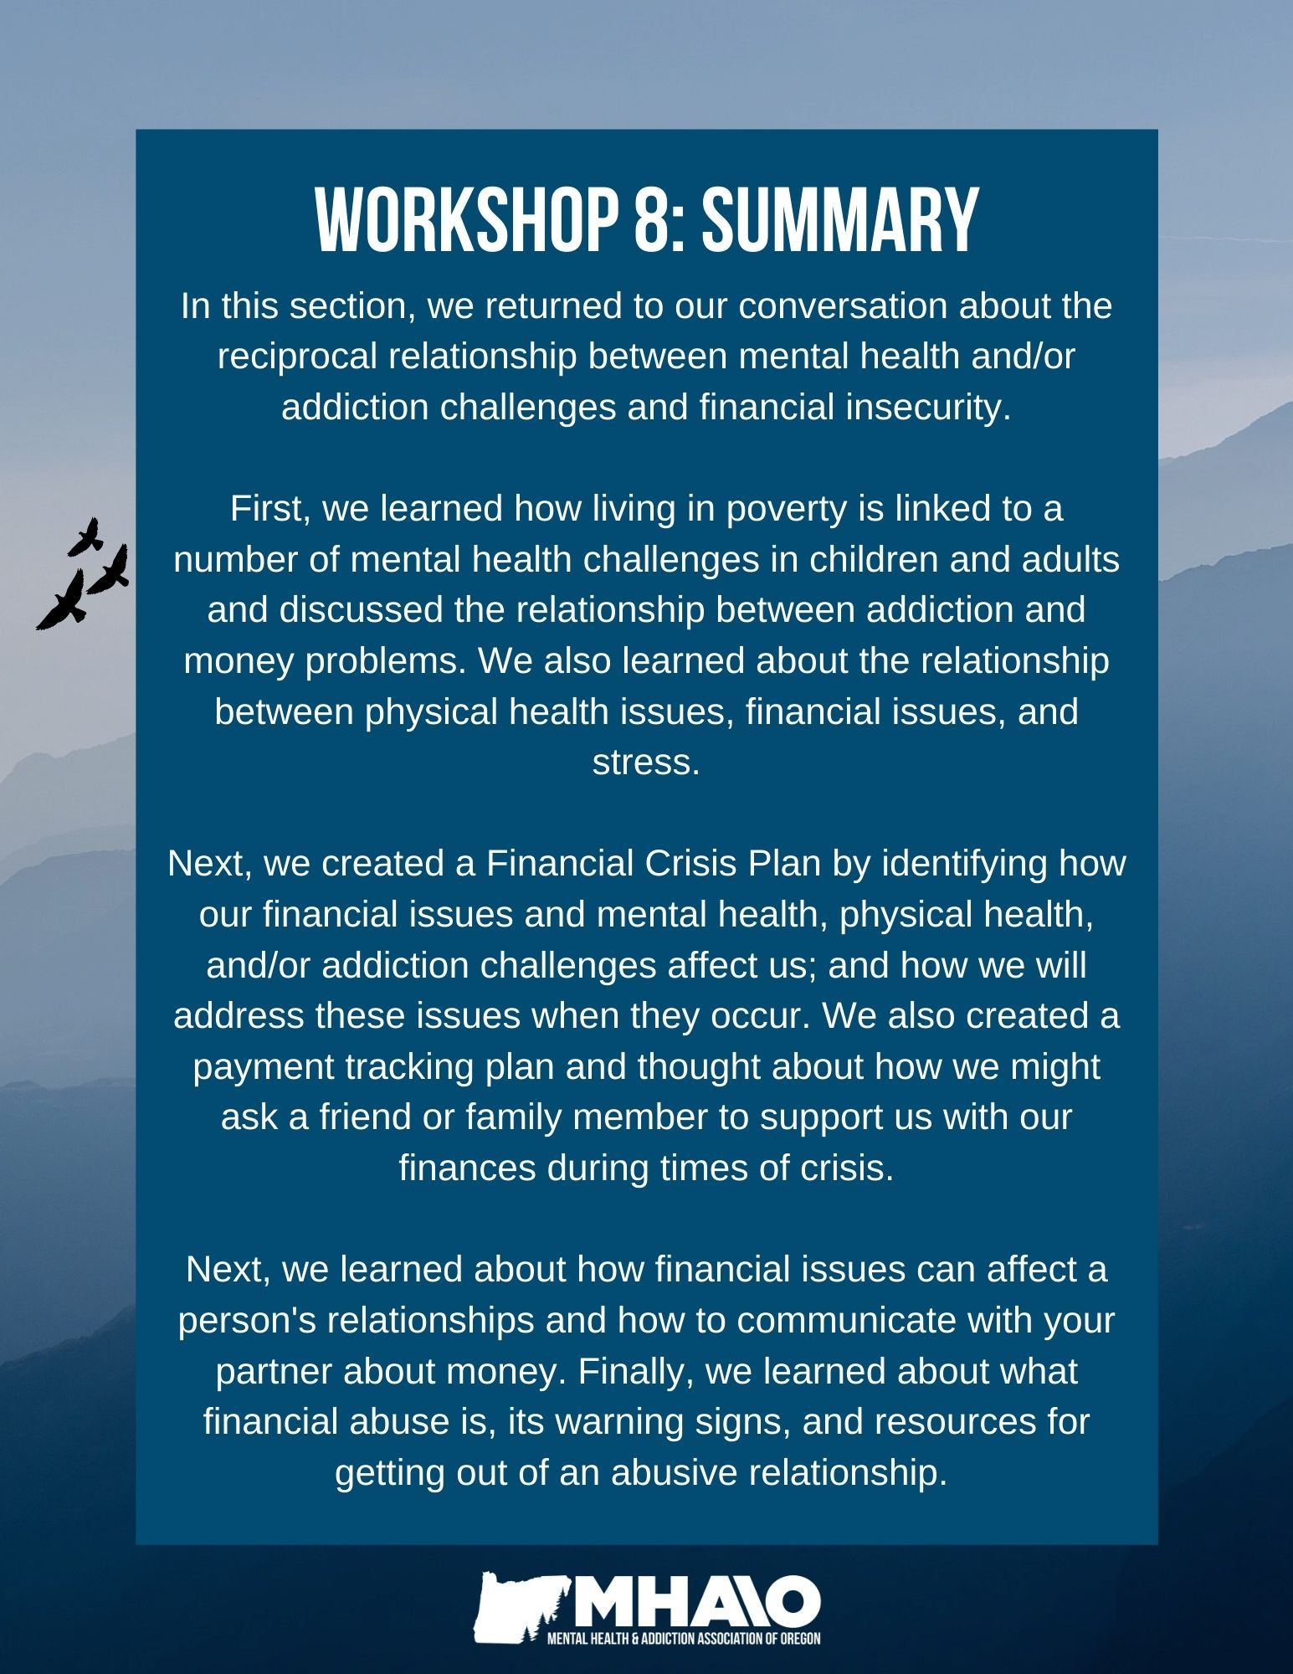
How can the topics I learned in this section be helpful for me?
Topic | N/A | How this will be helpful to me:
The relationship between money issues, poverty & mental health challenges
The financial costs of addiction & problem gambling
Financial issues & physical health issues
Creating a Financial Crisis Plan; tracking expenses; identifying someone to help
Relationship issues & financial issues
Financial abuse: warning signs & resources



Workshop 9
Taxes & Mental Health
Taxes are mandatory contributions from citizens collected by their local, state, and federal governments to fund government spending on public services.
Filing your state and federal income tax returns can be stressful and confusing, especially for first-time taxpayers, people who have had negative experiences with filing taxes in the past, and people with lived experience of mental health and/or addiction challenges. The thought of taxes or tax season may bring about feelings of shame, confusion, anxiety, or guilt.
The following section is designed to address some of the stress and negative emotions that can be associated with taxes, and provide you with tools and resources to file your tax returns easily and take care of your mental health.
What, if any, has your experience been with filing and paying taxes? How have taxes affected your mental health?
Taxes Basics
Why do we pay taxes?
We pay taxes because federal and state governments need revenue to support infrastructure and public services. State and federal tax systems are also called revenue systems, because they pay for the building blocks of our communities.
Tax revenue pays for national and local government services such as building and repairing roads, highways, and bridges, and funding schools, libraries and parks. In the United States, most of our federal income tax dollars go towards Social Security, health programs like Medicare and Medicaid, the defense budget, interest on the national debt, and other social safety net programs such as SNAP benefits, school meals, and housing and childcare assistance. One study suggested that federal social safety net programs kept 37 million Americans out of poverty in 2018.
There are three categories of taxes:
- Taxes that apply to consumption: sales tax for goods and services.
- Taxes that apply to what people earn: income and payroll taxes.
- Taxes that apply to what people own: property and estate taxes.
We will be focusing on income and payroll taxes in this section.
State & Federal Taxes
Federal income taxes are collected by the federal government each year to pay for various government programs, while state taxes are collected by certain state governments to fund state-specific services and bills.
Taxes vary by state: some states have flat tax systems (all income levels are taxed at the same rate), some have progressive tax systems (different income brackets are taxed at different rates, with higher incomes being taxed more), and some do not have a state income tax at all. Federal income taxes are progressive.
A progressive tax system is considered the most fair, because it is proportional to an individual or family’s income. A progressive tax system asks more proportionately of the rich than it does of the poor. The opposite of a progressive system is a regressive system, in which the average tax burden decreases instead of increases with income, causing low-income taxpayers to pay more relative to their income.
Taxpayers must file a Federal Income Tax return and a State Income Tax Return for the state(s) they earned income in. You may also have to pay taxes to your local municipality.
Oregon’s Tax System
Oregon’s state budget is funded by tax dollars. Nearly all of this money goes towards funding education, human services, and public safety. The biggest source of funding for Oregon’s budget is the personal income tax.
The other primary sources of funding are property taxes (the main way local governments pay for services like libraries, parks, and education), unemployment insurance tax (which provides benefits for workers who have lost their job), excise taxes (sales taxes on specific goods such as gas, cigarettes, and alcohol), and the corporate income tax.
Oregon has a progressive tax system. However, when state and local taxes are added up, the system appears not progressive but regressive – asking more of lower-income Oregonians. For example, in previous tax years, the bottom 20% of earners in Oregon paid on average 12% of their income, while the richest 1% paid only 8% of their income. For this reason and many others, the tax system in Oregon – and across the country – reflects and perpetuates inequities and is in need of reform.

Common Tax Forms
Form 1040: The form you use each year for filing your personal Federal Income Tax Return. A 1040 form calculates your total taxable income and determines how much should be paid to or refunded by the government. You can fill out and return this form online or by mail.
W-2 Form: If you received $600 or more from an employer as their employee, you will receive a W-2 form in the mail. This form shows how much your employer paid you and how much they withheld from your paychecks for income, Social Security, and Medicare taxes. The amount withheld from your wages are called payroll taxes.
W-4 Form: When you begin a new job, you usually have to fill out a W-4 form, which helps your employer determine your withholding status (for State and Federal income tax and contributions to Social Security and Medicare). A W-4 form also requires you to disclose your filing status, number of dependents, and whether you work multiple jobs.
On your W-4, you also indicate how many allowances you would like to claim (how much money you would like withheld from your paycheck). The more allowances you claim, the less income tax will be withheld from your paycheck.
The number of withholdings or allowances that you select does not impact how much you will owe in taxes - only the amount that will be deducted from your paycheck each pay period. Come tax time, you will be responsible for paying the full amount of taxes that you owe based on your circumstances.
The number of allowances you claim is based on your marital status, job status, earned income, and child care expenses.

Common Tax Terms
The Internal Revenue Service (IRS): the American federal government revenue service that is responsible for collecting taxes and administering the Internal Revenue Code.
Tax liability: The payment owed by an individual or business to a federal, state, or local tax authority. Income taxes, sales tax, and capital gains tax are all forms of tax liabilities. For our purposes, we will focus on income taxes. When a person earns a high-enough income, they are subject to income taxes, which most Americans pay to the IRS every April in the form of a tax liability. An individual can lower their tax liability by claiming deductions and credits.
Filing Status: There are 5 different filing statuses for the federal tax return: 1) single, 2) married filing jointly, 3) head of household, 4) married filing separately, and 5) qualified widow/widower with a dependent child. Your filing status depends on a number of criteria and determines the forms you need to fill out and the filing requirements, credits, deductions, exemptions, and tax rates you are subject to.
Deductions: Deductions reduce your tax obligation by lowering your gross income (the sum of all wages, tips, and other earnings before taxes).
When filling out their federal tax return, taxpayers can choose to take the standard deduction or itemize their deductions. A standard deduction depends on a person’s filing status, age, and income. Itemized deductions are a variety of expenses the taxpayer has incurred over the year, such as charitable contributions, daycare costs, medical bills, tuition, local taxes, real estate taxes, and more. Both types of deductions reduce the amount of your income subject to taxes.
Taxable Income: Your gross income (total income) minus deductions.
Earned Income: Taxable income you make from the employer that you work for, or from a business you run. Sometimes disability benefits count as earned.
Credits: A reduction in the amount of taxes you pay. For example, if you owe $5,000 in taxes but qualify for a $1,000 tax credit, then your tax liability (the total amount of tax you owe the government), will lower to $4,000. Some credits are refundable, which means you get money back even when the credit is more than the tax you owe, while others are nonrefundable and only refund your money up to the amount of taxes you owe.
Earned Income Tax Credit (EITC): Refundable credit that can lower your tax bill. If you have a lower-income, you may qualify for this credit, which can often result in a refund. To claim this credit, you need to file a federal income tax return and meet specific criteria.
To qualify for EITC, you must:
- Show proof of earned income
- Have investment income below $3650 for the tax year you are filing for
- Have a valid Social Security number
- File as married filing jointly, head of household, qualifying widow(er), or single
- Be a U.S. citizen or a foreign national living in the U.S. for at least 6 months of the year you’re filing for with a valid Social Security number
Note: Military members, Clergy members, and taxpayers with disabilities and/or relatives with disabilities have special qualifications for EITC.
Dependent: A child, relative, or other individual who a taxpayer can claim on their federal income tax return to receive an exemption. The IRS defines a dependent as either a qualifying child (under age 19 or under 24 if a full-time student) or qualifying relative (sibling, parent) who makes less than $4,300 a year. A dependent may have a job, but you must provide more than half of their annual support in order to claim them as a dependent.
Child Tax Credit: By claiming a child under 17 as a dependent on your tax return, you are eligible for child tax credit, which can reduce the amount of taxes you owe by $1000. In 2021, the maximum child tax credit was raised to $3,600 for qualifying children age 6 and under and $3,000 for qualifying children 6-17.

Tax-Exempt: Income or transactions that are free from federal, state, or local taxes. Many organizations are tax-exempt, such as charities, universities, and nonprofits. Tax exemptions for individuals were the ability to exclude a certain amount of income from taxation. Before 2018, taxpayers could exclude $4,050 off their income from personal exemptions, but personal exemptions are no longer accepted. To reduce your tax liability, deductions and credits must be applied instead.

Self-Employment Tax: If you work for someone else, your employer will generally calculate and deduct your payroll taxes from your wages for you; when you work for yourself, you have to do this for yourself. Self-employment taxes are the portion of your self-employment income you contribute to Social Security and Medicare.

Amended Return: If you realize after filing your tax return that you made a mistake, you can submit an amended tax return to the IRS with the form 1040X. However, you don’t need to submit this form if you did the math wrong (the IRS will adjust that) or forgot a form (the IRS will contact you).

The IRS allows you to file an amended return to correct your filing status, your gross income, the number of dependents you claim, or to increase or decrease the number of deductions and credits you claimed on your original tax return.

Payroll: If you work for an employer, they are required to withhold taxes from your paycheck. When you file a state or federal income tax return, you will receive money back if you overpaid these payroll taxes. Alternatively, you will owe the government money if you underpaid your payroll taxes.
What taxes are withheld from my paycheck?
- Federal income tax (varies by income)
- State income tax, 9%
- Social Security tax, 6.2%
- Medicare, 1.45%
- Maybe additional local/state taxes
- Additional items: health insurance premiums, retirement plan contributions, union dues, child support, court orders
How to File an Income Tax Return
Step 1: Decide how you will file. Before you begin the process of filing your federal and state income tax returns, decide how you would like to file. You can 1) print the forms off the IRS website and mail them to the IRS office, 2) file online using the e-file forms on the IRS website or a guided tax preparation website, or 3) hire a tax professional to file for you.
Step 2: Gather forms. If you’ve decided to file yourself, you will begin by gathering the required documents. First, you will need IRS Form 1040, which you can access on the IRS website. If you decide to use a tax preparation software (like TurboTax, H&R Block, Tax Slayer, or Tax Act), the website will provide this form for you.
Next, you will need to know how much money you made the previous year. This can be done by gathering the required tax documents, as are applicable. These may include:
- A W-2 form. This will be sent to you by your employer.
- Tax forms that report other types of income such as Form 1099 or Form 1099-INT.
- Receipts for charitable donations, medical expenses, child care expenses etc. if you are itemizing your deductions.
- If you work in the gig economy, you’ll need to report that income to the IRS by filling out and attaching a Schedule C form to your Form 1040. If you drive for ride sharing or food delivery services, you can deduct expenses like miles driven on this form.
Think about if you did anything in the last year that may impact your taxes, like changing your job, opening a savings account, selling stocks or mutual funds, or paying student loan interest or college tuition.
Step 3: Complete Form 1040. Follow the instructions on the form by the IRS, or answer the questions asked by the tax preparation software.
You will:
- Choose your filing status.
- Determine if you are claiming any dependents.
  - If you have young children or older children who you still support, you can claim them as a qualifying child or qualifying relative. If you live with your parents or if your parents pay for your education and most of your living expenses, they may be able to claim you as a dependent.
- Consider tax deductions and credits, which can lower your tax bill or increase your refund. Decide if you are taking the standard deduction or itemizing your deductions. Common tax deductions and credits for first-time filers include:
  - Standard or itemized deductions
  - Earned Income Tax Credit
  - Education credits
  - Student loan interest deduction
  - Home office deduction, if you’re self-employed
Step 4: Submit. Submit your federal (and state, if applicable) income tax return(s) online using the IRS website or tax preparation software or by mail by the deadline (mid-April).
Note: The IRS recommends E-filing using guided tax preparation websites for more accurate and efficient tax returns. These websites generally allow you to file your state and federal income tax returns at the same time, and are free if you qualify.
If you file electronically by yourself or using a guided tax assistance website, you will likely receive your tax refund back in just a few weeks.
Resources for Filing
IRS Free File
The IRS has a number of resources and partner websites that can help you file your taxes online. For example, if your income is under $72,000, you can use a website like TaxSlayer or Tax Act to file your federal and state income taxes for free. These websites will fill out your federal (and sometimes state) tax returns simply by asking you questions. They do all the math for you. All you will need is your W2 and/or 1099, your current filing status, any adjustments to your income, and if you are claiming any dependents or deductions.
It is important to note that at times, tax-filing websites may make it difficult to access or complete the free-file option. For example, companies like H&R Block and TurboTax often have free options but make it confusing to find these free services on their website, or advertise additional services throughout the process that you would have to pay for. If you decide to use a guided tax preparation website, we recommend using one of sites that partner with the IRS to provide this resource, which can be found on the IRS website.
You can access the IRS Free File website here: ​​https://apps.irs.gov/app/freeFile/
For additional support, tutorials, and tips from the IRS on how to file your federal income tax return, visit: https://apps.irs.gov/app/understandingTaxes/student/tax_tutorials.jsp
Volunteer Income Tax Assistance (VITA)
The VITA program offers free tax help for people who need assistance in preparing their own tax returns, including:
- People who make $57,000 or less per year
- People with disabilities
- Taxpayers who have limited English proficiency
Tax Counseling for the Elderly (TCE)
The TCE program offers free tax help, particularly for individuals 60 years of age or older, and specializes in questions about pensions and retirement-related issues.
VITA and TCE programs are staffed by volunteers who want to give back to their communities. These volunteers are trained and certified by the IRS, and as such, their services are reliable and trustworthy in addition to being free of charge.
To learn more about these programs or find a VITA or TCE Site near you, visit:
https://www.irs.gov/individuals/free-tax-return-preparation-for-qualifying-taxpayers

Claiming Deductions & Credits
Should you take the standard deduction or itemize your deductions? The decision will come down to the time you have available and the amount of money you hope to save.
When to Itemize: If you add up your itemized deductions and the sum is more than your standard deductions, then itemizing will save you more money.
When to Take the Standard Deduction: If your standard deduction is more than the sum or your itemized deductions, then the standard will save you more money and will be quicker than filling out the forms and providing proof of your itemized deductions. The standard deduction has increased in recent years, so it may be a better option even if you have itemized in the past.
Note: A tax advisor or tax advising software can calculate your tax return both ways to determine whether itemizing or taking the standard deduction will result in a lower tax bill or greater refund.
Common Deductions & Credits You May Qualify For:
- American Opportunity Tax Credit: You can claim the first $2,000 spent on tuition, books, and other school fees + 25% of the next $2,000, for a total of $2,500. Cannot be used for transportation or living expenses.
- Student Loan Interest Deduction: If you paid interest on your student loans, you can deduct up to $2,500 from your taxable income.
- Lifetime Learning Credit: For the first $10,000 you pay towards tuition and fees, you can claim 20%, resulting in a $2,000 maximum credit.
- Child Tax Credit: You could get $2,000- $3,600 per child or $500 for a non-child dependent.
- Child and Dependent Care Tax Credit: You can claim up to 35% of $3,000 in day care and other care-related expenses for children under 13 or other dependents such as a spouse or relative unable to care for themselves. For two or more dependents, you can claim up to 35% of $6,000 of expenses.
- Earned Income Tax Credit: If your income is less than $57,000, you could receive credit between $500 and $6,000.
- Charitable Donations Deduction: You can subtract the value of your charitable donations for the year from your taxable income.
- Medical Expenses Deduction: You can deduct certain medical expenses (unreimbursed) that are more than 7.5% of your gross income for the tax year
- Deduction for state and local taxes: You can deduct a maximum of $10,000 for combined property taxes and state/local income taxes or sales taxes
- Self-employment Expenses Deduction: If you are self-employed, there are a number of business deductions you can make
- Saver’s Credit: Depending on your filing status and income, you could take between 10% and 50% off of up to $2,000 in contributions to a 401(k), 403(b) or IRA retirement plan.
- Educator Expenses Deduction: If you’re a teacher, you can deduct up to $250 for classroom supplies.
Owing & Paying Taxes
There are a number of reasons why you might end up owing taxes:
- Withholding too little: The amount withheld from your paycheck each pay period is an estimate of what you’ll owe in taxes when it is time to file. If you overpay or “over-withhold,” you will receive a tax refund. If you do not pay enough or “under-withhold,” you’ll have to pay the IRS additional tax money.
- Filing late: If you file late and don’t get a tax extension in time, you may owe late fees and interest that will make your tax bill higher.
- Changes in tax code: New tax laws can put you in a different tax bracket, which can affect whether you get a refund or whether you owe the IRS.
- Higher income: If your income increases, so too do your taxes. If you get moved up a tax bracket due to an increase in wages, you may have to pay more in taxes than previously.
- Changes in deductions: You may owe taxes because you no longer qualify for certain credits or deductions, such as earned income credit or the child tax credit.
Payment Options
You can pay the amount of taxes you owe by sending a check in the mail to the IRS, or on the IRS website with your debit or credit card or by transferring the money directly from your bank account (direct deposit). If you don’t have the money to meet your tax obligation, you have options.
Option 1: Sign up for a payment plan with the IRS.
By setting up a payment plan on the IRS website, you can pay monthly installments of the taxes you owe as long as the entire balance is paid off within 6 years. If you decide to pursue this option, make sure you allot money for interest and penalties when calculating how much you plan to pay each month.
Option 2: Request a temporary delay in the collection process
If you are facing financial hardship and cannot pay any portion of your tax debt, you can call the IRS and request a delay of the payment date. The IRS will report your account currently not collectible and temporarily delay collection until your financial condition improves. This does not mean the debt goes away, it means the IRS has determined you cannot afford to pay at this time. Note that interest and penalties will be added on to your debt until you pay the full amount.
Option 3: Submit an Offer in Compromise
If you can’t pay your full tax liability, an offer in compromise allows you to settle your tax debt for less than the full amount you owe. The IRS generally approves an offer in compromise when the amount you offer represents the most the IRS can expect to collect within a reasonable period of time. The IRS recommends exploring all other payment options before you submit an offer in compromise.
Visit https://www.irs.gov/payments to review these options.
A last resort option is to take out a private loan to pay your tax obligation. You’ll likely pay more in interest, but a loan could allow you to pay off your tax debt by the deadline and avoid a payment plan and late fees with the IRS.

Important Things to Keep in Mind:
Tax Filing Deadline
The IRS Tax Filing Deadline, also known as Tax Day, is April 15, unless it falls on a holiday or weekend, in which case it will be the next business day. At times, the IRS may extend the filing deadline due to extenuating circumstances, such as the COVID-19 pandemic.
Tax Extensions
If you need more time to file your federal tax return, you can get an extension by sending the IRS Form 4868 by April 15. An extension will usually give you until October 15 to review and fix your tax return or have someone else do it for you. A tax professional or a tax software provider can help you identify additional deductions or credit you may have missed or weren’t aware of. If you file taxes late and do not get an extension by the deadline, you will incur a late-filing penalty: 5% of the taxes you owe for every month that your tax return is late.
The IRS will charge you a late filing penalty, a late payment penalty, and interest on the balance owed if you do not file your tax return or your extension on time or if you fail to pay your taxes on time.
Back Taxes
Back taxes are federal, state, or local taxes that have been partially or wholly unpaid the year they were due. Back taxes accumulate interest and penalties, so by not paying their taxes in a timely manner, a person can end up owing the IRS a lot of money.
Reasons for back taxes include: filing an income tax return and not paying the taxes you owe, failing to report total income earned during the tax year, or not filing a tax return at all. Not paying your back taxes can result in penalties and serious legal action. The IRS may seize a person’s property or assets to collect the total amount of money they owe. It is best to file taxes as early as you can and pay what you owe as quickly as possible in one lump sum or using a payment plan to avoid back taxes.
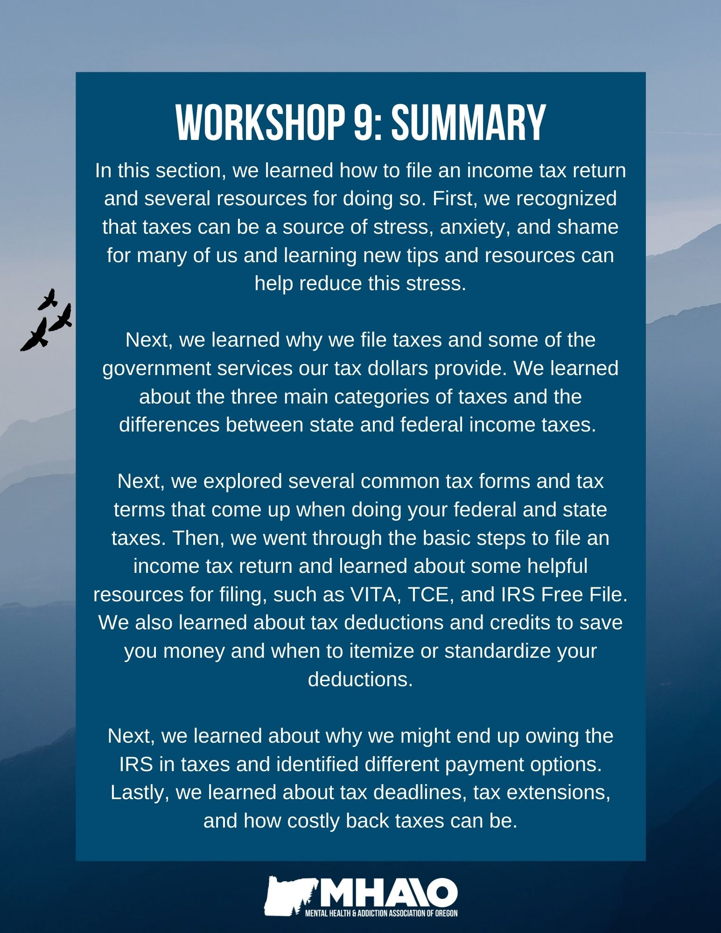
How can the topics I learned in this section be helpful for me?
Topic | N/A | How this will be helpful to me:
Why we file tax returns; the difference between state & federal taxes
Common tax forms, common tax terms
How to file a federal income tax return
Resources for filing taxes
Claiming deductions & credits
Owing & paying taxes, payment plans
Tax extensions, back taxes
“A wise person should have money in their head, but not in their heart.”
Jonathan Swift
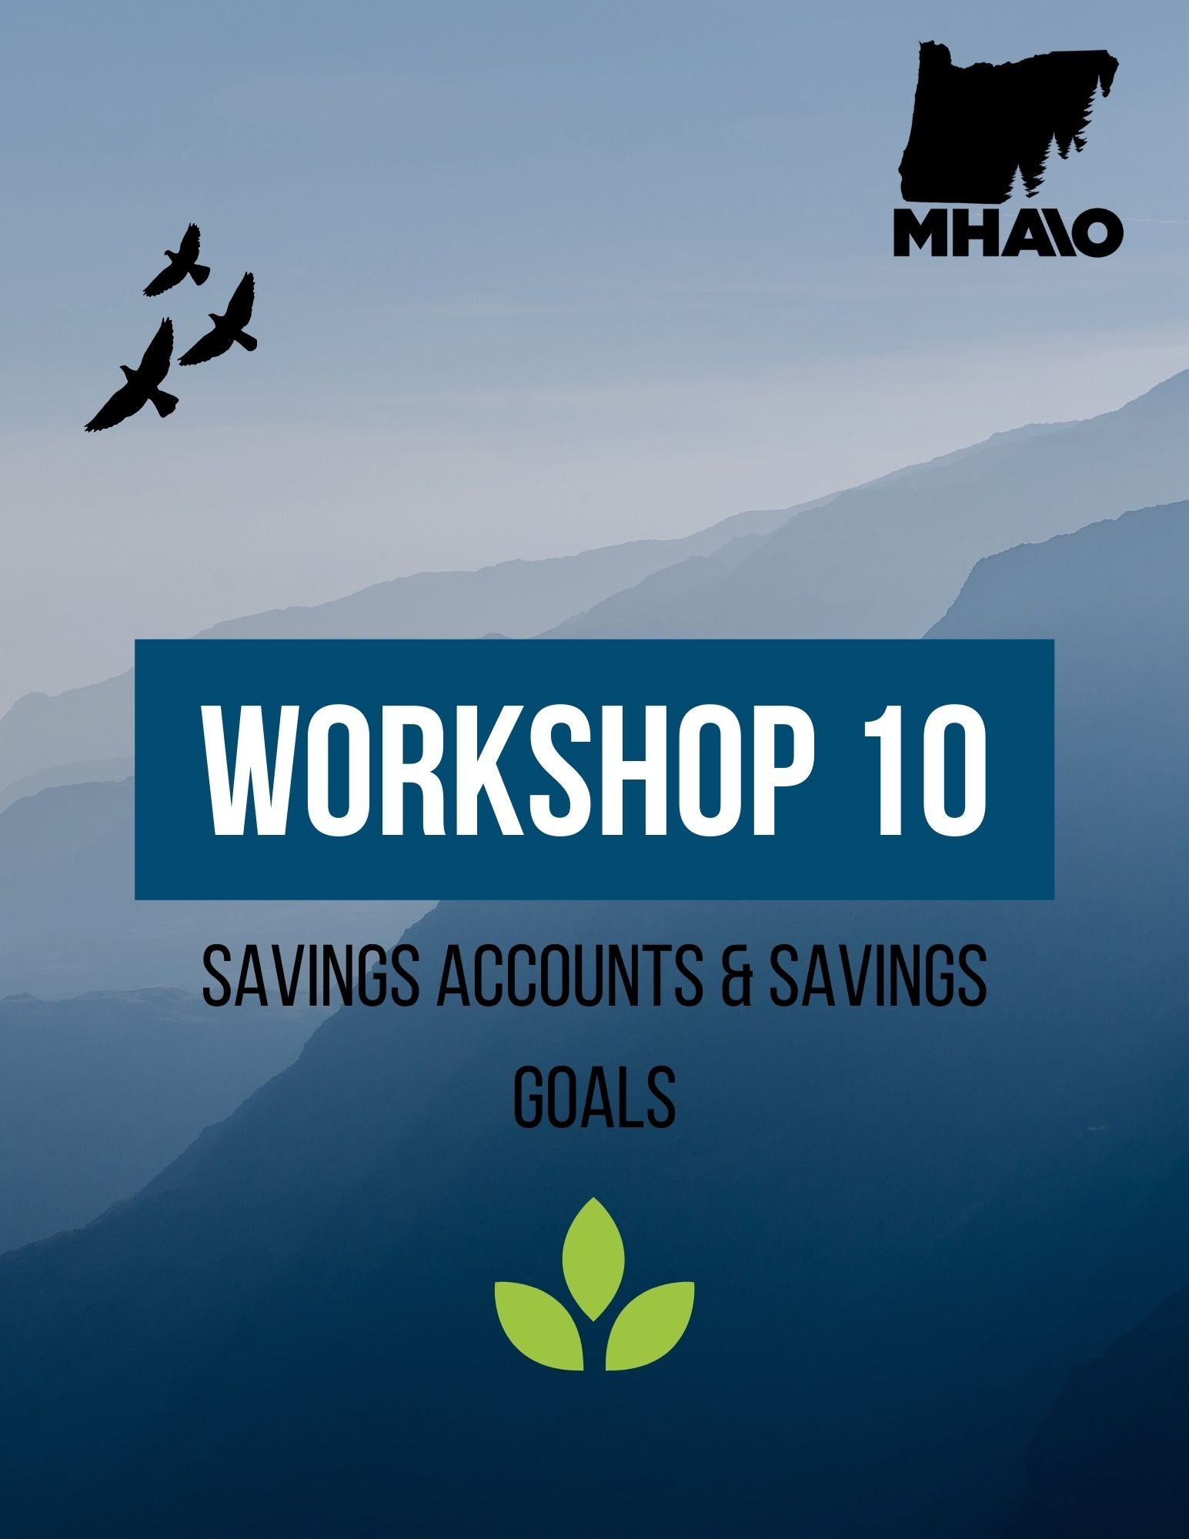
Workshop 10
Savings Accounts
The most common type of bank account, and probably the first account you'll ever have, is a savings account. Savings accounts allow you to keep your money in a safe place while it earns a small amount of interest each month. These accounts usually require a low minimum balance ($25), although some may require no minimum balance at all. This depends on the bank and the type of account.
Besides the fact that you will be less likely to spend it, putting your money in a savings account is a safer option because it is insured. In addition to insurance, banks and credit unions keep your money in a locked and fireproof safe.
Banks insure your money (up to $100,000) through the Federal Deposit Insurance Corporation (FDIC). This means that even if the bank goes out of business (which is very rare), your money will still be there. The FDIC is an independent agency of the federal government that was created in 1933 after the bank failures of the 1920s and early 1930s. Not a single person has lost money in a bank that was insured by the FDIC since then. Similarly, the National Credit Union Administration (NCUA) insures credit union accounts up to $250,000.
When you put your money into a savings account, it earns interest. Interest is money the bank pays you so that they can use your money to provide loans for other people. This does not mean you cannot have your money whenever you want it, it is simply how banks make money and how they are able to fund their loans.
It works like this:
- You open a savings account at the bank.
- The bank pays you interest on the money that you deposit and leave in that account.
- The bank then loans that money out to other people, charging a slightly higher interest rate on the loan than what they pay you for your savings account.
- The difference in interest the bank pays you vs. the interest they charge others is part of how they stay in business.
Interest on savings accounts is usually compounded daily and paid monthly. Compounded interest is the interest on a deposit that is calculated based on the original amount of money in your account (the initial principal) as well as the accumulated interest from previous periods. This accumulated interest is essentially a form of “interest on interest” that can help make an account grow faster.
The great thing about compounded interest is that your bank is paying you interest on the money they've already paid you in interest! That means that if your account earns 1% interest, then each day, 1/365th of that 1% of the amount of money you have in your savings account is then added to your total.
Daily compounding = Principal (1 + interest rate/365)365 = (daily compounded amount)
It should be noted that the interest an individual earns on their savings account is generally very little compared to interest earned on investments or very large deposits. The average interest rate is usually around 0.06%, which means you’ll likely earn just a few cents each month depending on the size of your deposit. Many online banks and credit unions offer higher interest rates on savings accounts, which means more interest earned.
Note: Savings accounts are a great way to keep your money safe, earn interest on that money, save up for bigger purchases in the future, and have a safety net or “emergency fund” in case of unexpected circumstances.

Different Types of Savings Accounts
Opening a savings account is the easiest way for people to save and earn money at the same time. It is the simplest form of investment. The following section goes through the different types of savings accounts available so you can decide which one is most suitable for you.
Regular Savings Accounts:
Regular savings accounts are great for people who plan to make monthly deposits and earn a small amount of interest at the same time. These accounts offer the greatest freedom to control your account and make as many withdrawals as you need.
Benefits: | Shortfalls:
- Easy to access  - Has low or no minimum balance  - No limits in making withdrawals  - No withdrawal charges | - Low interest rates  - Interest rates change with the market

Certificate of Deposit (CD):
Also known as “time deposits,” CDs offer the highest interest rates among saving accounts. By putting your savings in a CD for a predetermined time (anywhere from 6 months to 5 years), your money accumulates interest. Charges are applied when withdrawals are made before maturity of the account. This option is great for long-term saving but not if you need to access your savings account often to withdraw or transfer money.
Benefits: | Shortfalls:
- Offers the highest interest rates  - Fixed interest rates | - Charges apply when withdrawals are made preterm  - Withdrawals made preterm are made with notices ahead of time

Money Market Accounts:
Money market accounts are interest-bearing savings accounts offered by traditional and online banks and credit unions. They generally offer higher interest rates than regular savings accounts but come with more restrictions.
Benefits: | Shortfalls:
- Higher interest rates  - Easy to access  - No withdrawal charges above maintaining your balance  - Check writing and debit card options | - High maintaining balance and fees if your balance drops below it  - Limited transactions  - Limited check releases  - Interest rates fluctuate with the market
ABLE Accounts
Achieving a Better Life Experience (ABLE) accounts are tax-exempt savings accounts for individuals with disabilities and their families. ABLE accounts make it possible for individuals with disabilities to save for the future without affecting their benefits.
Many individuals with disabilities and their families are enrolled in a variety of public benefit programs to assist with income, food, housing, and health care. To be eligible for these benefits, an individual must be, and remain, poor. ABLE accounts recognize the extra, significant costs of living with a disability (such as finding accessible housing and transportation or raising a child with disabilities). As such, individuals and their families who qualify can establish an ABLE savings account that will not affect their eligibility for public assistance like SSI and Medicaid.
If you have a qualifying disability that began before you turned 26, you may be eligible for an ABLE savings account. To determine eligibility and open an account in Oregon, visit: https://www.oregonablesavings.com/ and to learn more about ABLE accounts, visit: https://www.ablenrc.org/

Types of Retirement Plans
Employer-provided:
There are several types of employer-provided retirement savings plans, in which employees contribute some of their salary to retirement. The most common are 401(k) plans, 403(b) plans, and pensions. All of these plans provide for the saving of pretax dollars into a tax-deferred account, which becomes fully taxable upon retirement. 401(k) retirement plans are employee benefits and can only be obtained through an employer. If you have a low-income and are contributing to a 401(k) plan, you may qualify for the Saver’s Credit when you file your income taxes. Visit the IRS website for eligibility requirements.
Individual Retirement Arrangements (IRAs):
IRAs are popular retirement savings options, especially if your employer does not provide you with a retirement account. IRAs are savings accounts with tax advantages that a person can use for long-term savings and investments. Anyone with earned income can open an IRA account, which can be done through banks, brokers, or investment companies. Some IRAs are owned by individuals, such as Traditional IRAs and Roth IRAs, while others function similar to a 401(k). Examples of employer-provided IRAs are the SEP IRA and SIMPLE IRA.
Traditional IRAs are called “tax-deferred” accounts. Contributions to a traditional IRA are made using pretax dollars and can be tax deductible (they can lower your tax bill for the years leading up to retirement). When you start withdrawing from these funds at retirement, you will have to pay taxes on these funds. With Roth IRAs, an individual pays an initial tax on their contribution. Contributions are made in after-tax dollars, meaning you pay the taxes up front and afterwards can withdraw your contributions at any time without tax or penalty. These accounts do not reduce your tax bill for the year you made contributions, instead the tax benefit comes at retirement.
Deferred Annuities:
A deferred annuity is a life insurance contract in which an individual pays one-time or recurring deposits to a bank or insurance company and in exchange, they provide the individual with incremental payments (essentially income) when the person retires.
Deferred annuities are purchased during a person’s working years and are used to save for retirement on a tax-deferred basis. Similar to a Traditional IRA or 401(k), your savings are not taxed until you retire and begin receiving payments. It is recommended that people make maximum contributions to employer-sponsored plans and IRAs before utilizing annuities for retirement.
Time Frame: All funds put into the accounts mentioned above are accessible when the investor turns 59 and 1/2. With the exception of Roth IRAs, a 10% IRS penalty typically occurs if the accounts are accessed before that age. In the case of Roth accounts, direct contributions can be withdrawn at any time without penalty or tax because the money has already been taxed.
Investments:
Within any of the accounts mentioned above, investors will typically purchase a number of investments, typically in stocks, bonds, real estate, cash, or commodities.
- Stocks (equities) are shares of ownership in a company and can be risky because the money that was invested moves with the market.
- Bonds are a loan issued by a company or government, and can be safer than stocks but still risky because their value fluctuates with interest rates.
- Mutual funds consist of a basket of assets (stocks, bonds, and cash equivalents), which is less risky than investing in just stocks or just bonds.
Note: A savings account or a CD is the safest investment you can make. When beginning to save for future purchases, retirement, or other financial goals, it is best to begin with safe investments so that you can grow your money safely and securely, without the possibility of losing money from changes to the stock market or interest rates.

Tips to Start Saving for Retirement: Start saving early to take advantage of compounding interest. Contribute to your 401(k) or open an IRA, and automate your retirement contributions so you don’t have to think about saving. Don’t put money you might need for the future into risky investments.
Asset Building
Asset building is a way for individuals, families, and communities to gather a variety of resources to help them move towards greater economic well-being in the short and long term. Asset building emphasizes the importance of helping individuals and families learn about and utilize healthy money management and budgeting practices to address current financial issues and set themselves up for financial stability and success in the future.
Asset building strategies include:
- Financial education
- Savings accounts
- Healthy management of credit and debit
- Tax credits and assistance with filing taxes
- Accessing federal and state resources
- Individual Development Accounts
Utilizing these different strategies and resources can help individuals and families address current financial challenges and build their financial resilience and human capital. An example of asset-building resources by state and federal government agencies are first-time homeowner’s benefits, such as closing cost matches, down payment assistance, or the Oregon Homeowner Assistance Fund. Another example is Oregon’s College Savings Plan, where parents can create college savings accounts for their children with an initial deposit of just $25. With these accounts, earnings grow tax-free, interest savings are compounded, and parents can claim a state income tax credit of up to $300.
For more information about homeowners’ benefits and the Oregon College Savings Plan, visit:
- https://oregonhomeownerassistance.org/
- https://www.oregon.gov/ohcs/homeownership/Pages/housing-counseling.aspx
- https://www.oregoncollegesavings.com/
Traditional assets, such as financial assets (cash, stocks, bonds, retirement accounts, CDs), physical assets (homes, cars, land, personal valuables) are also included in asset building activities. However, sound money management and financial resilience are most important to our understanding of asset building.
Individual Development Accounts
Individual Development Accounts (IDAs) are unique savings accounts that match the deposits of lower income people and families for asset-building purposes. For every dollar saved in an IDA, savers receive a corresponding match, which serves as both a reward and incentive to further the saving habit. Savers agree to complete financial education classes and use their savings for an asset-building purpose – typically for post-secondary education, job training, home purchase, or to fund the creation or maintenance of a small business. In addition to earning match dollars, individuals or families learn about budgeting and saving and receive additional training before they purchase an asset. IDAs make it possible for lower-income individuals and families to build the financial assets they need to achieve their financial goals.
How Do IDAs Work? IDAs are offered through partnerships between financial institutions (such as banks and credit unions) and local nonprofit organizations or program sponsors. The IDA program sponsor organization recruits participants for the program and provides financial education classes and additional training based on the participant’s asset choice. For example, training might include counseling and education for first-time homeowners, small business training, or guidance on choosing and enrolling in post-secondary education or job training programs.
After signing up for the IDA program, each participant opens a savings account with the partnering bank or credit union. The financial institution handles all transactions to and from the IDA, just as they do with other types of accounts. IDA account holders receive regular statements detailing how much they have saved and the amount of matched savings they have earned.
Time-frame & Withdrawal: An IDA program can be as short as six months or as long as several years from beginning to end. IDA participants are allowed to withdraw their money as soon as they have reached their savings goal, but they must first get approval from their IDA program sponsor. Some participants choose to use their funds toward one large savings goal, such as buying a home, while others choose to make withdrawals for a number of smaller, related goals, such as purchasing a computer and textbooks or paying for their college tuition.
Benefits of IDAs:
- IDAs have shown to be highly effective at improving savings and asset building for lower-income families.
- These services can help individuals and families build skills, further their education, and have the opportunity to purchase a home or start a business they would not have been able to do otherwise.
- IDAs can be a key tool in helping individuals and families out of extreme poverty or cycles of poverty.
Limitations of IDAs:
- Families with severe credit issues may not qualify for loans to help their situation, even with IDA assistance.
- IDA matching programs require a lot of money for every family served, so the reach of who receives an IDA from a bank or nonprofit can be limited.
To learn more about IDAs and find a local service provider, visit: https://www.oregonidainitiative.org/
Habitat for Humanity: Another resource for asset-building and homeownership is Habitat for Humanity. In their Sweat Equity concept, future homeowners work alongside volunteers to build their home or another family’s home. Homeowners can also participate in homeownership classes, clear debris from build sites, thank donors and make lunch for volunteers as forms of sweat equity. For more information, visit: https://www.habitat.org/stories/what-is-sweat-equity
Economic Empowerment
Empowerment is the ability, knowledge, and power to make an informed decision for oneself. Economic empowerment is the feeling when you know you are in control of your money instead of your money being in control of you.
Ways to achieve economic empowerment:
- Invest your time and energy in learning the fundamentals of personal finance.
- Review your expenses and look for unnecessary spending. Prioritize necessities when shopping, learn to live within your means, and think before you spend.
- Know the impact of interest on your loans and/or debts
- Make savings a priority. Begin saving for retirement and to build an emergency fund or financial cushion early on.

Dreaming Big With Minimal Resources:
Dreaming up a savings goal: What would you do if you had the money to buy what you really want? What’s something you have been wanting or needing for some time, but haven’t had the money to buy? What are some small, achievable purchases that will be useful to you or bring you joy?
Revisit the “Financial Dream” and “Life One Year from Now” sections of your Person-Directed Plan and think about one or two goals from your PDP that require you to save money.
Money Saving Ideas: Throughout the course, you have been committing to one money saving idea each week. Estimate the amount of money you are able to save each month using each of these tips. Only calculate the tips you are actually using.
Money Saving Tip | Money Saved Each Month
Using my SNAP card at the supermarket and farmers market. | $ 200
Cooking at home and making my own coffee instead of going out. | $ 100
 | $
 | $
 | $
 | $
 | $
 | $
 | $
 | $
 | $
 | $
Monthly Total: | $
How much can I expect to save after six months? | $
How much can I expect to save in one year? | $
It is important to note that there are other reasons to save money beyond specific goals. Knowing that you have money set aside for emergencies or a temporary drop in income can alleviate a great deal of financial stress.

Creating a Savings Plan
First, calculate how much money you will need to save in total for each savings goal. Next, figure out what your time frame is for each goal. Then, calculate how much money you will need to save each month to achieve each of these goals.
Example:
Goal: | Buy a new or gently-used bike
Timeline: | 6 months
Amount needed: | $300
How much do I need to save each month? | $50
Goal:
Timeline:
Amount needed:
How much do I need to save each month?

How to Save Money on a Limited Income
- The #1 tool at your disposal for saving money is sticking to a solid, working budget. Using the money saving goals you have established, you can recalculate your budget to reflect these savings.
- Make saving money feel like a reward. Turn every dollar saved toward your goal(s) into feeling good about yourself.
- Save your change every day. Keep it in a container in your home or car.
- Put small amounts at a time into savings. It’s usually much easier to put aside two or three dollars (or even five) than larger sums of money.
- Once it is set aside, don’t think about it, except how it applies toward your goals.
- Put any extra income you generate into savings. Now could be a great time to open a savings account if you haven’t already!
Keep in mind: your chances of success go up substantially if your savings goals are reasonable to you, if they don’t feel like punishment, and if they still allow you to keep some pleasures in life that are important to you.
Even if your resources seem limited, there are usually ways to set aside some money toward your savings goals if you commit to them. As you work toward your financial goals, you will become able to recognize what works for you and what doesn’t. Setting, and working towards, these important and achievable goals is an empowering process. You should feel proud of the work you are doing here!
“If you can imagine it, you can achieve it; if you can dream it, you can become it.”

William Arthur Ward

Congratulations!
You have made it to the end of The Mental Health & Addiction Association of Oregon’s Money Basics financial empowerment course! Thank you for your participation and engagement throughout these 10 workshops. You have done amazing work and we hope you are proud of all you have accomplished.
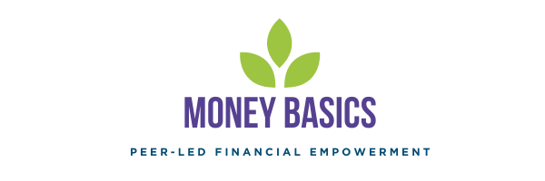We hope you found this course engaging and informative and that you can use the tools and resources you have learned to spend and save money in ways that work best for you. We also hope that the knowledge and skills learned and connections and community built in this course will help reduce feelings of stress or hopelessness you may have felt when it comes to your finances and help contribute to your own unique path to recovery, wherever you are on your journey.

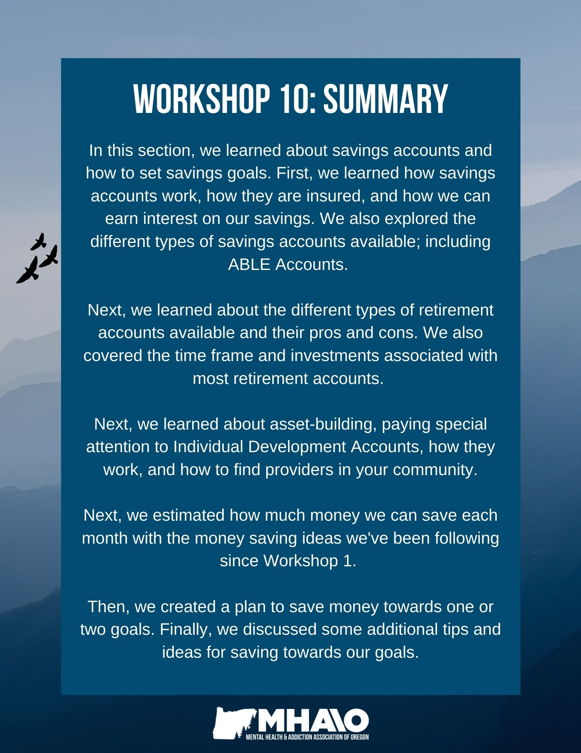
How can the topics I learned in this section be helpful for me?
Topic | N/A | How this will be helpful to me:
Different types of savings accounts, including ABLE accounts
Types of retirement plans & investments
Asset-building & Individual Development Accounts
How to save money on a limited income
Working toward a goal; planning saving in your budget

Glossary of Financial Terms

Adjustable Rate Mortgage (ARM)
A variable or adjustable-rate mortgage is a mortgage with an interest rate that the lender can increase or decrease from time to time, depending on changes to an outside standard (such as the prime rate, the interest rate on United States Treasury securities, or the rate of inflation).
Traditional, fixed-rate mortgages have an agreed-upon interest rate that stays the same for the entire duration of the loan, whereas an adjustable-rate mortgage allows the lender to increase or decrease the interest rate at specified intervals based on changing market conditions. The lender often begins the loan with a very low interest rate, then raises the rate as time goes on.
Annuities
An annuity is an insurance contract that can provide you with a predictable, steady stream of income during retirement. It works like this: you pay a lump-sum or monthly payment to a bank, insurance company, or investment broker, and when you retire they will pay you back in regular income payments. By making these payments now, you will have income to live off of in the future when you retire.
Annuities are complex life insurance contracts with fees, costs, terms, and features that can vary widely. Because of this, make sure to shop around, compare contracts and companies, and understand how the annuity works, what fees and charges you will pay, and all the terms and conditions before signing a contract.

Annual Percentage Rate (APR)
APR is the interest rate for a whole year, rather than each month, applied on a loan, mortgage, or credit card, or earned by an investment. Financial institutions must always disclose the APR before any agreement is signed.
In the context of credit cards, APR is the periodic rate (usually monthly) multiplied by the number of periods in a year. For example, a 1.5% monthly rate has an APR of 18% (1.5% a month multiplied by 12 months). In the context of consumer lending, the APR takes into account more than the interest rate applied to the principal per period.
Annual Percentage Yield (APY)
The Annual Percentage Yield (APY) is the true rate of return of an investment in one year, taking into account the effect of compounding interest. Because of this, a loan’s APY is higher than its APR. Unlike simple interest, compounding interest is calculated periodically and immediately added to the balance, making the account balance and interest paid on the account balance get a little bigger after each period.
Assets
Assets are objects of value that a person or organization owns that can be used for the payments of debts. For a company, this may be investments, cash, or property; whereas for a person or family, assets are often one’s car, home, land, savings accounts or retirement funds, or personal investments.
Attributes, such as special skills and higher education, may also be included as assets. When we think of asset-building, we are thinking of building useful qualities and skills, such as learning new money management skills and resources.

Automated Teller Machine (ATM)
A terminal that allows you to withdraw money from your checking or savings account, to check your balance, to make transfers from accounts, or to make deposits. ATMs allow you to complete basic transactions without the help of a teller. Nearly all ATMs allow anyone with a debit card to withdraw cash.
Balance Inquiry
Consumers can determine their available account balance using their bank’s website, smartphone app, or by calling a teller. You can also check your balance at most ATMs, although out-of-network ATMs might require a balance inquiry fee.
Balloon Payment
An oversized payment due at the end of a loan. In a balloon loan, the entire loan amount was not fully amortized, so the remaining balance is due in full in the final payment. Amortized loans are loans with scheduled, periodic payments applied to both the loan’s principal and its accrued interest.
Balloon loans are usually set-up for a relatively short term, in which the borrower enjoys smaller payments for most of the loan’s life until they are required to pay a very large amount, often at least twice the amount of the previous payments, at the end of the loan’s term.
Bankruptcy

A legal process in which a person or business is unable to pay off their debts, so the court decides whether or not – and how – to forgive their debts and repay their creditors (often by seizing some of their assets). In a bankruptcy case, all of the debtor’s assets are evaluated and some are usually used to pay the creditors.

There are two kinds of bankruptcy: involuntary (the creditors petition to have a debtor judged by a court) and voluntary (the debtor brings the petition). In both cases, the objective is an orderly and equitable settlement of debt obligations. Voluntary bankruptcy is more common, as it can sometimes be the only option for individuals to be free from their debts.
Bonds
A bond is a debt-security that is similar to an IOU. When you buy a bond, you are lending money to a corporation, municipality, or government (the issuer). In return, the issuer pays you a specified interest rate during the life of the bond, and will eventually repay the principal amount when the bond “matures.”

Bonds vary widely in maturity, security, and type of issuer, although most are sold in $1,000 denominations or, if a municipal bond, $5,000 denominations.

Budget
A budget is an estimate of income and expenses over a specified period of time. Budgets can be made for individuals, families, businesses, and governments. For individuals and families, personalized budgets act as a plan to track and control spending and encourage saving.
Capital Gains Tax
Capital gains are the profits made – when the sale price is higher than the initial purchase price – from the sale of an asset (stocks, bonds, a business, a piece of land). Capital gains are considered taxable income, and as such, the capital gains tax takes a percentage of the realized capital gain (the profits once the asset is sold). An unrealized capital gain is an asset that has increased in value, but has not yet been sold. For most assets held for over a year, capital gains taxes are either 0%, 15% or 20%.
Capitalization
Capitalization applies to federal student loans. When interest is capitalized, the unpaid interest on your student loan account is added to the initial student loan balance, increasing the amount you have to pay back. Not only does your loan balance become larger, you’ll pay interest on top of that capitalized interest.
Certificate of Deposit (CD)
A type of savings account in which your bank holds your money for a certain period of time and in exchange, pays you interest, guaranteeing the same rate of return (interest) for the entire period. When you take your money out of the CD, you receive your initial investment, plus interest. CDs usually require a minimum deposit and charge penalty fees for early withdrawal.

Certified Check
A certified check is a personal check for which your bank has verified is legitimate and has guaranteed payment. When a check is certified, it becomes an obligation of the bank, and the funds are immediately withdrawn from the account. With a certified check, the recipient knows the bank has verified the check, signature, and available funds.

Check Hold
When you deposit a check, your bank may delay crediting the funds to your account during the check hold period. It is a temporary hold that usually lasts between 1 and 5 business days, depending on the size of the deposit.
Charge-Off
If a loan or credit card is deemed "uncollectable,” it may be charged-off. This means the lender or creditor has written off the account as a loss, and has closed the account to future charges. The account may then be transferred to a collection agency or sold to a debt buyer. The individual with the credit card or loan payment is still required to pay off the debt, however now their payments go to the agency or debt buyer.

Accounts can be charged-off when an individual has fallen behind on their loan or credit card payments, and being charged-off will have a very negative affect on your credit report and credit score.
Chapter 7
Chapter 7, also called “liquidation bankruptcy,” is the most common type of bankruptcy in the United States. It requires an individual or a company to liquidate their assets in order to pay off their creditors. Individuals are allowed to keep certain assets, called “exempt property.”
Chapter 11
Chapter 11 allows a bankrupt company to remain in business while its owners attempt to pay off its debts. The company does not have to sell all of its assets, and instead is given the chance to come out of bankruptcy and become a healthy business.
Chapter 13
Chapter 13 allows an individual who has regular income to develop a payment plan for their debts (either a part of or all of their debts). This enables the individual to repay creditors over an extended period of time, and usually allows the person to retain their property.
Collateral
An asset (such as a car or a piece of property) that a person uses to take out a loan, promising to give the asset to the lender if loan payments cannot be met. Collateral is accepted as security for the loan, acting as a form of protection for the lender in case the borrower does not keep up with their payments.
Compounding
Compound interest is interest you earn based on your balance plus the interest that your money has already accrued. It is essentially earning “interest on top of interest” and will make your account grow at a quicker rate than simple interest. Many types of savings accounts compound yearly or quarterly.

Co-Signer
A person, other than the principal borrower, who also signs for a loan (oftentimes a parent, partner, or friend). The co-signer(s) promises to pay back the loan if the borrower does not.

Credit
An agreement – defined in a contract – between a borrower and a lender, in which the borrower receives money and promises to repay the lender this money, plus interest, at a later date. Credit is the ability for a person to obtain goods or services before actually paying for them by borrowing from the lender, based on trust that they will pay the lender back in the future.

Credit History
A record of an individual’s payment history on current and previous debt, which shows their ability, and responsibility, when it comes to repaying debts. A person’s credit history is recorded in their credit report.

If you make payments on time and do not acquire an excessive amount of debt, your credit history is likely to be good. Good credit history makes it more likely that potential creditors will lend to you and enables you to have better loan choices, lower interest rates, and access to opening up new lines of credit.

If a person has a bad credit history (history of late or missed payments, not being able to meet the terms of the credit agreement/loan), then they are likely to encounter low credit limits, high interest rates, security deposits, difficulty in getting a loan or credit card; and increased car insurance premiums.

Credit Rating
A measurement of a person or business’s ability to repay a lender, based on their income and credit history. Credit ratings are usually expressed as a credit score, and are assigned by the three major credit bureaus.

Debit Card
A card that allows a person to deduct money directly from their checking account to make purchases. Debit cards allow you to pay for goods and services or to withdraw cash from an ATM or store. Even if a debit card has a credit card logo, it does not function as a credit card (where a person borrows the money from their credit card company to make a purchase and pays them back later).

Debt
Money borrowed from, and owed to, an individual, company, bank, or other organization. Debt arrangements allow the borrower to use borrowed money under the condition that it will be paid back in the future, usually with interest. Credit card balances, student loans, mortgage loans, and medical bills are examples of common debts.

Debt-to-Income Ratio
A percentage number that compares your total monthly payments on your debts to your monthly income. This number is one way for lenders to measure your ability to manage monthly debt payments, and is a way for individuals to identify whether their current debts are becoming difficult to pay off with their current income.

Default
When a borrower fails to repay a debt – including the principal or interest – on a loan,
credit card, or security. A default on a loan can occur when a borrower misses payments, is unable to make payments on time, or stops making payments altogether.
Deferment
A temporary postponement on repaying federal student loans. Deferment allows you to temporarily stop making payments on your student loans, though with some student loans you may have to pay interest during the deferment period. There are a number of categories of deferment a person may be eligible for, including unemployment deferment or economic hardship deferment.
Delinquency
Failure to make timely payments on a debt, such as a loan or a credit card. Delinquency often leads to default.
Diversification
A method of balancing investment risk by mixing a wide variety of investments, such as stocks, bonds, real estate, and cash equivalents (Treasury bills, CDs), in one portfolio. The idea is that by investing in a variety of assets instead of just one, positive investment performances will balance out any negative performances, reducing risk.
Dividend
A portion of a company’s profits that is paid to its shareholders (individuals who own share(s) of stock in a company). These earnings are usually paid out in cash, though sometimes they are paid in the form of additional shares of stock.
Equity
In investment terms, equity is the ownership of an asset (a car, home, investment portfolio, etc.) after its associated debts are paid off. It is the value of the asset minus its liabilities. In corporate finance, equity represents the amount of money that would be returned to shareholders if all of a company’s assets were liquidated and all of its debts were paid off.
Fair Credit Reporting Act
A federal law that protects consumers from false or deceptive credit reporting. The law regulates the way the three credit reporting bureaus collect, use, and share the data in your credit report.
FDIC
The Federal Deposit Insurance Corporation (FDIC) is an agency created by Congress to maintain stability, safety, and confidence in the United States’ banks. The FDIC insures your deposits (generally up to $250,000 per account), meaning even if your bank closes, you will not lose your money.

Similarly, your money kept in non-profit credit unions is insured by the National Credit Union Share Insurance Fund (NCUSIF), which is also backed by the US Government.
Federal Student Loans
Student loans that are made by the federal government, in which the borrower repays the money they used for school, plus interest, back to the United States government. Federal student loans are usually offered after you apply for financial aid. These loans have a fixed interest rate, as well as deferment and forbearance options. There are different loan types whether you are an undergraduate or graduate student.
Finance Charge
A fee charged for the use of credit (or the extension of existing credit) that enables lenders to make a profit from lending their money to borrowers. The most common type of finance charge is interest rates. For credit services like loans, mortgages, and credit cards, finance charges have known ranges (like APR) and depend on a person’s credit history.
Financial Literacy

The possession of knowledge and skills to effectively manage financial resources, with the goal of life-long economic well-being. Financial literacy involves educating individuals about economics and finances, usually with the goal of assisting low-income families in their efforts to become financially resilient and self-sufficient.
Fixed Rate
A predetermined and specified interest rate applied to the principal that stays the same during the life of a loan. Loans with fixed interest rates provide payment stability.

Forbearance
A temporary postponement or reduction of student loan payments or mortgage payments. This doesn’t mean your payments owed are forgiven – it is just a pause or reduction that you may qualify for in times of financial struggle.

Home Equity
The difference between what you owe on your mortgage and what your home is currently worth (or what you get when you sell it). As you pay down your mortgage, your equity in your home will rise. If you decide to sell your home, you can use the equity you've built (the profit made) as a down payment for another home. However, there may be complex tax implications with this, such as capital gains tax.

Individual Development Account (IDA)

A savings account and asset-building strategy for low-income individuals and families. The funds put into an IDA are matched by a public or private organization to promote savings and future spending on educational purposes, starting a business, or homeownership.

IDAs are accompanied by programs for credit improvement and other financial literacy classes to help account holders get out of poverty. Studies have shown the success of IDAs in helping individuals become homeowners, which is the primary way lower-income families can build wealth.
Individual Retirement Account (IRA)
A tax-advantaged investment account, usually set up through a financial services company or bank, that helps you save for retirement.
Inflation
The rate of increase in the prices of goods and services over a given time period, usually a year. Inflation measures how much more expensive goods and services have become over a year, which influences the cost of living for consumers.
Installment Loan
A loan in which you receive a lump-sum payment and pay it back in equal parts over a period of time. Banks and credit unions, as well as online lenders, offer installment loans. The best installment loans have low interest rates and affordable monthly payments.
Interest
For loans and credit cards, interest is the additional amount you will pay to a lending institution to borrow money. It is the money a lender or financial institution receives for lending out money.

In terms of savings, interest is the additional amount you will earn for having your money in a savings account, CD, or other savings vehicle.

Simple Interest
Simple interest is interest paid only on the "principal" – the amount originally borrowed – and not on the interest owed on the loan.

Compound Interest
Compound interest is interest calculated not only on the principal but also on the interest that has accrued, or built up, at the time of the calculation. It is essentially “interest on interest.” Compound interest – where the borrower pays even more interest – is more common than simple interest. It is beneficial when the bank borrowing your money pays compounded interest on your savings account, and is not beneficial when you’re the one paying compounded interest on a loan. Compound interest can earn you money in savings or investment accounts but not on loan or debt payments.
Interest Rate
Interest rates can refer to a percentage of the principal (the amount loaned) that the lender charges the borrower as well as the percentage a savings account or CD has earned at a bank or credit union. APR typically refers to the interest rate on a loan, and APY typically refers to the interest rate for savings accounts. Interest rates depend on whether they’re for savings accounts, retirement accounts, and investments, or loans, mortgage payments, or debts.
Low interest rates make it cheaper to borrow money and are intended to boost economic activity and growth. The Federal Reserve usually lowers interest rates when the economy is struggling. Low interest rates usually means lower returns on savings accounts and investments, and the possibility of increased debt when interest rates rise again. High interest rates typically means the economy is doing well, though they can discourage big purchases, such as a house.
Liability
A liability is something an individual or company owes someone else, usually an amount of money that is paid off over time. Liabilities include loans, mortgages, and other debts. Liability refers to being responsible for something, thus it can apply not only to company and individual loans and debt payments but to taxes as well. When you owe the government money in taxes, you are liable (responsible) to pay it.

Lien
A creditor's claim or legal right against an asset – usually property – which may entitle the creditor to seize and sell the property if a debt is not repaid. Liens act as collateral to ensure a debt is repaid.
Maturity
The agreed-upon date when a loan, bond, or other investment option becomes due for payment to investors or creditors.
Minimum Payment
The minimum monthly payment required on a credit card or loan. For credit cards, this is typically 2% of your balance (changes month to month). Credit card companies will send you your minimum payment amount in your monthly bill.
Money Market Accounts
A type of savings account that tends to offer higher interest rates than basic savings accounts as well as check writing and debit card options. However they tend to have more restrictions than regular savings accounts and lower rates of return than other savings vehicles (e.g. bonds, mutual funds).

Mortgage
A loan used for the purchase of a house, property, or other real estate. Borrowers pay lenders back over time (usually many years) at regular intervals that include payments on the initial amount and interest accumulated. The property itself serves as collateral for the loan. Mortgages enable individuals, families, and businesses to buy property without needing to pay for the entire purchase up-front.
Mutual Funds
A mutual fund is a pool of money (fund) run by a professional or group of professionals who have experience in picking investments (a mutual fund company). Mutual fund investors pool the money from numerous investors and invest the funds in a variety of securities, such as stocks and bonds, to generate income for investors. Mutual funds are an example of diversified investment portfolios, which are thought to be less risky investments. Mutual funds can be a profitable investment but like all investments, there is the possibility of losing some or all of the money you invested.

Net Worth
The total wealth of an individual, household, or company, based on the value of all their financial assets and liabilities. Net worth is the difference between a person or company’s total assets and total liabilities (the value of total assets minus total liabilities).

Overdraft
Overdraft occurs when a person withdraws money when there isn’t enough in their account to cover it and the bank allows the transaction to go through anyway. For example, if an account holder has $1,000 in the account and withdraws $1,200, there is an overdraft of $200. The overdraft acts like a loan – the bank allows the customer to keep using their account, even with insufficient funds, but the customer will likely have to pay interest on the loan and a steep penalty fee ($35 or more).
Prime Rate
Prime rate is the lowest interest rate on bank loans, offered to preferred borrowers. It is the rate commercial banks charge their most “creditworthy” customers. Interest rates for personal loans, small business loans, and mortgages are based around the prime rate. The prime interest rate is determined by the federal funds rate (the overnight interest rate banks use to lend to one another) and most important prime rate is published daily by The Wall Street Journal.
Principal
The principal is the unpaid balance on a loan, not including interest. All loans begin as a principal (the initial amount) and accrue interest over time.
Promissory Note
A loan document that the lender and borrower both sign that indicates a promise to repay a loan under agreed-upon terms. Promissory notes typically contain the terms of the debt, such as the principal, interest rate, and the date the loan was issued and the date it will mature. Although some banks issue promissory notes, they are more common with other lenders and enable any individual or company to become a lender.
Rate of Return
The Rate of Return (ROR) or Return on Investment (ROI) is a percentage figure that measures how money grows in an investment. ROR is the total gain or loss of an investment from the beginning to the end of a specified period.
Rule of 72
The rule of 72 is a trick to calculate how much money you can earn from the interest on an investment. It is a simple way to calculate how long it will take your investment to double at a specified rate of return. To calculate, divide 72 by the interest rate of your account. The result is the number of years it will take to double your investment. For example, if your account earns 4% interest, 72% divided by 4% = 18 years to double your investment.

Service Charge
A specific fee charged by a financial institution, such as an out-of-network ATM fee, a fee for falling below a minimum balance, or the fee for triggering an overdraft checking account into use. Some companies also charge service fees for specific goods or services or for using a credit or debit card.

SIMPLE IRA (Individual Retirement Account)
A Savings Incentive Match Plan for Employees (SIMPLE) IRA is a type of tax-deferred retirement savings account for employees offered by employers. An employer may match employee contributions in a SIMPLE. SIMPLE IRAs are relatively easy to set up and work best for small businesses.
Simplified Employee Pension (SEP) IRA
A Simplified Employee Pension IRA is a retirement savings account for small business employers and for self-employed people (people who have their own businesses). SEP IRAs usually have higher annual contribution limits compared to standard IRAs.
Stocks
A security that represents ownership of a portion of a corporation, which means the owner of the stock receives a fraction of the corporation’s profits and assets depending on how much stock they own. When you buy stock in a company, you share in its ownership – making you a “shareholder.” Stock is purchased in units called "shares." Your share of the company depends on how many shares of the company's stock you own. The price of a stock goes up and down, depending on how the company performs and how investors think the company will perform in the future.
Subsidized Loans
There are two types of student loans: subsidized and unsubsidized. Subsidized loans are only for undergraduate students who demonstrate financial need. With subsidized loans, the federal government pays the interest that accrues on the loan (“subsidizes” the loan) while the student is in school, during the 6-month grace period after they leave school, and during periods of deferment.
Total Cost of Borrowing
When you take out a loan, it is important to know the Total Cost of Borrowing. This will be the total monetary amount you will pay over the life of the loan and includes the principal, loan fees, and interest.
Truth in Lending Act
The Truth in Lending Act (TILA) protects consumers against unfair lending practices. Loans under TILA must provide a Disclosure Statement of all of the terms and conditions of a loan or credit agreement, including APR, the loan term, and total costs of borrowing.
Representative Payee
A family member, friend, legal guardian, or member of an organization who is appointed by a government agency, such as the Social Security Administration (SSA) or the Department of Veteran Affairs (VA), to receive and manage public benefits on behalf of someone who cannot manage them on their own.
Loan Term
A loan term is the period from when a loan is issued until it is fully paid. It is the length of time it takes for a loan to be paid off when the borrower is making regular payments.
Loan terms can also refer to the provisions specified in a loan agreement. These are the terms you review before you sign a loan contract.
401(k)
A 401(k) is an employer-sponsored retirement savings plan that is tax deferred and that employees can contribute to. Many American employers offer 401(k) plans to their employees. When you sign up for a 401(k), you agree for a percentage of your paychecks to be deposited into an investment account. Your employer might match a portion, or all, of that contribution. You can choose between different investment options (usually mutual funds) to put your money in.

Traditional 401(k) plans are pre-tax, which means that you don’t pay taxes on the funds until you withdraw them for retirement. There are also Roth 401(k) plans, in which the money is deducted from your after-tax income, so you don’t have to pay additional taxes on the funds when you withdraw them for retirement.

Saver’s Credit: If you have a low income and are contributing to a 401(k), you may qualify for the Saver’s Credit. This is a tax credit of 50%, 20% or 10% (depending on your income) of your contributions to a 401(k), 403(b), SIMPLE plan, traditional or Roth IRA, or ABLE account. For more information, visit: https://www.irs.gov/retirement-plans/plan-participant-employee/retirement-savings-contributions-savers-credit
403(b)
A 403(b) is an employer-sponsored retirement savings plan very similar to a 401(k) but offered by nonprofit (tax-exempt) and government employers. People who can receive 403(b) plans include government employees, teachers, professors, librarians, nurses, doctors, and nonprofit employees.

Original material from Peerlink National Technical Assistance Center.
Original material from Peerlink National Technical Assistance Center.
Original material from Peerlink National Technical Assistance Center.
Brandon Duncan. “Four Ways Addiction Causes Financial Trouble.” Stepworks Recovery Centers. June 2, 2017. http://www.stepworks.com/2017/06/4-ways-addiction-causes-financial-trouble/
Original material from Peerlink National Technical Assistance Center.
Elizabeth Hartney. “Money Problems and Addictive Behavior.” VeryWell Mind. January 21, 2021. https://www.verywellmind.com/do-your-money-problems-stem-from-addictive-behavior-22177
Kelsey Borresen. “16 ways to practice self-care that cost next to nothing.” The Huffington Post, February 13, 2020. https://www.huffpost.com/entry/cheap-self-care-practices-low-cost-budget_l_5e3b4ae0c5b6f1f57f0ababe
“How is poverty measured? University of Madison Wisconsin. https://www.irp.wisc.edu/resources/how-is-poverty-measured/
“What is the current poverty rate in the United States?” UC Davis Center for Poverty and Inequality Research, September 15, 2020. https://poverty.ucdavis.edu/faq/what-current-poverty-rate-united-states
Daniel Kopasker, et al.“Economic Insecurity: A socioeconomic determinant of mental health.” SSM-Population Health, vol 6, December 2018. https://www.sciencedirect.com/science/article/pii/S2352827318300594
“Working Definition of Economic Well-Being.” Council on Social Work Education, October 2016. https://www.cswe.org/Centers-Initiatives/Initiatives/Clearinghouse-for-Economic-Well-Being/Working-Definition-of-Economic-Well-Being
Matthew Yglesias. “Everything you need to know about income inequality.” Vox, May 2015. https://www.vox.com/2014/5/7/18076944/income-inequality
Michael W. Howard. “Income Inequality.” Britannica. https://www.britannica.com/topic/income-inequality
Juliana Menasce Horowitz et al. “Trends in income and wealth inequality.” Pew Research Center, Jan. 9, 2020.https://www.pewresearch.org/social-trends/2020/01/09/trends-in-income-and-wealth-inequality/
“What is classism?” https://www.hungercenter.org/wp-content/uploads/2015/07/What-is-Classism.pdf
Katy Steinmetz. “She Coined the Term ‘Intersectionality’ Over 30 Years Ago. Here’s What It Means to Her Today.” TIME, February 20, 2020. https://time.com/5786710/kimberle-crenshaw-intersectionality/
“What is Systemic Racism?” Race Forward. https://www.raceforward.org/videos/systemic-racism
Michelle Singletary. “Systemic Racism, not $200 Air Jordans, Suppresses Black Wealth.” The Washington Post. November 6, 2020. https://www.washingtonpost.com/business/2020/11/06/black-net-worth-wealth-gap/
Terry Gross. “A ‘Forgotten History’ of How the U.S. Government Segregated America.” NPR, May 3, 2017. https://www.npr.org/2017/05/03/526655831/a-forgotten-history-of-how-the-u-s-government-segregated-america
“History of Racist Planning in Portland.” Portland.gov, 2022. https://www.portland.gov/bps/history-racist-planning-portland
Alana Semuels. “The Racist History of Portland, the Whitest City in America.” The Atlantic, July 22, 2016. https://www.theatlantic.com/business/archive/2016/07/racist-history-portland/492035/
“MHAAO’s Commitment to Change.” MHAAO DEI Initiative, 2021. https://www.mhaoforegon.org/dei-initiative
“What is intersectionality and privilege?” Surrey Place, February 18, 2021. https://www.surreyplace.ca/what-is-intersectionality-and-white-privilege/
“What does social justice mean?” Human Rights Careers. https://www.humanrightscareers.com/issues/what-does-social-justice-mean/
“Equity vs Equality: What’s the Difference – Examples and Definitions.” United Way of the National Capital Area, June 22, 2021. https://unitedwaynca.org/stories/equity-vs-equality/
Barbara O’Neill, “Steps Toward Financial Resilience.” Rutgers, August 2011. https://njaes.rutgers.edu/sshw/message/message.php?p=Finance&m=194
“U.S. Federal Poverty Guidelines Used to Determine Financial Eligibility for Certain Federal Programs.” Office of the Assistant Secretary for Planning and Evaluation. https://aspe.hhs.gov/topics/poverty-economic-mobility/poverty-guidelines/prior-hhs-poverty-guidelines-federal-register-references/2021-poverty-guidelines#guidelines
Amy Glasmeier and MIT. “Living Wage Calculator for Oregon.” Massachusetts Institute of Technology, 2021. https://livingwage.mit.edu/states/41
“Person-Centered Planning.” Department of Human Services Pennsylvania, 2021. https://www.dhs.pa.gov/Services/Disabilities-Aging/Pages/Person-Centered-Planning.aspx
Original material from Peerlink National Technical Assistance Center.
Original material from Peerlink National Technical Assistance Center.
Original material from Peerlink National Technical Assistance Center.
“Identifying Non-Monthly Expenses Calculator.” CSGNetwork http://www.csgnetwork.com/cashflowexpcalc.html
Rachel Ellen.“40 Variable and Non-Monthly Expenses You Might Want in your Budget.” YNAB, April 11, 2020. https://www.youneedabudget.com/a-list-of-43-variable-and-non-monthly-expenses-you-might-want-in-your-budget/
Lauren Schwahn. “What is a Budget?” Nerdwallet, Dec. 18, 2020. https://www.nerdwallet.com/article/finance/what-is-a-budget
Original material from Peerlink National Technical Assistance Center.
“Maslow’s hierarchy of needs.” Wikipedia, 2021. https://en.wikipedia.org/wiki/Maslow%27s_hierarchy_of_needs
Original material from Peerlink National Technical Assistance Center.
Original material from Peerlink National Technical Assistance Center.
“Personal Finance and Economic Empowerment.” Presented by Sebastian Rodrigues and Jessica Carrol at Peerpocalypse, 2021.
“Mental Disorders and Social Security Disability.” Disability Benefits Help, 2022 https://www.disability-benefits-help.org/disabling-conditions/mental-disorders
“Social Security Disability Insurance Benefits & Supplemental Security Income.” National Alliance on Mental Illness https://www.mhamd.org/information-and-help/paying-for-care/applying-for-disability-benefits-with-a-mental-illness/
Adam Hayes. “Mutual Fund.” Investopedia, October 3, 2020. https://www.investopedia.com/terms/m/mutualfund.asp
Adam Hayes, “Brokerage Company.” Investopedia, April 28, 2021. https://www.investopedia.com/terms/b/brokerage-company.asp
Original material from Peerlink National Technical Assistance Center.
Elizabeth Gravler. “7 Common banking fees and how to avoid them.” CNBC Select. https://www.cnbc.com/select/how-to-avoid-bank-fees/
Stephanie Colestock. “What are checking account monthly maintenance fees? Credit Karma, Oct. 19, 2021. https://www.creditkarma.com/money/i/monthly-maintenance-fee
Original material from Peerlink National Technical Assistance Center
Original material from Peerlink National Technical Assistance Center.
Original material from Peerlink National Technical Assistance Center.
Ben Luthi. “What is ChexSystems?” Experian. https://www.experian.com/blogs/ask-experian/what-is-chexsystems/
Spencer Tierney & Margarette Burnette. “5 Steps to Clear Up Your ChexSystems Record.” NerdWallet, May 3, 2019. https://www.nerdwallet.com/article/banking/banking-basics/steps-to-clear-up-your-chexsystems-record
Spencer Tierney & Chanelle Bessette “Second Chance Checking Accounts Across the U.S.” NerdWallet Aug. 13, 2020. https://www.nerdwallet.com/article/banking/second-chance-checking
Karren Bennett. “10 Types of Checking Accounts.” Bankrate September 14, 2021. http://www.bankrate.com/finance/checking/types-of-checking-accounts-2.aspx
“What is MICR?” TechTarget, 20201. https://searchsecurity.techtarget.com/definition/MICR
“How to read a check.” CheckWriter, 2021. http://checkwriter.net/how-to-read-a-check.htm
Original material from Peerlink National Technical Assistance Center.
Deborah Fowles. “How to Balance Your Checkbook.” The Balance, Nov. 16, 2020. https://www.thebalance.com/balancing-your-checkbook-1289297
Original material from Peerlink National Technical Assistance Center.
“Beware of ATM, Debit and Credit Card ‘Skimming’ Schemes.” FDIC Consumer News, 2018. https://www.fdic.gov/consumers/consumer/news/cnwin18/cardskimming.html
Original material from Peerlink National Technical Assistance Center.
Libby Wells. “What is ATM skimming and how do you protect yourself?” Bankrate, Oct. 19, 2020. https://www.bankrate.com/banking/what-is-atm-skimming/
“How to Spot an ATM Skimmer.” Northwest Community Credit Union, 2022. https://www.nwcu.com/learn/how-spot-atm-skimmer
“ATM Safety Tips.” American Bankers Association, 2021. https://www.aba.com/advocacy/community-programs/consumer-resources/protect-your-money/atm-safety-tips#
Original material from Peerlink National Technical Assistance Center.
Amber Murakami-Fester. “What is Online Banking? Definition, Pros and Cons. NerdWallet, May 25, 2021. https://www.nerdwallet.com/article/banking/pros-cons-online-only-banking
Julia Glum. “Do Investing Apps Actually Work? Here’s What to Know Before you Commit.” Money, Dec. 16, 2019. https://money.com/investing-apps-pros-cons/
“What are ACH Payments and Should I Accept Them?” Square, 2021. https://squareup.com/us/en/townsquare/ach-payments
“Get Your Payments Electronically” Social Security Administration, Dec. 2020. https://www.ssa.gov/pubs/EN-05-10073.pdf
Original material from Peerlink National Technical Assistance Center.
Federal Deposit Insurance Corporation (FDIC), 2021. https://www.fdic.gov/
Bev O’Shea. “Identity Theft: What It Is, How to Prevent It, Warning Signs and Tips.” Aug. 4, 2021. https://www.nerdwallet.com/article/finance/how-to-prevent-identity-theft
Original material from Peerlink National Technical Assistance Center.
Original material from Peerlink National Technical Assistance Center.
Natalie Issa. “How do Credit Scores Work?” Credit.com, April 18, 2019. https://www.credit.com/credit-reports/how-credit-works/
Original material from Peerlink National Technical Assistance Center.
“Credit Score FAQs.” Experian. https://www.experian.com/blogs/ask-experian/credit-education/faqs/credit-score-faqs/
“Best Secured Credit Cards of February 2022.” NerdWallet. Feb 18, 2022. https://www.nerdwallet.com/best/credit-cards/secured
Original material from Peerlink National Technical Assistance Center.
Original material from Peerlink National Technical Assistance Center.
Melinda Opperman. “10 Warning Signs You Have Debt Problems.” Credit.org. https://credit.org/blog/10-warning-signs-of-a-debt-problem/
Alexandria White. “The best credit cards for building credit of 2021.” NBC Select, April 27, 2021. https://www.cnbc.com/select/the-best-credit-cards-for-building-credit/
Original material from Peerlink National Technical Assistance Center.
Matt Lee. “Fixed and Variable Rate Loans: Which is Better?” Investopedia, April 23, 2021. https://www.investopedia.com/ask/answers/07/fixed-variable.asp
Original material from Peerlink National Technical Assistance Center.
Adam Hayes. “Predatory Lending.” Investopedia, February 27, 2021. https://www.investopedia.com/terms/p/predatory_lending.asp
Amy Livingston. “How to Spot & Avoid Predatory Lending (& What to Do If You’re a Victim).” Money Crashers, March 5, 2019. https://www.moneycrashers.com/spot-avoid-predatory-lending-victim/
Original material from Peerlink National Technical Assistance Center.
“John Egan. “How Do I Find Out What Debts I Owe?” Experian. April 24, 2021. https://www.experian.com/blogs/ask-experian/how-do-i-find-who-i-owe-money-to/
Original material from Peerlink National Technical Assistance Center.
Ashley Eneriz. “Debt Avalanche vs. Debt Snowball: What’s the Difference?” Investopedia, April 28, 2021. https://www.investopedia.com/articles/personal-finance/080716/debt-avalanche-vs-debt-snowball-which-best-you.asp
“Crushing Debt: Snowball vs. Avalanche Method.” Denver Community Credit Union. https://denvercommunity.coop/financial-education/crushing-debt-snowball-vs-avalanche-method/
“Personal Finance and Economic Empowerment.” Presented by Sebastian Rodrigues and Jessica Carrol at Peerpocalypse, 2021.
Steve Nicastro and Jackie Veling. “5 Ways to Consolidate Credit Card Debt.” Nerd Wallet, Aug. 5, 2021. https://www.nerdwallet.com/article/loans/personal-loans/consolidate-credit-card-debt-personal-loan
“Personal Finance and Economic Empowerment.” Presented by Sebastian Rodrigues and Jessica Carrol at Peerpocalypse 2021.
“Debt Management Plans.” National Foundation for Credit Counseling. https://www.nfcc.org/what-we-offer/debt-management-plans/
Amy Fontenelle. “Debt Settlement: Cheapest Way to Get Out of Debt?” Investopedia, June 16, 2021. https://www.investopedia.com/personal-finance/debt-settlement-cheapest-way-get-out-debt/
“What is Bankruptcy & How Does it Work?” Debt.org https://www.debt.org/bankruptcy/
Original material from Peerlink National Technical Assistance Center.
Original material from Peerlink National Technical Assistance Center.
Original material from Peerlink National Technical Assistance Center.
“The Impact of Discrimination.” American Psychological Administration, 2015. https://www.apa.org/news/press/releases/stress/2015/impact
“Identity and Cultural Dimensions.” NAMI, 2022. https://www.nami.org/Your-Journey/Identity-and-Cultural-Dimensions
Original material from Peerlink National Technical Assistance Center.
Original material from Peerlink National Technical Assistance Center.
Original material from Peerlink National Technical Assistance Center.
Original material from Peerlink National Technical Assistance Center.
Elizabeth Scott. “Financial Stress: How to Cope.” VeryWell Mind, Sept. 17, 2021. https://www.verywellmind.com/understanding-and-preventing-financial-stress-3144546
“Representative Payee.” Social Security Administration. https://www.ssa.gov/payee/
Original material from Peerlink National Technical Assistance Center.
Ann Smith. “Blaming Money for Relationship Woes?” Psychology Today, January 28 2010. https://www.psychologytoday.com/us/blog/healthy-connections/201001/blaming-money-relationship-woes
Sherri Gordon. “How to Identify Financial Abuse in a Relationship” VeryWell Mind, May 6, 2020. https://www.verywellmind.com/financial-abuse-4155224
Original material from Peerlink National Technical Assistance Center.
Julia Kagan. “Income Tax Returns Guide: Taxes.” Investopedia, Oct. 14, 2021. https://www.investopedia.com/terms/t/taxes.asp
“Policy Basics: Where Do Our Federal Tax Dollars Go?” Center on Budget and Policy Priorities, April 9, 2020. https://www.cbpp.org/research/federal-budget/where-do-our-federal-tax-dollars-go
“Oregon Tax System: Explained.” Oregon Center for Public Policy. Webinar, Oct. 28, 2021.
Julia Kagen “Regressive Tax.” Investopedia, April 29, 2021. https://www.investopedia.com/terms/r/regressivetax.asp
Jo Willets. “The Difference Between Federal vs State Taxes.” Jackson Hewitt Tax Service, Feb. 18, 2021. https://www.jacksonhewitt.com/tax-help/jh-tax-talk/difference-federal-state-taxes/
“Oregon Tax System: Explained.” Oregon Center for Public Policy. Webinar, Oct. 28, 2021.
“Oregon Tax System: Explained.” Oregon Center for Public Policy. Webinar, Oct. 28, 2021.
“How to Fill Out Form W-4 to Keep More Money in your Pocket.” TaxAct, 2019. https://blog.taxact.com/complete-form-w-4/
“Tax Terms Glossary.” Intuit TurboTax, Sept. 27, 2021. https://turbotax.intuit.com/tax-tips/general/tax-terms-glossary/L2M1PfoYy
Laura Zulliger, “40 common tax terms to know when filing your own taxes.” Credit Karma, Feb. 8, 2018. https://www.creditkarma.com/tax/i/common-tax-terms-know-filing-taxes
“Tax Liability.” Investopedia, Sep. 13, 2021. https://www.investopedia.com/terms/t/taxliability.asp
“Who Qualifies for the Earned Income Tax Credit (EITC)?” IRS, Sept. 13, 2021. https://www.irs.gov/credits-deductions/individuals/earned-income-tax-credit/who-qualifies-for-the-earned-income-tax-credit-eitc
“Rules for Claiming a Dependent on Your Tax Return.” TurboTax, March 29, 2022. https://turbotax.intuit.com/tax-tips/family/rules-for-claiming-a-dependent-on-your-tax-return/L8LODbx94
“Child Tax Credit.” Benefits.gov https://www.benefits.gov/benefit/938
Tina Orem. “Tax Exempt:What it Means & How it Works.” Nerd Wallet, Oct. 5, 2021. https://www.nerdwallet.com/article/taxes/what-are-tax-exemptions-and-how-do-they-work
“What Are Tax Amendments?” Intuit TurboTax, July 24, 2021. https://turbotax.intuit.com/tax-tips/amend-return/what-are-tax-amendments/L0bvaRd6J
“5 Tips for How to File Taxes for the First Time.” Intuit TurboTax, Sep. 8, 2021. https://turbotax.intuit.com/tax-tips/general/tips-for-how-to-file-taxes-for-the-first-time/L6nNi6uJn
“Free File: Do Your Federal Taxes for Free.” IRS, Oct. 7, 2021.https://www.irs.gov/filing/free-file-do-your-federal-taxes-for-free
Tina Orem. “Tax Deductions Guide and 20 Popular Breaks in 2021.” Nerd Wallet, April 12, 2021. https://www.nerdwallet.com/article/taxes/tax-deductions-tax-breaks
Lauren Ward. “5 Common Reasons Why You Might Owe Taxes This Year.” Go Banking Rates, March 18, 2021. https://www.gobankingrates.com/taxes/filing/why-do-i-owe-taxes/
William Perez. “How to Pay Taxes.” The Balance, Sep. 13, 2021. https://www.thebalance.com/owe-taxes-how-to-pay-the-irs-3974000
Julia Kagen. “What Are Back Taxes?” Investopedia, Nov. 13, 2020. https://www.investopedia.com/terms/b/back-taxes.asp
Jason Fernando. “Compound Interest.” Investopedia Feb, 16, 2021. https://www.investopedia.com/terms/c/compoundinterest.asp
Original material from Peerlink National Technical Assistance Center.
Matthew Goldberg. “What is the average interest rate for savings accounts?” Bankrate, April 28, 2022. https://www.bankrate.com/banking/savings/average-savings-interest-rates/#:~:text=The%20national%20average%20interest%20rate,ll%20earn%20on%20your%20savings.
Original material from Peerlink National Technical Assistance Center.
Jim Probasco. “Money Market Account.” Investopedia, March 23, 2021. https://www.investopedia.com/terms/m/moneymarketaccount.asp
“About ABLE Accounts.” ABLE National Resource Center, 2021. https://www.ablenrc.org/what-is-able/what-are-able-acounts/
Original material from Peerlink National Technical Assistance Center.
“Retirement Savings Contributions Credit (Saver’s Credit)” IRS, 2022. https://www.irs.gov/retirement-plans/plan-participant-employee/retirement-savings-contributions-savers-credit
“Individual Retirement Account (IRA). Investopedia, Oct. 4, 2021. https://www.investopedia.com/terms/i/ira.asp
David Rodeck & John Schmidt. “What is a Deferred Annuity?” Forbes, Feb. 4, 2021. https://www.forbes.com/advisor/retirement/deferred-annuity/
Original material from Peerlink National Technical Assistance Center.
Administration for Children & Families. “Asset Building and Early Childhood Programs.” U.S. Department of Health & Human Services. https://www.acf.hhs.gov/occ/fact-sheet/asset-building-and-early-childhood-programs-strategies-family-financial-security
“Individual Development Accounts (IDAs).” Rural Family Economic Success Action Network. https://rufes.org/2012/11/21/individual-development-accounts-idas/
Original material from Peerlink National Technical Assistance Center.
“Adjustable-rate mortgage.”Bankrate, 2021. https://www.bankrate.com/glossary/a/adjustable-rate-mortgage/
David Rodeck & Benjamin Curry. “Retirement Basics: What is an Annuity?” Forbes, June 29, 2020. https://www.forbes.com/advisor/retirement/what-is-an-annuity/
Jason Fernando. “Annual Percentage Rate (APR).” Investopedia, Sept. 19, 2021. https://www.investopedia.com/terms/a/apr.asp
James Chen. “Annual Percentage Yield (APY).” Investopedia, Sept. 2, 2021. https://www.investopedia.com/terms/a/apy.asp
“Asset.” Cambridge Dictionary, 2021. https://dictionary.cambridge.org/us/dictionary/english/asset
Julia Kagen. “Automated Teller Machine.” Investopedia, Sep. 15, 2021. https://www.investopedia.com/terms/a/atm.asp
Eric Bank. “What is a Free Checking Account’s Balance Inquiry Fee?” PocketSense, March 24, 2021. https://pocketsense.com/checking-accounts-balance-inquiry-fee-8286317.html
Carol M. Kopp. “Balloon Payment.” Investopedia, June 28, 2020. https://www.investopedia.com/terms/b/balloon-payment.asp
Alicia Tuovila. “What is Bankruptcy?” Investopedia, Sep 2, 2021. https://www.investopedia.com/terms/b/bankruptcy.asp
“What are Bonds?” Investor.gov, 2021. https://www.investor.gov/introduction-investing/investing-basics/investment-products/bonds-or-fixed-income-products/bonds
Akhilesh Ganti. “Budget.” Investopedia, March 18, 2021. https://www.investopedia.com/terms/b/budget.asp
Tina Orem. “2020-2021 Capital Gains Tax Rates – and How to Calculate Your Bill.” Nerd Wallet, Sep 10, 2021. https://www.nerdwallet.com/article/taxes/capital-gains-tax-rates
Anna Helhoski. “What is Capitalized Interest on Student Loans?” Nerd Wallet, April 9, 2021. ​​https://www.nerdwallet.com/article/loans/student-loans/student-loan-interest-capitalization
“Certificates of Deposit (CDs).” Investor.gov, 2021. https://www.investor.gov/introduction-investing/investing-basics/investment-products/certificates-deposit-cds
“What is a Certified Check: How & Where to Get a Certified Check” Huntington National Bank, 2021. https://www.huntington.com/learn/checking-basics/what-is-a-certified-check
“Check hold.” Farlex Financial Dictionary, 2012. https://financial-dictionary.thefreedictionary.com/Check+hold
“What is a Charge-Off? Equifax, 2021. https://www.equifax.com/personal/education/credit/report/charge-offs-faq/
“Steve Nitz. “The Different Chapters of Bankruptcy Explained.” NFCC Sep. 22, 2017. https://www.nfcc.org/resources/blog/different-chapters-bankruptcy-explained/
Nitz. “The Different Chapters.”
Nitz. “The Different Chapters.”
Julia Kagen. “Collateral.” Investopedia, Dec. 27, 2020. https://www.investopedia.com/terms/c/collateral.asp
Jason Fernando. “Compound Interest.” Investopedia, Feb. 16, 2021. https://www.investopedia.com/terms/c/compoundinterest.asp
“Why might I need a co-signer in order to get vehicle financing?” Consumer Financial Protection Bureau, Aug. 5, 2016. https://www.consumerfinance.gov/ask-cfpb/why-might-i-need-a-co-signer-in-order-to-get-vehicle-financing-en-811/
“Credit.” Investopedia, March 7, 2021. https://www.investopedia.com/terms/c/credit.asp
“Credit History.” Investopedia, April 9, 2021. https://www.investopedia.com/terms/c/credit-history.asp
“Credit rating.” Bankrate, 2021. https://www.bankrate.com/glossary/c/credit-rating/
Amy Fontinelle. “Debit Card.” Investopedia, March 25, 2021. https://www.investopedia.com/terms/d/debitcard.asp
James Chen. “Debt.” Investopedia, July 11, 2021. https://www.investopedia.com/terms/d/debt.asp
“What is a debt-to-income ratio?” Consumer Financial Protection Board, Nov. 15, 2019. https://www.consumerfinance.gov/ask-cfpb/what-is-a-debt-to-income-ratio-why-is-the-43-debt-to-income-ratio-important-en-1791/
James Chen. “Default.” Investopedia, Feb. 17, 2021. https://www.investopedia.com/terms/d/default2.asp
“Student Loan Deferment.” Federal Student Aid. https://studentaid.gov/manage-loans/lower-payments/get-temporary-relief/deferment
Christina Majaski. “Delinquent.” Investopedia, Nov. 28, 2020. https://www.investopedia.com/terms/d/delinquent.asp
Troy Segal. “Diversification.” Investopedia, April 21, 2021. https://www.investopedia.com/terms/d/diversification.asp
Adam Hayes. “Dividends.” Investopedia, Aug. 16, 2021. https://www.investopedia.com/terms/d/dividend.asp
Jason Fernando. “Equity.” Investopedia, Feb. 27, 2021. https://www.investopedia.com/terms/e/equity.asp
“Understanding the Fair Credit Reporting Act.” Experian, 2021. https://www.experian.com/blogs/ask-experian/credit-education/report-basics/fair-credit-reporting-act-fcra/
“Deposit Insurance FAQs.” FDIC, Dec. 8, 2021. https://www.fdic.gov/resources/deposit-insurance/faq/
“Loans.” Federal Student Aid. https://studentaid.gov/understand-aid/types/loans
Julia Kagen. “Finance Charge.” Investopedia, March 31, 2021. https://www.investopedia.com/terms/f/finance_charge.asp
“What is Financial Literacy?” PBS: Your Life, Your Money. https://www.pbs.org/your-life-your-money/more/what_is_financial_literacy.php
“Fixed Rate.” Bankrate, 2021. https://www.bankrate.com/glossary/f/fixed-rate/
“Learn about forbearance.” Consumer Financial Protection Bureau, Oct. 21, 2021. https://www.consumerfinance.gov/coronavirus/mortgage-and-housing-assistance/help-for-homeowners/learn-about-forbearance/
“What is Home Equity, and How Can You Use it? Quicken Loans, Dec. 3, 2020. https://www.quickenloans.com/learn/home-equity-and-how-to-use-it
“Individual Development Accounts: a Vehicle for Low-Income Asset Building and Homeownership.” HUD User, Fall 2012.
Andrea Coombes & Tina Orem. “What is an IRA? Guide to Individual Retirement Accounts.” Nerd Wallet, Sep. 13, 2021. https://www.nerdwallet.com/article/investing/learn-about-ira-accounts
Ceyda Oner. “Inflation: Prices on the Rise.” International Monetary Fund. https://www.imf.org/external/pubs/ft/fandd/basics/30-inflation.htm
Annie Millerbernd. “Best Installment Loans of October 2021.” Nerd Wallet, Oct. 1, 2021. https://www.nerdwallet.com/best/loans/personal-loans/installment-loans
James Chen. “Interest.” Investopedia, Nov. 25, 2020. https://www.investopedia.com/terms/i/interest.asp
James Chen. “Interest.” Investopedia, Nov. 25, 2020. https://www.investopedia.com/terms/i/interest.asp
Caroline Banton. “Interest Rate.” Investopedia, Sep. 1, 2021. https://www.investopedia.com/terms/i/interestrate.asp
Caroline Banton. “Interest Rate.” Investopedia, Sep. 1, 2021. https://www.investopedia.com/terms/i/interestrate.asp
James Chen. “Interest.” Investopedia, Nov. 25, 2020. https://www.investopedia.com/terms/i/interest.asp
Adam Hayes. “Liability Definition.” Investopedia, Sep 10, 2021. https://www.investopedia.com/terms/l/liability.asp
Will Kenton. “Lien.” Investopedia, April 16, 2021. https://www.investopedia.com/terms/l/lien.asp
Elizabeth Blessing. “Maturity.” Investopedia, June 6, 2021. https://www.investopedia.com/terms/m/maturity.asp
“Minimum payment.” Bankrate, 2021. https://www.bankrate.com/glossary/m/minimum-payment/
Jim Probasco. “Money Market Account.” Investopedia, March 23, 2021. https://www.investopedia.com/terms/m/moneymarketaccount.asp
Julia Kagen. “What is a Mortgage? Investopedia, Sep. 8, 2021. https://www.investopedia.com/terms/m/mortgage.asp
“Mutual Funds.” Investor.gov, 2021. https://www.investor.gov/introduction-investing/investing-basics/investment-products/mutual-funds-and-exchange-traded-1
Akhilesh Ganti. “Net Worth.” Investopedia, Feb. 11, 2021 https://www.investopedia.com/terms/n/networth.asp
Julia Kagen. “Overdraft.” Investopedia, Oct. 18, 2021. https://www.investopedia.com/terms/o/overdraft.asp
James Chen. “Prime Rate.” Investopedia, Nov. 2, 2021. https://www.investopedia.com/terms/p/primerate.asp
“Principal.” Bankrate, 2021. https://www.bankrate.com/glossary/p/principal/
Adam Barone. “Promissory Note.” Investopedia, Oct. 19, 2021. https://www.investopedia.com/terms/p/promissorynote.asp
Will Kenton. “Rate of Return.” Investopedia, April 22, 2021. https://www.investopedia.com/terms/r/rateofreturn.asp
Laura Leavitt. “Rule of 72: What is it and how to use it,” Bankrate, July 28, 2021. https://www.bankrate.com/investing/what-is-the-rule-of-72/
“Service Charge.” Bankrate, 2021. https://www.bankrate.com/glossary/s/service-charge/
Julia Kagen. “SIMPLE IRA.” Investopedia, April 25, 2021. https://www.investopedia.com/terms/s/simple-ira.asp
“Simplified Employee Retirement Pension SEP” Investopedia, Feb. 23, 2021. https://www.investopedia.com/terms/s/sep.asp
Adam Hayes. “Stock.” Investopedia, May 22, 2021. https://www.investopedia.com/terms/s/stock.asp
Original material from Peerlink National Technical Assistance Center
Emily Starbuck Gerson. “What is a Subsidized Loan?” Experian, July 13, 2020. https://www.experian.com/blogs/ask-experian/what-is-a-subsidized-loan/
“The Total Cost of Borrowing Money.” Wells Fargo, 2021. https://www.wellsfargo.com/goals-credit/smarter-credit/manage-your-debt/total-cost-of-borrowing/
Will Kenton. “Truth in Lending Act (TILA).” Investopedia, Oct. 28, 2021. https://www.investopedia.com/terms/t/tila.asp
Adam Hayes. “Representative Payee.” Investopedia, June 17, 2021. https://www.investopedia.com/terms/r/representative-payee.asp
Justin Pritchard. “What is a Loan Term?” The Balance, Oct. 21, 2020. https://www.thebalance.com/loan-time-period-specifics-315513
Jason Fernando. “401(k) Plan: The Complete Guide.” Investopedia, March 11, 2021. https://www.investopedia.com/terms/1/401kplan.asp
“Retirement Savings Contributions Credit (Saver’s Credit).” IRS, 2022. https://www.irs.gov/retirement-plans/plan-participant-employee/retirement-savings-contributions-savers-credit
“401(k) and 403(b) Plans: Knowing the Difference.” Investopedia, March 19, 2021. https://www.investopedia.com/ask/answers/100314/what-difference-between-401k-plan-and-403b-plan.asp

